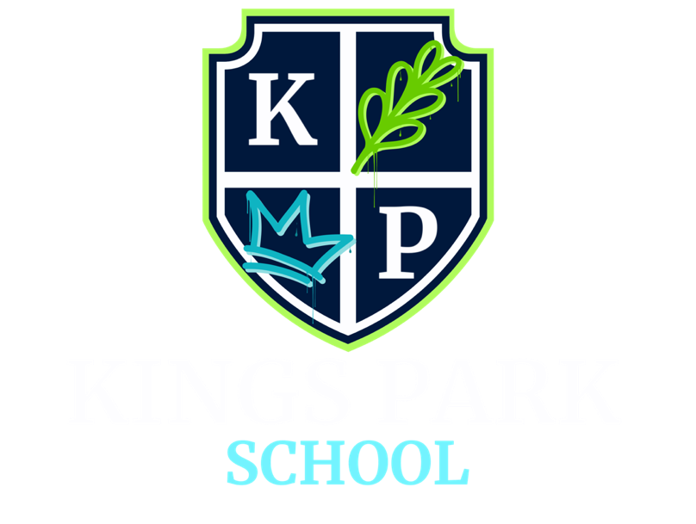

BEHAVIOUR AND RELATIONSHIP POLICY

POLICY NO. | KPS-BRP-004
POLICY OWNER | HEADTEACHER
DATE FIRST ISSUED | 26/11/2024
LATEST REVIEW DATE | 01/09/2025
NEXT REVIEW DATE | 01/09/2026

 | SIGNED | DATE
HEADTEACHER  MISS S J WATSON |  | 01/09/2025
PROPRIETOR  MRS AMY SAUNDERS |  | 01/09/2025
CHAIR OF GOVERNORS
MR ALEX RICHARDS

CONTENTS
- INTRODUCTION
- LEGAL FRAMEWORK AND GUIDANCE
- PURPOSE OF THIS POLICY
- OUR ETHOS AND VALUES
- THERAPEUTIC AND TRAUMA-INFORMED APPROACH
- SCHOOL-WIDE RESPONSIBILITIES
- CREATING AN INCLUSIVE COMMUNITY
- KPS EXPECTATIONS
- POSITIVE BEHAVIOUR SUPPORT PLANS
- PRESCRIBED MEDICATION
- RESPONDING TO DISTRESS AND NEED
- DE-ESCALATION AND PREVENTION
- THE USE OF RESTRICTIVE PHYSICAL INTERVENTION
- SEARCHING, SCREENING AND CONFISCATION
- REMOVAL FROM CLASSROOM
- SUSPENSION AND PERMANENT EXCLUSIONS
- ANTI-BULLYING
- CHILD-ON-CHILD ABUSE and SEXUAL HARASSMENT
- ONLINE INCIDENTS
- REPAIR AND REFLECTION
- RECORDING AND REPORTING
- COMPLAINTS

Appendix A: KPS Expectations Posters
Appendix B: Positive Behaviour Support Plan

To be read alongside the Positive Handling Policy and to be considered in conjunction with our Anti-Bullying, Equality, Diversity & Inclusion, Online Safety and Child Protection & Safeguarding policies.

INTRODUCTION

Kings Park School is an independent specialist provision, offering support and education for pupils from ages 7-16 with various individual needs. Each child and young person’s support is guided by their Education, Health and Care Plan (EHCP), which outlines the provision required to meet their individual needs. With spacious, light-filled classrooms and a highly skilled team of specialist SEN staff, our school provides a calm and supportive environment where pupils are empowered to move beyond past challenges.

Each learner follows a personalised timetable tailored to their individual needs and interests, with clear, achievable targets that promote motivation, confidence, and progress. In addition to the statutory annual review process, we conduct a broad range of formal and informal assessments throughout the year to monitor progress and adapt provision where necessary.

Classes are small with up to 8 pupils, depending on the individual needs. Each class is led by a teacher and supported by a dedicated teaching assistant, with additional teaching assistants provided where necessary and stated on the child’s EHCP. Pupils will be placed in a class based on suitability rather than age. Our nurture-based approach ensures that emotional wellbeing is prioritised alongside learning, and our classrooms are designed to be sensory-friendly, providing calm, supportive environments that help students feel safe, regulated, and ready to engage.

At Kings Park School (KPS), we place the safety, well-being, and development of our students at the heart of everything we do. Our behaviour and relationships policy reflects our commitment to providing a safe, inclusive, and aspirational learning environment for pupils with a range of neurodivergent profiles and social, emotional and mental health needs.

Our approach is underpinned by current clinical research and national guidance, using trauma-informed, strength-based practices. We seek to nurture relationships, build emotional resilience, and empower pupils to succeed academically, socially, emotionally and personally. This policy is guided by the belief that all behaviour is a form of communication. We place a strong emphasis on partnership with parents and carers, using regular communication and review meetings to share updates and respond promptly to any concerns. This ensures that support remains responsive, relevant, and aligned with each learner’s evolving needs.

At Kings Park School we recognise that non-restorative approaches are not effective in supporting individuals to develop new ways of managing challenging situations. When staff feel that a consequence may be necessary, we always reflect on its purpose by asking: Who is the consequence really for, and whose needs does it meet? Our focus remains on restorative and supportive strategies that promote growth, understanding, and long-term positive change.

2.0 LEGAL FRAMEWORK AND GUIDANCE

This policy is based on advice from the Department for Education (DfE) on:

- Behaviour in schools: advice for headteachers and school staff (DfE, 2024)
- Searching, screening and confiscation (DfE, 2022, updated 2023)
- Keeping Children Safe in Education (DfE, 2025)
- Suspension and Permanent Exclusion (DfE, 2023)
- Independent School Standards (2024 amendments)
- Working Together to Safeguard Children (Dec 2023 revision)
- Supporting pupils with medical conditions (DfE, 2023)
- Use of reasonable force in schools (DfE, 2025)

It is also based on the special educational needs and disability (SEND) code of practice and:

• Section 175 of the Education Act 2002, which outlines a school’s duty to safeguard and promote the

welfare of its students.

• Sections 88-94 of the Education and Inspections Act 2006, which require schools to regulate students’

behaviour and publish a behaviour policy and written statement of behaviour principles and give schools the authority to confiscate students’ property.

• Schedule 1 of the Education (Independent School Standards) Regulations 2014; paragraph 7 outlines a school’s duty to safeguard and promote the welfare of children; paragraph 9 requires the school to have a written behaviour policy and paragraph 10 requires the school to have an anti-bullying strategy.

3.0 PURPOSE OF THIS POLICY

At Kings Park School, our approach to behaviour is rooted in our belief that every child deserves to feel safe, valued, and inspired to thrive. Guided by our school motto – “Inspiring dreams, building bright futures together” – and our values of Kind words, Positive minds, and Strong hearts, we aim to create a nurturing environment where all students feel a genuine sense of belonging and purpose.

This Behaviour and Relationships Policy is designed to move away from traditional, non-restorative models of behaviour management and towards a strength-based, person-centred, neurodivergence-affirming approach. We recognise that behaviour is always a form of communication and reflects a child’s emotional state, needs, and experiences. Our goal is to understand the “why” behind the behaviour so that we can provide meaningful, compassionate, and effective support.

We do not use sanctions or punishments. Instead, we focus on:
- Building trusting, consistent relationships between students and staff.
- Creating an inclusive community where kindness and mutual respect are modelled and taught.
- Supporting pupils to develop emotional literacy and self-regulation skills, in line with their individual needs and capacities.
- Using positive behaviour support (PBS) strategies to enhance quality of life and reduce behaviours that challenge, through understanding and proactive, individualised support.
- Ensuring that consequences, when used, are natural, reflective, and focused on restoration and learning, not control or compliance.

At Kings Park School pupils are encouraged to take part in shaping the school community. Through student voice opportunities such as our School Council, class discussions, and regular feedback, they contribute to key decisions – including shaping anti-bullying initiatives and reviewing this policy. This ensures our practices remain relevant, respectful, and inclusive.

We also recognise that many of our students have faced challenges in previous educational settings. At KPS, we provide the high levels of support and understanding needed for them to rebuild confidence, form positive relationships, and achieve personal success in a way that is meaningful to them.
By fostering positive minds, modelling kind words, and nurturing strong hearts, we strive to help every young person grow into their brightest future together.

4.0 OUR ETHOS AND VALUES
We are guided by our school motto: "Inspiring Dreams, Building Bright Futures Together." Our core values are:
- Kind Words: We speak with empathy and understanding.
- Positive Minds: We approach challenges with optimism and resilience.
- Strong Hearts: We show courage, compassion and strength in our relationships.

These values are more than aspirations – they are embedded in every interaction, decision, and environment within Kings Park School.
Kind Words reflect our belief in the power of language to heal, uplift, and include. Whether it is peer encouragement, staff guidance or family communication, we model respectful, thoughtful speech in all we do.
Positive Minds encourage our students and staff to reframe difficulties as opportunities to learn and grow. We promote a strengths-based approach that focuses on what each individual child can do and how they can build confidence through success.
Strong Hearts remind us of the importance of compassion, resilience and relationships. We teach students to persist through challenges, support others, and show bravery in being true to themselves.
Together, these values underpin our approach to behaviour, learning, and building a safe, inclusive school community.

5.0 THERAPEUTIC AND TRAUMA-INFORMED APPROACH

At Kings Park School, all staff are trained in therapeutic, trauma-informed approaches to behaviour, ensuring that every response is grounded in empathy, understanding, and respect for the individual needs of our pupils. Staff are supported by a team of internal and external clinical professionals, allowing for a truly integrated and reflective approach to emotional and behavioural development. We prioritise the building of strong, consistent, and trusting relationships, recognising that emotional safety is the foundation for learning and growth. Staff respond to signs of distress with empathy and compassion, avoiding any use of shame-based or non-restorative language or practices. Instead, our approach focuses on co-regulation, helping students to manage their emotions in the moment, followed by reflective and restorative conversations to repair and learn from incidents in a supportive and non-judgemental way.

All practice aligns with the Working Together to Safeguard Children (2023) guidance.

6.0 SCHOOL WIDE RESPONSIBILITIES

Leadership Team:

At Kings Park School, the leadership team plays a visible and active role in shaping and maintaining a positive, inclusive school culture. Leaders are regularly present and engaged with students, staff, and families, promoting an environment where everyone feels safe, supported, and valued.

All new staff are carefully inducted into the ethos of Kings Park School, including our core values, routines, and expectations. This induction ensures that every team member understands how to contribute to a nurturing, structured environment that supports pupils to thrive socially, emotionally, and academically.

New staff receive bespoke training as part of their induction, including:

- Understanding neurodiversity through specialist training modules.
- Trauma-Informed Practice to support emotional regulation and relational safety.
- De-escalation and Behaviour Support strategies.
- Ongoing professional development and reflective practice.

All Staff:

At Kings Park School, all staff share a collective responsibility to create and maintain a safe, calm, and supportive environment where every child and young person can thrive. This includes modelling emotional regulation, promoting respectful relationships, and actively working to prevent all forms of bullying including cyberbullying, prejudice-based bullying, and any form of discriminatory or child-on-child abuse.

Staff play a key role in building an atmosphere where pupils feel safe, understood, and ready to learn. This involves establishing consistent expectations and boundaries and using every interaction as an opportunity to model positive behaviour and relationships.

Our whole-school approach to behaviour is upheld by staff through:

Teaching and modelling appropriate behaviour and social interaction.

Using visual supports and clear routines to aid understanding.

Encouraging open communication, so that students feel confident to ask for help.

Staff receive clear guidance on professional conduct, aligned with our school values and outlined in the Code of Conduct Policy.

Through consistency, care, and clear communication, staff support pupils to develop positive habits that promote wellbeing, belonging, and readiness to learn.

Pupils:

At Kings Park School, we believe that every child and young person has the right to learn in a calm, safe, and supportive environment where they are treated with dignity and respect. To ensure this, all students are supported - in line with their individual needs and levels of understanding - to become familiar with the school’s expectations, routines, behaviour standards, pastoral support, and the use of therapeutic approaches.

We actively teach pupils that they are a valued part of our school community and that they play a role in helping to create a positive, respectful culture. Their feedback is gathered in accessible and meaningful ways, ensuring that their voices contribute to the ongoing development and review of our behaviour policy and wider school practices.

Every student is supported to reach their full potential through a personalised induction and transition process, helping them to feel safe, settled, and confident within the school’s nurturing environment. Our approach recognises each child and young person as an individual, and our systems are designed to promote both wellbeing and achievement.

Parents/Carers:

At Kings Park School, we recognise that parents and carers play a vital role in shaping and sustaining our positive school culture. Building strong, trusting relationships with families is key to providing consistent, holistic support around each child or young person.

We actively encourage parents and carers to:

Familiarise themselves with the school’s Behaviour Policy and related policies.

Engage with the wider life of the school wherever possible.

Collaborate with staff to ensure consistency in support and expectations between home and school.

When concerns arise, we encourage open, respectful dialogue so that we can work together to resolve issues and maintain a unified approach. We are committed to listening and responding to parental views as part of our person-centred and neurodiversity-affirming ethos.

We keep parents and carers informed through regular communication, celebrating student achievements and providing updates on progress. Where appropriate, families are invited to participate in pastoral and behaviour reviews, ensuring that the strategies and interventions in place are effective and responsive to their child’s needs.

By working in partnership, we aim to create a consistent and supportive environment that enables every child and young person to thrive both at school and at home.

7.0 CREATING AN INCLUSIVE COMMUNITY
At Kings Park School, our behaviour and relationship approach is built around clear expectations, consistent structure, and compassionate communication, tailored to the individual strengths and needs of our pupils. We use therapeutic, inclusive strategies to ensure all students are supported to feel safe, understood, and ready to learn.
- Clear Expectations and Consistent Boundaries
Expectations are communicated through spoken language, visual supports, Makaton, and modelling, ensuring that both students and staff understand what is expected in a way that is accessible and meaningful, according to each child and young person’s developmental stage and communication style.
- The Curriculum
Our approach to behaviour and relationships is integrated into our Personal, Social, and Health Education (PSHE) and Relationships and Sex Education (RSE) curriculum, supporting the development of emotional regulation, positive relationships, and social understanding.
- Routines
A predictable and structured environment supports our learners’ sense of security. Staff ensure that visual timetables and now and next boards are presented and lessons are delivered with clear structure - including a defined beginning, middle, and end - providing routine and reducing anxiety.
- Environment
We prioritise calm, clean, welcoming spaces that are designed with sensory regulation in mind, creating environments where learners feel safe and able to focus, with adjustments made to meet individual sensory profiles.
- Communication
We use a total communication approach, combining spoken language, signing, symbols, visuals, and objects of reference, ensuring that all learners can access information and express themselves in a way that works best for them.
- Emotional Understanding
We recognise that many of our learners may experience heightened emotional responses or difficulties in identifying and expressing emotions. Tools such as Zones of Regulation, ELSA and other therapeutic models are used across the school to develop emotional literacy and co-regulation, and to establish a shared emotional language for all members of our community.
- Rewards and Recognition
We celebrate effort, small-step progress, and positive behaviour, rather than just outcomes. We have a variety of reward systems that are tailored to individual preferences and motivators. We actively avoid competitive or exclusionary incentives, such as attendance awards. Importantly, once a reward is earned, it will never be withdrawn as a consequence.

All staff are expected to model the behaviour and attitudes we want our pupils to learn, and to uphold the school’s values in every interaction.

8.0 KPS EXPECTATIONS

At Kings Park School, we recognise that behaviour is a form of communication, particularly for pupils with special educational needs. Our expectations of Be Ready, Be Respectful and Be Safe, supported by our core values of Kind Words, Positive Minds and Strong Hearts, provide a clear and consistent framework to help pupils understand what positive behaviour looks like. Expectations are carefully adapted to reflect pupils’ age, developmental stage and individual learning needs, ensuring they remain achievable and meaningful for all learners. These expectations are embedded throughout the school through visual displays, consistent language and daily modelling by staff. All staff are familiar with the expectations and use them consistently to support pupils in developing self-regulation, positive relationships and safe choices, creating a calm and supportive learning environment for everyone.

See appendix A

9.0 POSITIVE BEHAVIOUR PLANS

At Kings Park School, each pupil has an individual Positive Behaviour Plan (PBP) which outlines their specific needs, triggers, supportive strategies and appropriate responses to behaviour. These plans recognise that pupils may communicate their needs through behaviour and ensure that staff respond in a consistent, supportive and informed way. Positive Behaviour Plans are shared with all staff working with the pupil so that everyone understands the child’s individual profile and knows how to support them effectively. By using these plans, staff are able to provide predictable routines, proactive support and clear responses, helping pupils to feel safe, understood and regulated. This consistent approach across the school ensures that behaviour is managed in a way that supports pupils’ emotional development, wellbeing and ability to engage in learning.

See appendix B

10.0 PRESCRIBED MEDICATION

At Kings Park School, some of our pupils may be prescribed medication as part of their care and support. We work closely with prescribing professionals, families, and other key adults involved to ensure the young person’s needs are safely and effectively supported, in line with our statutory responsibilities.

We monitor and support the use of prescribed medication and its impact on each student’s wellbeing and learning. We also encourage and support our learners to develop an understanding of their medication and to be involved in making informed choices about their care, where appropriate.

11.0 RESPONDING TO DISTRESS AND NEED

At Kings Park School, we recognise that some of our pupils may experience periods of distress and require additional support to regulate their emotions and behaviour. When this occurs, staff respond with empathy, clarity, and consistency, always aligned with the principles of our Person-Centred Neurodivergence-Affirming Behaviour Policy.

Our immediate priority is to ensure the physical and emotional safety of all students and staff, and to re-establish a sense of calm within the environment. Maintaining a safe, supportive and regulated atmosphere is central to all our responses.

Staff are also trained to consider whether the behaviour may indicate that a child or young person is suffering, or is at risk of suffering, harm. In such cases, the school’s Safeguarding Policy must be followed without exception. Any concern, no matter how small, must be promptly reported to the Designated Safeguarding Lead (DSL) or Deputy DSL.

Kings Park School recognises that behaviour outside of school, including in online environments, may still have a significant impact on a young person’s well-being and the wider school community. We will respond to such behaviour as far as it is reasonable, particularly where it affects the safety, relationships, or emotional security of any member of the school.

Our approach includes a range of proactive and therapeutic strategies designed to support students’ emotional regulation and reduce the need for reactive responses. These strategies are personalised, strengths-based and informed by clinical and educational best practices.

12.0 DE-ESCALATION AND PREVENTION

At Kings Park School, our approach to behaviour is rooted in proactive, preventative strategies that support the emotional regulation and well-being of our students. We understand that behaviour is a form of communication, particularly for neurodivergent learners who may face challenges in expressing their feelings, needs, or sensory experiences through conventional means.

Our priority is always to prevent distress wherever possible, and when it does arise, to respond with empathy, consistency, and respect. We do this by:

1. Building Safe, Predictable Relationships
- All staff form trust-based, attuned relationships with pupils, using consistency and co-regulation to foster feelings of safety.
- Learners are supported to recognise their own emotional states and signals of escalation through emotion coaching, the Zones of Regulation, and other personalised supports.

2. Creating Calm, Structured Environments
- Classrooms and communal areas are sensory-considered, low-arousal spaces, designed to reduce environmental triggers.
- We establish clear routines and visual schedules to reduce anxiety and promote predictability.

3. Individualised Support Plans
- Every learner has a personalised support plan that includes known triggers, early signs of distress, preferred calming strategies, and successful communication tools.
- These plans are co-created with input from learners, staff, families, and clinical professionals, and reviewed regularly.

4. Staff Training and Team Approach
- All staff are trained in de-escalation and therapeutic approaches, including Team Teach. This ensures a consistent and safe response when learners become distressed or dysregulated.
- Staff focus on using non-threatening body language, calm tone, and emotionally attuned responses.
- Staff will use positive framing language.

5. Early Intervention and Emotional Literacy
- We teach emotional understanding and self-regulation skills as part of our Personal, Social, and Health curriculum, as well as through daily interactions.
- Staff actively look for early signs of dysregulation and intervene with low-key, preventative strategies such as offering a break, a safe/sensory space, weighted objects, using humour, changing the environment, or introducing a trusted adult.

6. Restorative and Reflective Practice
- After any incident, we create time and space for reflection and restoration, when the learner is ready. This helps rebuild trust, deepen understanding, and prevent recurrence.
- Staff support the learner in recognising what happened, how they felt, and what could be done differently next time – never through blame or shame, but through curiosity and compassion.

This approach ensures that our pupils are protected from escalation and harm, that their dignity is preserved, and that staff are supported to respond in ways that are trauma-informed, therapeutic, and effective.

13.0 THE USE OF RESTRICTIVE PHYSICAL INTERVENTION
At Kings Park School, we recognise that any form of physical intervention, including restraint, can be distressing and may impact a child or young person’s emotional well-being and their relationships with trusted adults. For this reason, Team Teach is used as our approved and accredited positive handling framework for safe, positive handling, always within a wider context of preventative, therapeutic support.
Restrictive physical intervention is only ever used as a last resort, when all other strategies have been unsuccessful, and only to protect the learner or others from immediate and significant risk of harm. Any intervention is:
- Reasonable.
- Proportionate.
- The least restrictive necessary, carried out for the shortest duration possible to ensure safety and restore calm.
Our staff are trained to use Team Teach principles, which prioritise de-escalation, risk reduction, and relational repair. Any physical intervention is carried out with dignity, care, and empathy, and always in accordance with our school values: Kind Words, Positive Minds, Strong Hearts.
We place great emphasis on student voice and where appropriate, co-develop personalised de-escalation strategies with learners, families, and clinical professionals. These plans reflect the student’s preferences, known triggers, and preferred calming strategies, so that if a crisis occurs, the response feels predictable, safe, and attuned.
All incidents involving physical intervention are recorded appropriately, reviewed, and followed by reflective debriefs for both staff and students. This ensures accountability, promotes learning, and protects the emotional safety of all involved.

14.0 SEARCHING, SCREENING AND CONFISCATION
At Kings Park School, our priority is to maintain a safe and secure environment where all students feel protected and supported. In accordance with the Education and Inspections Act 2006, staff have the authority to confiscate items that are unlawful or banned by the school, where doing so is lawful and proportionate. This includes any item that may pose a risk to the safety or wellbeing of the student or others.
Staff may remove such items without prior notice if they believe the item could cause harm or disruption. Where necessary, a teacher or another adult with lawful control of the child or young person may request to search a student with their consent for items that are not allowed in school. In line with legal powers, the Headteacher or authorised staff may also carry out a search without consent if they have reasonable grounds to suspect that a child or young person is in possession of a prohibited item.
Prohibited items include, but are not limited to:
- Knives or weapons
- Alcohol.
- Illegal drugs.
- Psychoactive substances (“legal highs”).
- Stolen items.
- Tobacco, e-cigarettes, and associated paraphernalia.
- Fireworks.
- Pornographic images.
- Items that could be used to commit an offence or cause harm.

Under the Education Act 2011, if an electronic device (e.g. mobile phone or tablet) is confiscated, staff have the legal right to examine its contents where there is a good reason to do so. Any inappropriate material may be deleted if deemed necessary before the device is returned.
Cigarettes, e-cigarettes, and related items will not be returned to students and will be disposed of safely.
All actions taken in relation to confiscation and searching are conducted with sensitivity, proportionality, and in accordance with safeguarding guidance, considering the individual needs of our students.

15.0 REMOVAL FROM CLASSROOM
At Kings Park School, removal from the classroom is only considered when it is necessary to protect the safety and well-being of the individual CYP, their peers, or staff. Any such decision is made with care and in recognition of the learner’s emotional, cognitive, and sensory needs. If removal is required, the learner will continue to receive appropriate supervision and support in a calm, therapeutic space.
The Headteacher holds strategic oversight of all removals to ensure that:
- The reasons for removal are clearly understood by all staff and explained in a way appropriate to the learners understanding.
- Removal is for the shortest possible time and used only when no other appropriate strategy is effective in the moment.
- The alternative space is safe, supportive, and appropriately resourced to help the learner regulate, reflect, and re-engage.
- The learner is supervised by trained staff who use therapeutic and person-centred approaches.
- A clear reintegration plan is followed to support the learner’s return to class as soon as it is safe and appropriate to do so.
Pupils will never be removed for extended periods without the explicit authorisation of the Headteacher, and every effort will be made to use proactive and preventative strategies before any removal is considered. The focus remains on regulation, restoration, and re-engagement.
16.0 SUSPENSION AND PERMANENT EXCLUSIONS
At Kings Park School, all pupils have the right to an education in a calm, safe, and supportive environment. The use of suspension or permanent exclusion is considered only in response to serious incidents or when there is persistent unsafe behaviour that has not improved despite the implementation of individualised support and in-school adaptations.

These decisions are treated with the utmost seriousness and will always be a last resort. We recognise that removing a child or young person from an environment built on trusted relationships and therapeutic support is rarely in their best interest. Where such action is necessary, we collaborate closely with the young person and their family/carers to ensure the impact is minimised and that appropriate support is in place.

Our approach prioritises restoration, understanding, and future planning for reintegration or transition. For further details, please refer to the Suspension and Permanent Exclusion Policy.

17.0 ANTI-BULLYING
Some pupils at Kings Park School may experience difficulties in understanding or managing social relationships. This may be due to a lack of previous positive role modelling or differences in social communication linked to their individual needs.
Staff are trained to remain consistently alert to the signs of bullying, recognising that these may be subtle or overt, and may occur face-to-face or online. Any concerns will be responded to promptly and in accordance with our Anti-Bullying Policy, with a focus on restorative practice, education, and emotional safety.
We understand that all behaviour is a form of communication, and we support our pupils in developing the skills and confidence needed to build safe, respectful and trusting relationships within the school community.

18.0 CHILD-ON-CHILD ABUSE and SEXUAL HARASSMENT
At Kings Park School, we are committed to creating a safe and respectful environment for all pupils. Any report or concern relating to child-on-child abuse, including sexual harassment whether online or offline, will be taken extremely seriously and responded to in line with our Child-on-Child Abuse Policy. This includes harmful sexual behaviour (HSB), as outlined in KCSIE 2025 and DfE guidance ‘Sexual violence and sexual harassment between children in schools and colleges (2021, still current). Staff must notify the Designated Safeguarding Lead (DSL), or Deputy DSL immediately to ensure appropriate wraparound support.
The school maintains a zero-tolerance stance on all forms of sexual harassment or abuse. We are clear that sexual violence, harassment, and abusive behaviours are never acceptable, will not be tolerated under any circumstances, and will be addressed swiftly. All staff are trained and expected to challenge any inappropriate or harmful language or conduct between students. We do not excuse or minimise harmful behaviour as "banter" or part of growing up.
We actively promote a culture of dignity, respect, and positive relationships. Staff and students are expected to model courteous, appropriate, and supportive interactions at all times.
When a student discloses harm, it is essential that they feel heard, believed, and supported. Pupils will be:
- Reassured that they are being taken seriously.
- Supported to feel safe and emotionally secure.
- Never made to feel like they are causing a problem by speaking up.
- Protected from any form of blame or shame related to their experience.

Incidents that occur online or outside of school premises will be treated with equal seriousness as those that happen in school. Kings Park School ensures that students are empowered to speak out and receive timely and compassionate support, with staff trained to respond in a trauma-informed, developmentally appropriate manner.

19.0 ONLINE INCIDENTS
At Kings Park School, we recognise that the way pupils interact online can have a significant impact on the wider school community. Negative or unkind behaviour in the online space can affect learners sense of safety and belonging and may harm the school’s supportive culture. Online incidents – whether they happen inside or outside school—can be complex, particularly where anonymity is involved. However, our expectations remain consistent: students are expected to show the same respect, kindness, and consideration online as they do in person.
Inappropriate online behaviour, including cyberbullying, the use of offensive or discriminatory language, the sharing or requesting of nude or semi-nude images or videos, and any form of sexual harassment, will be dealt with using the same principles as offline incidents. Where a safeguarding concern is raised, staff must follow the school’s Safeguarding Policy and report the matter immediately to the Designated Safeguarding Lead or Deputy.
The school will take appropriate action when online behaviour causes harm or distress to another child or young person, or if it impacts the safety, wellbeing, or reputation of the school. Our approach is always centred around supporting young people to understand the impact of their actions and to develop safer, more respectful online behaviours.
This section aligns with DfE Teaching Online Safety in Schools (2019, updated 2023) and KCSIE 2025 guidance on filtering and monitoring.

20.0 REPAIR AND REFLECTION
At Kings Park School, it is recognised as best practice to provide a supportive and timely space for pupils to debrief following a significant incident, with the goal of promoting relationship repair, emotional processing, and learning. This reflective process is always guided by what is in the child or young person's best interest and takes place only when they are emotionally and cognitively ready to engage.
We use visual, narrative, and sensory-regulation strategies tailored to each learner’s individual profile to support this process. We understand that many of our neurodivergent learners may experience memory disruption or emotional overload during moments of distress, which may limit their capacity to recall or reflect immediately.
Debriefing is seen not only as a time for the child or young person to be heard, but also as an opportunity for staff and students to reflect together on how to strengthen understanding, identify adjustments that may be needed in the environment or support strategies, and reinforce emotional safety and trust. Any changes made to support strategies or plans will be a collaborative approach between the school, the child or young person, the families, and any other relevant professionals.
21.0 MONITORING, ANALYSIS AND REPORTING
At Kings Park School, we have a robust and reflective system for monitoring and evaluating behaviour across the school. We use Arbor to record all elements of the behaviour culture, including both positive behaviour and incidents requiring intervention, as well as recording these on our safeguarding platform. This data is reviewed regularly by the senior leadership team as part of a structured monitoring and evaluation cycle, which includes input from school leaders, governors, and relevant stakeholders.
We collect and analyse a wide range of information including:
- Behaviour incidents
- Attendance and punctuality
- Suspensions and any instances of permanent exclusion
- Incidents involving searching, screening, or confiscation.
- Stakeholder feedback (via regular surveys involving students, staff, parents/carers, governors, and proprietors) on their experiences of the behaviour culture.

All data is reviewed objectively and systematically, with patterns explored at multiple levels: whole school, staff team, and individual child and young person. Leaders use this data to identify potential barriers, unmet needs, or systemic issues – ensuring that any behaviour is not seen in isolation but understood within context. Importantly, behaviour data is analysed with attention to protected characteristics, in line with the school’s duties under the Equality Act 2010, helping ensure fair and inclusive practice for all.

Incidents of behaviour indicating a risk to safety or potential criminal damage with be escalated appropriately. This includes referrals to external agencies, such as the police or the Local Authority. Any concerns involving members of staff will be addressed following the school’s Safeguarding Policy.

This responsive and inclusive approach ensures that behaviour monitoring at Kings Park School is not just about accountability but about continuous improvement, safeguarding, and meaningful support for every child and young person.

Behaviour data is reviewed termly by the Proprietor and Governing Board.

22.0 COMPLAINTS

Any complaint or concern raised by a child or young person is taken seriously, and staff remain vigilant to both clear and subtle signs of distress or dissatisfaction. All complaints will be handled in line with the school's Complaints Policy, ensuring a prompt, sensitive, and appropriate response.

In accordance with paragraph 33 of Part 7 of the Independent School Standards, the school's complaints procedure and information on complaint statistics is always available to parents/carers.

This policy will be reviewed by the governing board every year. At every review, the policy will be approved by the chair of governors.

APPENDIX A

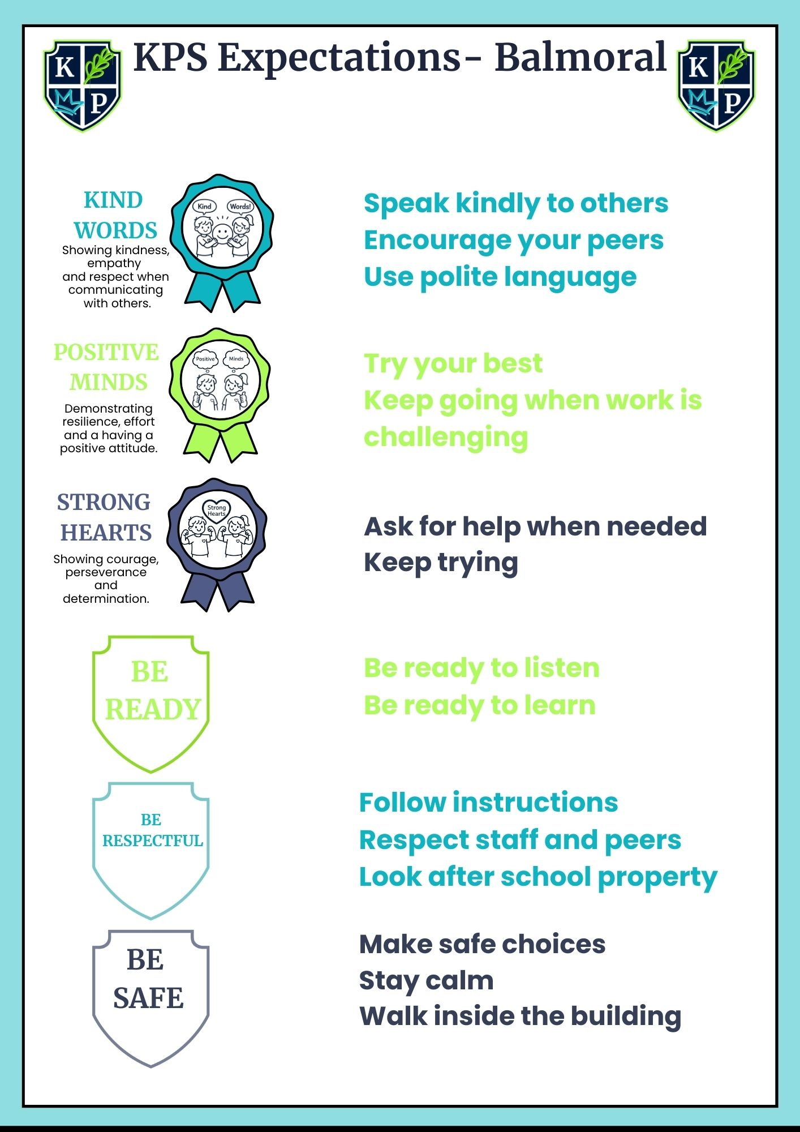

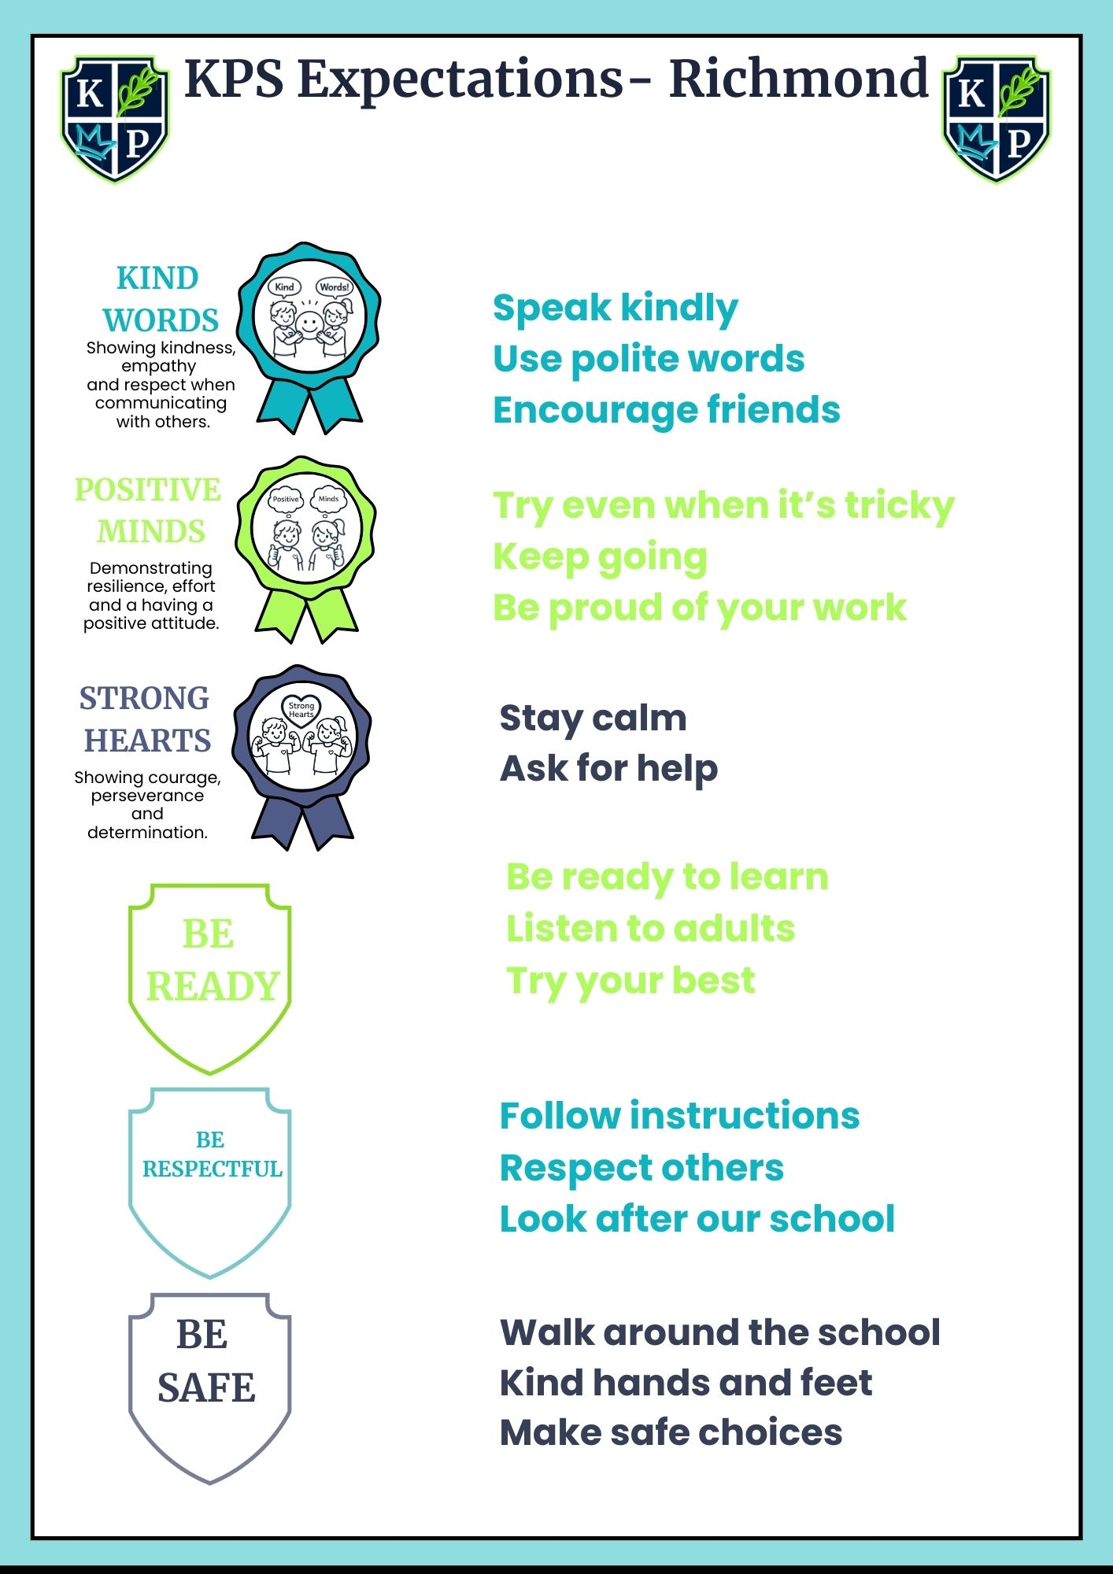
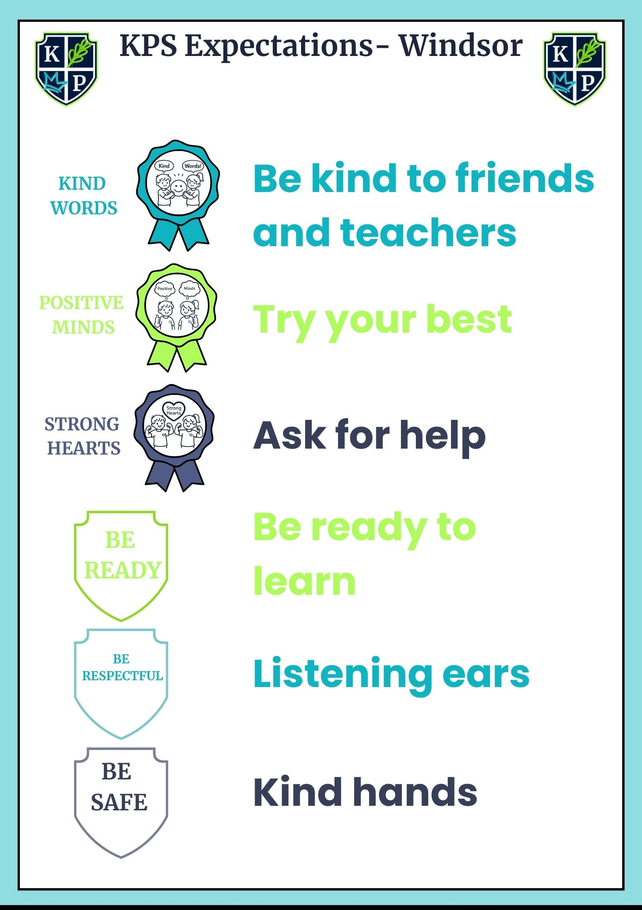

APPENDIX B

