

COMPLAINTS POLICY

POLICY NO. | KPS-COM-005
POLICY OWNER | HEADTEACHER
DATE FIRST ISSUED | 26/11/2024
LATEST REVIEW DATE | 14/09/2026
NEXT REVIEW DATE | 14/09/2027

 | SIGNED | DATE
HEADTEACHER  MISS S J WATSON |  | 14/09/2026
PROPRIETOR  MRS AMY SAUNDERS |  | 14/09/2026
CHAIR OF GOVERNORS  MR ALEX RICHARDS | 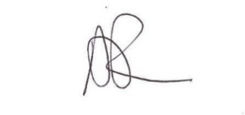 | 01/04/2026

CONTENTS
- INTRODUCTION
- AIMS
- LEGAL FRAMEWORK AND GUIDANCE
- PURPOSE OF THIS POLICY
- OUR ETHOS AND VALUES
- CONCERNS VS COMPLAINTS
- WHO CAN RAISE A COMPLAINT
- STAGES OF COMPLAINTS PROCESS
- COMPLAINTS BY PUPILS
- UNREASONABLE COMPLAINTS
- RECORD KEEPING AND CONFIDENTIALITY
APPENDIX A: COMPLAINTS PROCEDURE

1.0 INTRODUCTION

Kings Park School is an independent specialist provision, offering support and education for children and young people from ages 7-16 with various individual needs. Each child and young person’s support is guided by their Education, Health and Care Plan (EHCP), which outlines the provision required to meet their individual needs. With spacious, light-filled classrooms and a highly skilled team of specialist SEN staff, our school provides a calm and supportive environment where children and young people are empowered to move beyond past challenges.

Each learner follows a personalised timetable tailored to their individual needs and interests, with clear, achievable targets that promote motivation, confidence, and progress. In addition to the statutory annual review process, we conduct a broad range of formal and informal assessments throughout the year to monitor progress and adapt provision where necessary.

Classes are small with up to 8 pupils, depending on the individual needs. Each class is led by a teacher and supported by a dedicated teaching assistant, with additional teaching assistants provided where necessary and stated on the child’s EHCP. Children and young people will be placed in a class based on suitability rather than age. Our nurture-based approach ensures that emotional wellbeing is prioritised alongside learning, and our classrooms are designed to be sensory-friendly, providing calm, supportive environments that help students feel safe, regulated, and ready to engage.

At Kings Park School (KPS), we place the safety, well-being, and development of our students at the heart of everything we do. We are committed to providing a safe, inclusive, and aspirational learning environment for children and young people with a range of neurodivergent profiles and social, emotional and mental health needs.

AIMS
Our school aims to meet its statutory obligations when responding to complaints from parents and carers of pupils at the school, and others.
When responding to complaints, we aim to:
- Be impartial and non-adversarial
- Facilitate a full and fair investigation, where necessary
- Address all the points at issue and provide an effective and prompt response
- Respect confidentiality, where necessary
- Treat complainants with respect and courtesy
- Make sure that any decisions we make are lawful, rational, reasonable, fair and proportionate, in line with the principles of administrative law
- Keep complainants informed of the progress of the complaints process
- Consider how the complaint can feed into school improvement evaluation processes

We try to resolve complaints by informal means wherever possible. Where this is not possible, formal procedures will be followed.

The school will aim to give the complainant the opportunity to complete the complaints procedures in full.
To support this, we will make sure we publicise the existence of this policy and make it available on the school website.

Throughout the process, we will be sensitive to the needs of all parties involved, and make any reasonable adjustments needed to accommodate individuals.

These aims reflect our values of Kind Words, Positive Minds and Strong Hearts. We listen and respond with respect, approach concerns with an open mind, and have the courage to acknowledge mistakes and put things right. By handling complaints fairly and learning from them, we strengthen the trust and sense of belonging we want every learner and family to feel at Kings Park School.

LEGAL FRAMEWORK AND GUIDANCE

This policy follows the Education (Independent School Standards) Regulations 2014, Schedule, Part 7, paragraph 33 (complaints) and Part 6, paragraph 32(1)(f) (availability of the procedure and formal complaint numbers).

It also has regard to –

the Equality Act 2010

the UK General Data Protection Regulation

Data Protection Act 2018

the Children Act 1989

Children Act 2004 where safeguarding concerns arise

section 109 of the Education and Skills Act 2008 concerning inspection.

Relevant current guidance includes the Department for Education Independent school standards guidance (April 2026) and Keeping children safe in education 2026 (in force September 2026).

- PURPOSE OF THIS POLICY

The purpose of the Kings Park School Complaints Policy is to provide a clear and fair process for handling concerns or complaints. It encourages early resolution through open communication and ensures all complaints are taken seriously and dealt with promptly. The policy helps the school learn and improve from feedback while meeting legal requirements and reflecting our values of Kind Words, Positive Minds and Strong Hearts.

This policy does not cover complaints procedures relating to:

Admissions

Statutory assessments of special educational needs (SEN)

Safeguarding matters

Suspension and permanent exclusion

Whistleblowing

Staff grievances

Staff discipline

Please see our separate policies for procedures relating to these types of complaint.
If there are concerns that a pupil has been harmed or may be at risk of harm, the School’s Safeguarding Policy must be followed without delay.

5.0 OUR ETHOS AND VALUES
We are guided by our school motto: "Inspiring Dreams, Building Bright Futures Together." Our core values are:
- Kind Words: We speak with empathy and understanding.
- Positive Minds: We approach challenges with optimism and resilience.
- Strong Hearts: We show courage, compassion and strength in our relationships.

These values are more than aspirations—they are embedded in every interaction, decision, and environment within Kings Park School.
Kind Words reflect our belief in the power of language to heal, uplift, and include. Whether it is peer encouragement, staff guidance or family communication, we model respectful, thoughtful speech in all we do.
Positive Minds encourage our students and staff to reframe difficulties as opportunities to learn and grow. We promote a strengths-based approach that focuses on what each individual child can do and how they can build confidence through success.
Strong Hearts remind us of the importance of compassion, resilience and relationships. We teach students to persist through challenges, support others, and show bravery in being true to themselves.
Together, these values underpin our approach to behaviour, learning, and building a safe, inclusive school community.

6.0 CONCERNS VS COMPLAINTS
A concern is an expression of worry or uncertainty about something considered important, where reassurance or clarification is being sought. A complaint is an expression of dissatisfaction about an action that has been taken or not taken, regardless of how it is raised.
At Kings Park School, we believe it is in everyone’s best interest to resolve complaints as early as possible. Many issues can be addressed quickly and effectively through informal discussions (Stage 1), without needing to move into formal procedures (Stages 2 and 3). We take all concerns seriously and will always do our best to respond promptly and appropriately.
When responding to complaints, we aim to:
- Remain impartial and avoid conflict.
- Conduct thorough and fair investigations, involving independent individuals or panels when needed.
- Address all aspects of the complaint and provide timely, effective responses.
- Respect confidentiality wherever possible.
- Treat all individuals with kindness and respect.
- Ensure our decisions are fair, lawful, and proportionate.
- Keep those involved updated throughout the process.

- Reflect on outcomes to support ongoing school improvement.
Wherever possible, we seek to resolve matters informally. If that is not achievable, we will follow our formal complaints procedures. We are committed to allowing every complainant the opportunity to complete the process in full. This policy is shared openly and is available on our school website.
We remain mindful of the needs of everyone involved and will make reasonable adjustments to ensure the process is accessible and fair.
Raising a complaint will not disadvantage a learner or affect the education, care or support they receive. The person complained about will have a fair opportunity to respond, and no person directly involved in the complaint will make the final decision about it.

7.0 WHO CAN RAISE A COMPLAINT?
Parents or carers of learners currently receiving education at Kings Park School may use the full three stage procedure below. A complaint started while a learner is on roll may continue after they leave. Learners and other people, including members of the public, may raise concerns; KPS will agree a suitable response, but the statutory parent panel entitlement does not automatically extend to them. Matters with their own statutory or employment procedures will be directed to those routes without delaying any immediate safeguarding action.
To help ensure that a complaint is handled effectively and resolved in a timely way, we ask that complainants:
- Follow the steps outlined in this policy.
- Work constructively with the school and respond promptly to communication.
- Ask for support if needed to understand or engage in the process.
- Treat all individuals involved with respect and courtesy.
- Refrain from contacting individual governors directly about the complaint.
- Avoid posting details of the complaint on social media.

The Investigator
When a complaint is made, an impartial and appropriately senior individual will be appointed to investigate the matter. The investigator will:
- Speak with all relevant people and record the conversations carefully.
- Review any relevant documents and evidence, storing them securely.
- Prepare a detailed report for the Headteacher or complaints panel, summarising the facts and recommending possible outcomes.

Complaints Co-ordinator
The person overseeing the complaints process will act as the Complaints Co-ordinator. This may be the Headteacher (Stevie-Jane Watson) or the Chair of Governors (Alex Richards).
The complaints co-ordinator will:
- Keep the complainant up to date at each stage in the procedure.
- Make sure the process runs smoothly by liaising with team members, the headteacher, chair of governors, and clerk.
- Keep records.
- Be aware of issues relating to:
  - Sharing third-party information.
  - Additional support needed by complainants; for example, interpretation support or where the complainant is a child or young person.
The proprietor (Amy Saunders) is responsible for ensuring this procedure is available, compliant and followed in practice. The Headteacher normally coordinates complaints unless involved. An investigator must be impartial. At Stage 3, the panel chair ensures both sides can present relevant evidence and the clerk arranges and records the hearing. Governors reviewing complaint themes must avoid becoming involved in the detail of cases they may later be asked to hear.

8.0 STAGES OF THE COMPLAINTS PROCESS
Stage 1 – Informal Resolution
We encourage open communication, and many concerns can be resolved informally. Complainants are invited to speak with the class teacher, pastoral lead, or a member of the Senior Leadership Team.
We will:
- Acknowledge the concern promptly.
- Offer a resolution within 10 working days.
- Communicate any delays and revised timeframes.

If the issue remains unresolved, the complainant may proceed to Stage 2.
Working days in this policy are days when the school is open to learners. If a deadline cannot be met, the school will explain the reason and provide a revised date. Urgent safeguarding concerns are acted on immediately, including during school holidays.

Stage 2 – Formal Complaint to Headteacher
A Stage 2 formal complaint must be made in writing to the Headteacher; an email counts as writing. If a complainant raises it verbally or needs help, a member of staff will write down their complaint and confirm the account with them. The complaint should explain the issues, relevant dates and the outcome sought. A third party may write on a complainant’s behalf with their consent.
The Headteacher will:
- Acknowledge receipt within 3 working days.
- Appoint an investigator if appropriate.
- Provide a full written response within 10 working days (or provide a revised timeline if extended investigation is needed).

A complaint about the Headteacher should be sent confidentially to the Chair of Governors through the school office. A complaint about an individual governor should be sent to the Chair, unless the Chair is involved. A complaint about the Chair, most or all governors, or the proprietor should be addressed confidentially to the Headteacher whereby an uninvolved decision maker or external investigator will be appointed as appropriate, with access to all three stages and an independent panel at Stage 3.

Stage 3 – Independent Review Panel Hearing
If the complainant remains dissatisfied after Stage 2, they may request a Stage 3 hearing through the school office. We ask that the request identifies the unresolved issues and is made within 20 working days of the Stage 2 response; a later request will be considered fairly. There is no fee. The hearing remains available if the parent chooses not to attend.
- The panel will be appointed by or on behalf of the proprietor and consist of at least three people with no direct involvement in the matters complained about. At least one must be an independent reviewer with no prior connection to KPS, its workforce, proprietor, governing body or management. The independent reviewer is a member of the panel: a single reviewer alone would not satisfy the independent school standard.
- A hearing will be arranged within 30 working days.
- The complainant may attend and be accompanied by a person of their choice. The clerk will offer reasonable hearing arrangements and circulate relevant papers in advance. Both sides will be able to present information, subject to appropriate protection of third party data. Where the complainant chooses not to attend, the panel will still meet and consider the written evidence.
- A written outcome will be provided within 10 working days of the hearing.

The panel may:
- Uphold the complaint in full or part.
- Dismiss the complaint.
- Recommend changes to school policy or practice.

The panel, including the independent reviewer, will make written findings and recommendations. Within 10 working days of the hearing, a copy will be provided to the complainant, proprietor and Headteacher and, where relevant, the person complained about. A copy will also be available for inspection on school premises by the proprietor and Headteacher.
The panel hearing ends KPS’s internal complaints procedure. If still dissatisfied and concerned that KPS, as an independent school, is failing to meet the Independent School Standards, a complainant may refer the concern to the Department for Education using gov.uk/complain-about-school/private-schools. The Department does not normally investigate or overturn an individual private school complaint but may consider serious regulatory concerns. Child protection concerns should be reported immediately to children’s services or the police, and immediate danger to 999. Separate SEND and disability discrimination routes may apply to their respective issues.

9.0 COMPLAINTS BY PUPILS
At Kings Park School, we encourage pupils to speak openly about any concerns they may have, whether related to school or experiences outside of it. Pupils can speak to any trusted adult in school, and they will always be listened to with care and respect.
- Pupils may choose to share something that does not amount to a formal complaint. In these cases, support will still be offered as appropriate.
- If a formal complaint is made, the staff member will log it in the school’s Complaints Log, and the school’s response will also be recorded.
- For serious matters, the pupil’s parent or carer will be informed, and a meeting may be held to discuss the issue further.
- Some concerns require a referral to the local authority or another agency. Safeguarding referrals will be made without delay under the Safeguarding Policy; the school will not wait 10 working days where a child may be at risk.
- If a pupil asks to speak to someone from outside the school, efforts will be made to facilitate this, and the referral will be documented.
- If the complaint involves an allegation against a member of staff, the school’s Safeguarding Policy and the Allegations against Staff Procedure will be followed in full.

10.0 UNREASONABLE COMPLAINTS
Kings Park School is committed to respectful, productive communication. We recognise that people raising complaints may feel strongly about the issues they are experiencing. However, complaints may be considered unreasonable if the person:
We will not describe a complaint as unreasonable merely because a complainant is persistent, strongly disagrees with a decision, or asks for the next stage. Any limits on contact will be proportionate, explained in writing and reviewed, while preserving access to safeguarding routes and the complaints procedure.
- Refuses to clearly explain the complaint, the grounds for it, or the outcome they seek.
- Fails to cooperate with the investigation process but still expects a resolution.
- Insists on outcomes or processes that are not aligned with the school’s policy.
- Repeatedly changes their complaint or refuses to accept previous conclusions.
- Seeks unrealistic outcomes or repeatedly raises the same complaint despite it being addressed.
- Makes personal attacks or unfounded complaints about those handling the issue.
In addition, a complaint may be considered unreasonable if it is made using:
- Malicious or aggressive behaviour
- Threats, intimidation, or violence
- Abusive, offensive, or discriminatory language
- Knowingly false or misleading information
- Publicly shared false or inappropriate content (e.g. via social media or publications)
Where behaviour is becoming unreasonable:
- The Headteacher or Chair of Governors will first try to resolve concerns informally.
- If it continues, a formal letter may be issued to ask for the behaviour to stop.
- A communication plan may be implemented, limiting methods and frequency of contact.
- In cases of serious aggression or threats, the school will document the incident and contact the police. This may result in the individual being banned from the school site.

11.0 RECORD KEEPING AND CONFIDENTIALITY
- The Headteacher will securely maintain a written record of every Stage 2 formal complaint, whether resolved formally or heard by the panel, and of action taken by the school regardless of whether the complaint is upheld. The record will include dates, outcomes and any action completed. Informal concerns may also be logged to identify patterns.
- The number of complaints registered under the formal procedure during the preceding school year will be made available to parents, including through kingsparkschool.co.uk. Individual case records and identities will not be published.
- Correspondence, statements and records relating to individual complaints will be kept confidential except where the Secretary of State or a body conducting an inspection under section 109 of the Education and Skills Act 2008 requests access to them. A copy of the panel’s findings and recommendations will be available for inspection at school by the proprietor and Headteacher.
- All personal information will be treated in accordance with data protection laws.
The proprietor will review anonymised complaint numbers, themes, timeliness, outcomes and follow up actions so that lessons lead to improvements in practice. Panel members must not be given details of a complaint before their appointment if this would compromise their independence.
This policy will be reviewed at least annually by the headteacher and the proprietor, taking account of complaint themes and any change to the law or guidance. This will then be reviewed by the chair of governors.

Final approval, review date and policy owner should be recorded in the policy control table.

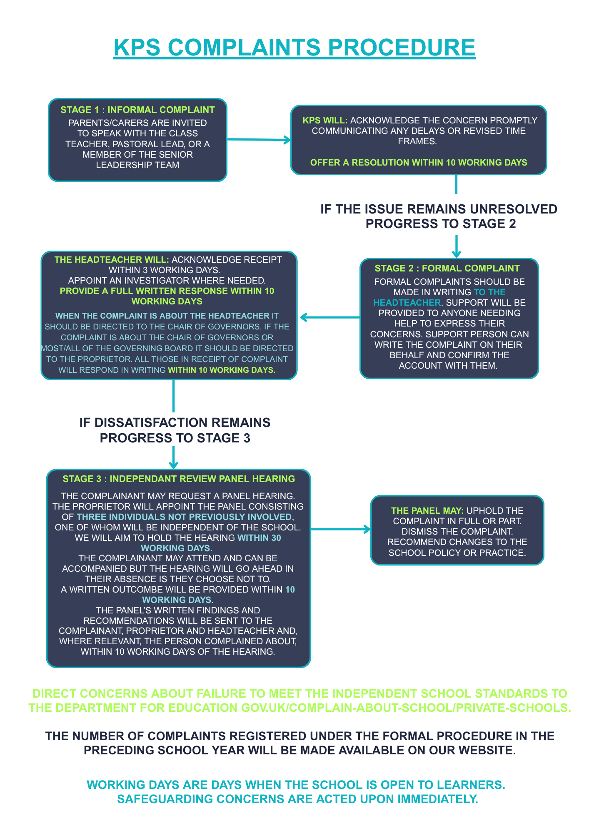
APPENDIX A -

