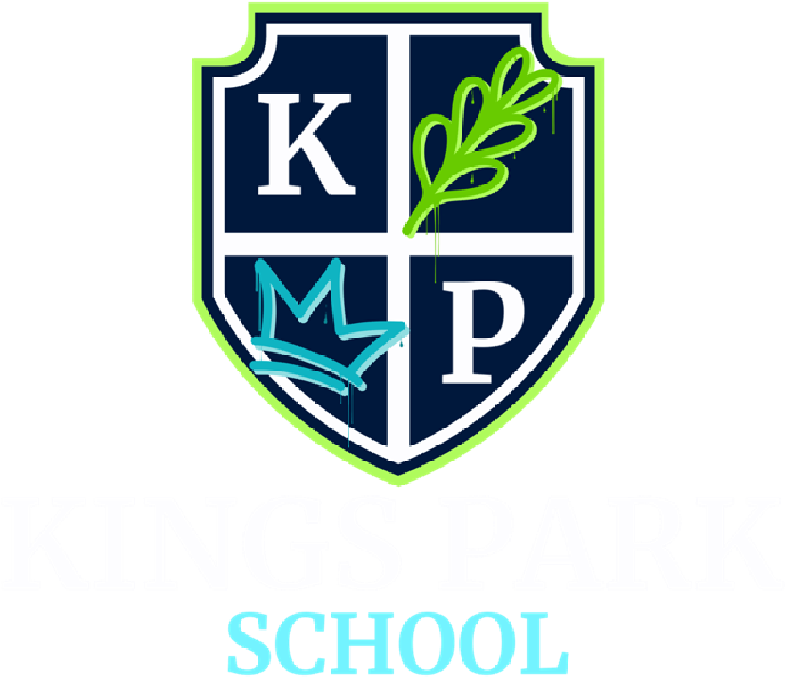

ALLERGY SAFETY POLICY

POLICY NO. | KPS-ASP-005
POLICY OWNER | HEADTEACHER
DATE FIRST ISSUED | 31/08/2026
LATEST REVIEW DATE | 01/09/2026
NEXT REVIEW DATE | 01/09/2027

 | SIGNED | DATE
HEADTEACHER  MISS S J WATSON |  | 01/09/2026
PROPRIETOR  MRS AMY SAUNDERS |  | 01/09/2026
RATIFIED BY CHAIR OF
GOVERNING BOARD
MR ALEX RICHARDS

CONTENTS
1.0 INTRODUCTION
2.0 LEGAL FRAMEWORK AND GUIDANCE
3.0 PURPOSE OF THIS POLICY
4.0 OUR ETHOS AND VALUES
5.0 ROLES AND RESPONSIBILITIES
6.0 AIMS
7.0 INDENTIFYING INDIVIDUALS AT RISK
8.0 ASSESSING RISK
9.0 MINIMISING RISK
10.0 PROCEDURES FOR HANDLING AN ALLERGIC REACTION
11.0 ADRENALINE DEVICES (AD’S)
12.0 SERIOUS INCIDENTS AND ‘NEAR MISSES’
13.0 ALLERGY AWARENESS
14.0 WELLBEING
15.0 INFORMATION SHARING
16.0 MONITORING ARRANGEMENTS

APPENDIX A – BSACI ALLERGY ACTION PLAN
APPENDIX B – BSACI ALLERGY ACTION PLAN WITH EPIPEN
APPENDIX C – ADRENALINE AUTO-INJECTOR USE LOG (INCIDENT RECORD)
APPENDIX D – PARENT CARER CONTACT SHEET
APPENDIX E – MONTHLY ADRENALINE AUTO-INJECTOR LOG
APPENDIX F – ANAPHYLAXIS DRILL TEST RECORD SHEET

1.0 INTRODUCTION

Kings Park School is an independent specialist provision, offering support and education for children and young people from ages 7-16 with various individual needs. Each child and young person’s support is guided by their Education, Health and Care Plan (EHCP), which outlines the provision required to meet their individual needs. With spacious, light-filled classrooms and a highly skilled team of specialist SEN staff, our school provides a calm and supportive environment where children and young people are empowered to move beyond past challenges.

Each learner follows a personalised timetable tailored to their individual needs and interests, with clear, achievable targets that promote motivation, confidence and progress. In addition to the statutory annual review process, we conduct a broad range of formal and informal assessments throughout the year to monitor progress and adapt provision where necessary.

Classes are small with up to 8 pupils, depending on the individual needs. Each class is led by a teacher and supported by a dedicated teaching assistant, with additional teaching assistants provided where necessary and stated on the child’s EHCP. Children and young people will be placed in a class based on suitability rather than age. Our nurture-based approach ensures that emotional wellbeing is prioritised alongside learning and our classrooms are designed to be sensory-friendly, providing calm, supportive environments that help students feel safe, regulated and ready to engage.
At Kings Park School, our curriculum is designed to meet the holistic needs of all pupils, with a strong focus on personalised learning, wellbeing and preparation for adulthood. As a nurturing SEN school, we recognise the diverse abilities and learning profiles of our students, many of whom have diagnoses including Autism Spectrum Disorder (ASD), ADHD and Specific Learning Difficulties (SpLD). Our curriculum is broad, balanced and aspirational, providing meaningful learning experiences that promote academic progress, personal development, independence and positive engagement with the world around them. We aim to ensure that every pupil is supported to achieve their full potential in a safe, inclusive and encouraging environment.

2.0 LEGAL FRAMEWORK AND GUIDANCE

This policy is based on the Department for Education (DfE)’s statutory guidance on allergy safety in schools and supporting pupils with medical conditions at school, the Department of Health and Social Care’s guidance on using emergency adrenaline auto-injectors in schools, and the following legislation:
The Food Information Regulations 2014
The Food Information (Amendment) (England) Regulations 2019

3.0 PURPOSE OF THIS POLICY
This policy aims to:
- Set out our school’s approach to allergy safety, including reducing the risk of exposure and the procedures in place in case of allergic reaction
- Make clear how our school supports pupils with allergies to ensure their wellbeing and inclusion
- Promote and maintain allergy awareness among the school community

LINKS TO OTHER POLICIES
This policy links to the following policies and procedures:
- Health and safety policy
- Data protection policy
- Behavior policy
- Safeguarding and Child Protection Policy
- Staff Handbook

4.0 OUR ETHOS AND VALUES

We are guided by our school motto: "Inspiring Dreams, Building Bright Futures Together." Our core values are:
- Kind Words: We speak with empathy and understanding.
- Positive Minds: We approach challenges with optimism and resilience.
- Strong Hearts: We show courage, compassion and strength in our relationships.

These values are more than aspirations—they are embedded in every interaction, decision and environment within Kings Park School.
Kind Words reflect our belief in the power of language to heal, uplift and include. Whether it is peer encouragement, staff guidance or family communication, we model respectful, thoughtful speech in all we do.
Positive Minds encourage our students and staff to reframe difficulties as opportunities to learn and grow. We promote a strengths-based approach that focuses on what each individual child can do and how they can build confidence through success.
Strong Hearts remind us of the importance of compassion, resilience and relationships. We teach students to persist through challenges, support others and show bravery in being true to themselves.
Together, these values underpin our approach to behaviour, learning and building a safe, inclusive school community.
5.0 ROLES AND RESPONSIBILITIES

THE GOVERNING BOARD/PROPRIETOR
The Governing Body is responsible for ensuring:
- Risks relating to pupils with allergies are included in the risk register and actively managed
- The school has an allergy safety policy which sets out:
  - Arrangements to reduce the risk of individuals coming into contact with their known allergens
  - Emergency response plans for cases of anaphylaxis
The Governing Board delegates the day-to-day implementation of this policy to the allergy safety lead.
The Named Governor for Allergy Safety is Name
ALLERGY SAFETY LEAD
The nominated allergy safety lead is Dan McKay.
They’re responsible for:
- Implementing this allergy safety policy
- Reviewing the allergy safety policy at least annually, updating it when needed, and making sure it is published
- Promoting and maintaining allergy awareness across our school community
- Developing and reviewing arrangements for the safe storage and disposal of adrenaline devices (AD)
- Ensuring:
    - All allergy information is up to date and readily available to relevant members of staff
    - All pupils who require support with allergies have an up-do-date individual healthcare plan (IHP)
    - All pupils with a known food or insect sting allergy have up-to-date allergy action plans issued by a medical professional
    - All staff receive regular allergy awareness training
    - All staff are aware of the school’s policy and procedures regarding allergies
    - Relevant staff are aware of what activities need an allergy risk assessment
    - Serious incidents and ‘near misses’ relating to allergy safety are recorded and reported as appropriate, and to consider and share with staff:
- What lessons there are to learn
- Any potential changes to the medical conditions and/or allergy safety policies and/or to any pupil’s IHP
HEADTEACHER
The headteacher is responsible for:
- Deciding (in discussion with the parents/carers and any relevant healthcare professionals) whether a pupil’s allergy can be managed through the adjustments made under the school’s medical conditions policy or whether an IHP is required to specify arrangements that reflect the pupil’s circumstances
NAMED ALLERGY SAFETY SUPPORT STAFF
Grace Nicholls and Dan McKay are responsible for:
- Checking spare AAIs are present and in date on a monthly basis
- Making sure that replacement AAI’s are obtained when expiry dates approach
- Making sure that the AAI’s in stock are the same as those that staff are trained in using and those that any named students have been prescribed where at all possible.
- That sharps bins are disposed of appropriately as required.
TEACHING AND SUPPORT STAFF
All teaching and support staff are responsible for:
- Completing any training identified by school leaders, within the timeframe given and sharing evidence of completion with the Business Manager. This includes practice with a practice AAI.
- Promoting and maintaining allergy awareness among pupils
- Maintaining awareness of our allergy safety policy and procedures
- Being able to recognise the signs of severe allergic reactions and anaphylaxis
- Being aware of specific pupils with allergies in their care
- Reducing the risk to pupils with known allergies coming into contact with known allergens
- Ensuring the wellbeing and inclusion of pupils with allergies
- Reporting any allergic reaction or case of anaphylaxis to the allergy safety lead
PARENTS/CARERS
Parents/carers are responsible for:
- Being aware of our school’s allergy safety policy
- Providing the school with up-to-date details of their child’s medical needs, dietary requirements, and any history of allergies, reactions and anaphylaxis
- If required, providing their child with 2 in-date adrenaline auto-injectors and any other medication, including inhalers, antihistamine etc., and making sure these are replaced in a timely manner
- Following the school’s guidance on food and other potential allergens that cannot be brought in to be shared
- Updating the school on any changes to their child’s condition

PUPILS WITH ALLERGIES
If age-appropriate, these pupils are responsible for:
- Being aware of their allergens and the risks they pose
- Carrying their AD on their person and only using it for its intended purpose
- Recognising the signs that they need to use their AD.
- Understanding how and when to use their AD
PUPILS WITHOUT ALLERGIES
These pupils are responsible for:
- Being aware of allergens and the risk they pose to their peers
- Following the rules with regards to which items should not be brought onto school site. (NB this can include edible items, perfumed items and any specific items named within the policy.

IDENTIFYING INDIVIDUALS AT RISK
Allergy is a spectrum of different allergic diseases. Reactions occur when a susceptible person is exposed to something (an “allergen”) they are allergic to. Common allergic conditions include:
- Hay fever (allergic rhinitis), triggered by allergens carried in the air, such as pollen, house dust mite, animal fur/feathers, or mould
- Skin allergies (e.g. eczema, contact dermatitis, contact urticaria/hives) caused by contact with allergens including house dust mite, pollen and substances like nickel, latex and some chemicals
- Food allergy, which can cause symptoms ranging from mild itching in the mouth to "whole body" reactions including anaphylaxis
- Asthma which may be triggered by airborne allergens, which can include perfumes, aerosols and pollen
- Allergy to insect stings and medicines
IDENTIFYING PUPILS AT RISK
We will:
- For new starters, send a form to all parent/carers of pupils after their place at the school has been confirmed, but before their first day on roll, to confirm any allergy the pupil has and whether they carry medication.
- Ensure all parents of new starters understand the importance of updating us with regards to any new diagnosis and, when this happens, we will send a new form and put arrangements in place within 1 week
- Send a reminder to parents/carers at the start of each year asking them to update their child’s medical information as necessary.

We ask that parents/carers proactively inform us by either phone 01233 553053 or an office@kingsparkschool.co.uk to inform us if their child’s medical needs change during the school year.

IDENTIFYING STAFF AND VISITORS AT RISK
We will:
- Ask new staff to provide details of their allergies in advance of their start date, which will be included in their pre employment medical checks form.
- Ask visitors to provide details of their allergies in advance of their visit.
- Ensure all staff and visitors are made aware of any items / allergens that should not be brought on site before they visit and they are reminded as they arrive.
INDIVIDUAL HEALTHCARE PLANS (IHP)
Pupils should have an IHP if they:
- Have an allergy which has a functional impact on them in the school environment
- They are at risk of harm as a result of their allergy; and
- Require arrangements which are additional to or different from those made generally

It is not necessary for a pupil to have a formal diagnosis of allergy for them to have an IHP. Healthcare professionals may decide that it is more appropriate to accept that the child shows symptoms, rather than proceeding to a formal diagnosis.
The IHP will set out the additional and/or different arrangements that will be in place for supporting the pupil. The school will make every effort to make sure that arrangements are put in place within 2 weeks, or by the beginning of the relevant term for pupils who are new to our school.
Not all children with an allergy will require an IHP. Some allergies will have little or no impact on the pupil while they are at school, or pose no risk to the pupil. Some allergies will not require arrangements which are additional to or different from those made generally.
The headteacher is responsible for deciding (in discussion with the parents/carers and any relevant healthcare professionals) whether a pupil’s allergy can be managed through the adjustments made under the school’s medical conditions policy or whether an IHP is required to specify arrangements that reflect the pupil’s circumstances.
The school will consider the following principles:
- If the arrangements or support which a pupil requires would be available to any pupil as part of normal policies, an IHP may not be required
- If the pupil only needs non-prescription medication and the school’s medical conditions policy would permit them to carry and administer it, an IHP may not be required
IHPs will be reviewed at least annually and more frequently if the pupil’s needs have changed. Where a pupil moves on to a new school or college, their IHP will be shared as part of the transition.
ALLERGY AND ASTHMA ACTION PLANS
All pupils who have a known allergy to a food, item or insect stings should be issued with an appropriate allergy action plan by their healthcare professional.
All pupils who have asthma should be issued with an asthma action plan by their healthcare professional.

The plans include medical and parental consent for staff to administer emergency medicines, including adrenaline for anaphylaxis or reliever inhaler in the event of an asthma attack.
The allergy action plan and/or asthma action plan should be attached to the pupil’s IHP. Whenever the allergy action plan is updated, the pupil’s IHP should be reviewed to incorporate it.
REGISTER OF PUPILS WITH KNOWN ALLERGIES
- The school maintains a register of pupils who have a known allergy. The register includes:
  - Known allergens and risk factors for anaphylaxis
  - Whether a pupil has been prescribed ADs (and if so, what type and dose)
  - Where a pupil has been prescribed an AD, whether parental consent has been given to administer emergency medication
  - A photograph of each pupil to allow a visual check to be made
- The register is kept in the office on site and in a shared area of the drive so that all staff can access it and can be checked quickly by any member of staff as part of initiating an emergency response. Where children are of an appropriate age, they will keep their AD’s with them so that delay is reduced and allows for confirmation of consent without the need to check the register.

ASSESSING RISK

The school will conduct a risk assessment for any pupil at risk of anaphylaxis taking part in:
- Lessons such as food technology
- Science experiments involving foods
- Crafts using food packaging
- Off-site events and school trips
- Any other activities involving animals or food, such as animal handling experiences or baking

A risk assessment for any pupil at risk of an allergic reaction will also be carried out where a visitor requires a guide dog.

MINIMISING RISK
HYGIENE PROCEDURES
- Pupils are reminded to wash their hands before and after eating
- Sharing of food, food containers, and food utensils is not allowed
- Pupils have their own named water bottles, and lunch boxes provided to pupils with food allergies will be clearly labelled with the name of the child for whom they are intended
- Where food is not directly provided by the school, parental engagement and permission will be sought in advance
CATERING
The school is committed to providing safe food options to meet the dietary needs of pupils with allergies.To this end,
we will ensure:
- Our cook receives appropriate training and are able to identify pupils with allergies
- Our cook understands the controls required to ensure that food service complies with relevant requirements
- School menus are available for parents/carers and pupils to view with ingredients clearly labelled, and catering staff are available to discuss the provision of allergy safe meals with parents/carers
- Where changes are made to school menus, we will make sure these comply with legislation, and continue to meet any special dietary needs of pupils
- Food allergen information relating to the ‘top 14’ allergens is displayed on the packaging of all food products, allowing pupils and staff to make safer choices. Allergen information labelling will follow all legal requirements that apply to naming the food and listing ingredients, as outlined by the Food Standards Agency (FSA)
- Where food is provided by the school, staff will understand how to read labels for food allergens
- Our cook will follow hygiene and allergy procedures when preparing food to avoid cross-contamination
INSECT BITES/STINGS
When outdoors:
- Shoes should always be worn
- Food and drink should be covered
ANIMALS
We will not have a blanket ban on interaction with animals for pupils with an allergy to a named animal. Instead, we will assess the risk of each activity against each child’s specific risk assessment. For example, a pupil who has an allergy to cat fur may be okay to take part in an activity involving snakes and therefore would be allowed to take part if they wished to.
To avoid any allergic reactions where pupils have an allergy to an animal or animals we will ensure that:
- All pupils and staff will always wash hands after interacting with animals to avoid putting pupils with allergies at risk through later contact, this includes washing their hands on entry to the school if they have pets at home.
- Pupils with animal allergies will not interact with animals unless a full risk assessment has been completed and staff are sure that the animal interactions are safe. Parents/carers and appropriate medical staff will be consulted as required.
VISITS AND TRIPS
- No pupils with allergies will be excluded from taking part in activities off site when they are appropriate or necessary to their achievement.
- The school will plan accordingly for all visits and trips, and arrange for the staff members involved to be aware of pupils’ allergies and to have received appropriate training
- The school will conduct a risk assessment for any pupil at risk of anaphylaxis taking part in any off-site activity.
- Pupils at risk of anaphylaxis should have their own ADs with them
- All staff will be trained to administer adrenaline in an emergency.
- Appropriate measures will be taken in line with the school’s AD protocols for off-site events and school trips (see section 8.5)

PROCEDURES FOR HANDLING AN ALLERGIC REACTION
- All staff are trained to recognise the signs of both mild and severe allergic reactions (known as anaphylaxis) and respond appropriately
- Staff are trained in the administration of adrenaline to minimise delays in an emergency
- If the pupil has an allergy action plan, this must be followed
- A spare school AD device will only be used if:
  - The pupil does not have a prescribed AD
  - The pupil’s prescribed AD are not available or misfire
- All off site / venue risk assessments will include an identification of the closest pharmacies, walk in centres, hospitals and doctors where necessary, should a child have an issue with their own prescribed AD, the school AD misfires or the child suffers an allergic reaction to something that was previously unknown to cause anaphylaxis.

ADRENALINE DEVICES (ADS)
Prescribed ADs
Pupils who are prescribed ADs are encouraged to keep them near or on their person at all times including when travelling to or from the school and on school trips. It is recommended that two devices are carried at all times. Pupils with prescribed ADs should take them home with them at the end of each school day, and parents are responsible for ensuring that they are in date.

If a pupil cannot keep their ADs with them in the classroom (due to age or other considerations), then the devices will be stored:
In the school reception. This room is within 1 minute of any learner in any room on site due to the incredibly small size of the school.
Off-site in a mobile container, held by the staff member as required. This will be kept at room temperature (in line with manufacturer’s guidelines), protected from direct sunlight and extremes of temperature.
Where children can carry their own AD, they will do so on their journey by taxi to and from school. They will show the staff that they have their AD’s as they enter the school. Should they have forgotten their AD, parents/carers will be contacted and arrangements made for the immediate delivery of the Ads.
Where children cannot carry their own ADs, a discussion with parents/carers, the local authority and taxi company will take place regarding how the AD’s will be transported from home to school and back again. Any agreements will be added to the child’s Individual Allergy Plan.
A copy of the pupil’s individual allergy action plan is kept alongside their medication, as it includes instructions on how it should be used in an emergency.
All staff will be trained in the administration of the type of AD prescribed for the pupil, or, if two different AD;s are prescribed for two different children, staff will be trained in one type only. (Epipen)
Records will be kept of any administration of the AD in our school medicines book, first aid book and on the child’s individual IHP record. The child’s risk assessment will also be updated to outline the circumstances in which the AD was administered so that any issues can be avoided in the future.
SPARE ADS AND INHALERS
Please note: Current regulations only allow our school to purchase adrenaline auto-injectors (AAIs) as spare devices. Non-injectable adrenaline devices (nasal spray) may be prescribed to individuals but cannot currently be stocked as a spare device. If an individual who is prescribed nasal adrenaline suffers anaphylaxis, our school’s spare AAIs may be used in an emergency. Our school can purchase an emergency asthma reliever inhaler which can only be used if the pupil’s prescribed inhaler is not available and where written consent has been obtained.
The allergy safety lead (Dan McKay is responsible for sourcing spare ADs and an emergency asthma reliver inhaler (if required and with parental permission). He will also be responsible for ensuring they are stored according to the guidance.
Our initial spare ADs will be purchased from Eureka, a National supplier, alongside the call point, posters and other necessary materials. When these need to be renewed, we will purchase them from our local pharmacy.
We will purchase 2 emergency AD’s for our school site.
The number of AD’s purchased may be increased should we have multiple pupils who require AD’s who work off site. These will be purchased and stored in pairs as required.
As there are no children who currently require AD’s, all spare AD’s purchased will be Epipen.
Due to the age range and likely size of our children, the Epi Pens purchased will be 300 mcg. Should we have a smaller child who requires an Epi pen, we will purchase smaller dosage pens.
Spare ADs will be stored:
In the school reception/office. This room is within 1 minute of any learner in any room on site due to the incredibly small size of the school.
Off-site in a mobile container, held by the staff member as required. This will be kept at room temperature (in line with manufacturer’s guidelines), protected from direct sunlight and extremes of temperature.

Spare AAIs will be kept:
- In pairs, in case a second one is necessary
- Separate from any pupils’ prescribed ADs and clearly labelled to avoid confusion

Grace Nicholls and Dan McKay are responsible for:
- Checking spare AAIs are present and in date on a monthly basis
- Making sure that replacement AAI’s are obtained when expiry dates approach
- Making sure that the AAI’s in stock are the same as those that staff are trained in using and those that any named students have been prescribed where at all possible.
- That sharps bins are disposed of appropriately as required.

DISPOSAL
ADs can only be used once. Once an AD has been used, it will be disposed of in line with the manufacturer's instructions in our school sharps bin. We will arrange for the local council to pick it up as required.
USING SPARE ADS IN AN EMERGENCY SITUATION WITHOUT PRIOR CONSENT
The Human Medicines (Amendment) Regulations 2017 do not require consent to have been obtained for spare adrenaline devices to be used in an emergency.
The school will obtain advance consent from parents/carers or pupils for spare adrenaline devices to be used, so that in an emergency, consent can be assumed to be in place.
However, in an emergency situation, anyone may take reasonable action to save a life without checking whether prior consent has been given. This avoids potentially fatal delays in treatment
USE OF ADS OFF SCHOOL PREMISES
Pupils at risk of anaphylaxis who are able to administer their own adrenaline should carry their own ADs with them on school trips and off-site events.
School owned Emergency pens will also be taken by staff where necessary on school trips. These will be stored as appropriate. If required, we will purchase two additional AD’s so that two remain on site. In addition to this, the closest pharmacies, walk in centres, hospitals and doctors’ surgeries will be recorded on the risk assessment should a child have an issue with their own prescribed AD, the school AD misfires or the child suffers an allergic reaction to something that was previously unknown to cause anaphylaxis.

SERIOUS INCIDENTS AND ‘NEAR MISSES’
A serious incident is any event relating directly to a medical condition (including allergy) in which a pupil, member of staff or visitor with a medical condition or allergy is harmed or is placed at an immediate and significant risk of harm, including situations requiring emergency medication, urgent clinical intervention or attendance by emergency services.

A 'near miss' is an event relating directly to a medical condition (including allergy) that did not result in harm but had the clear potential to do so – for example, where an error, omission, or system failure could reasonably have led to a serious incident had circumstances been only slightly different.
INCIDENT RECORDING
The school will record serious incidents and ‘near misses’ relating to allergy safety as soon as is feasible. The incident will be recorded in the accident book, including the following information:
- Who was affected
- What happened, when and where
- Why the incident occurred (as far as is known)
- How staff and pupils responded and what was done to support the individual
- Whether emergency services were called
- How the incident concluded
The school will approach serious incidents and ‘near misses’ in a ‘no blame’ spirit of seeking to learn lessons.
INCIDENT REPORTING
The parents/carers of a pupil aged up to 16 should be notified of the incident or ‘near miss’ as soon as possible. In the case of a pupil aged 16 and over, the school will confirm that the pupil agrees that their parents/carers should be informed.

The school will share the report with the pupil’s parents, the pupil or the individual involved.
They will be given the opportunity to discuss what happened and to contribute their views to the consequent lessons learned review. The school will then confirm what we have learnt from the incident and outline any actions we are taking as a result. Where required, information will also be shared with other professionals involved with the pupil, including social workers, medical practitioners and

In some cases, the impact of exposure to an allergen at school may be delayed and not recognised until the pupil is at home. This means that incident reporting is not limited to staff – the pupil, parents/carers or others (such as healthcare professionals) will need to report to the school if there has been an incident with a delayed reaction.

Staff will always share the incident report with Dan McKay. The allergy safety lead will consider whether the allergy safety arrangements in place were appropriate or if changes are needed to this policy and/or the pupil’s IHP. Any learning will be shared appropriately with staff so they can act on them and reduce the chance of an incident reoccurring.
The school will also share the report with other agencies in the following circumstances:
- With the Health and Safety Executive (HSE): incidents which arise directly out of the way the school carried out a work activity which results in death or immediate hospitalization. For example, where a pupil has suffered harm after consuming an allergen due to incorrect preparation of food by a member of staff.
- In the event that the incident or ‘near miss’ was related to the delivery of a care plan or action plan issued by a healthcare professional, the relevant healthcare professional will be notified.

ALLERGY AWARENESS
STAFF TRAINING
The school ensures that all staff who work directly with children or who work on site when children are present, receive allergy awareness training at least annually. New starters will complete this training as part of their induction.
This includes permanent staff, temporary staff, supply teachers, peripatetic staff, agency workers and regular volunteers. It does not include contractors carrying out work with no pupil-facing role such as builders, electricians or other ad hoc maintenance personnel.
The school has purchased 'training pens' from EpiPen and Jext so staff can practise safely and be familiar with the differences.
The school will conduct allergy safety drills termly. This is a simulated case of anaphylaxis to test out how staff respond, without risk to any individual. The results of the drill will be recorded and used to inform the ongoing review of this policy.
Allergy awareness training will ensure that all staff:
- Have an awareness of allergy, the risks it poses, how allergic reactions can occur and how to manage it
- Understand that allergy includes multiple conditions (food allergy, asthma, eczema, hay fever, others), which can co-exist
- Understand the difference between food allergy, coeliac disease and food intolerance
- Know where to find information on allergy triggers
- Can identify the range of symptoms of allergic reactions
- Understand and can recognise anaphylaxis
- Know how to respond in an emergency, including:
- Calling emergency services and informing parents/carers
- How to locate and administer emergency medication
- How to use the medication/device in an emergency
- Understand the impact allergy can have on a pupil’s wellbeing
- Understand the school’s allergy safety policy
- Know how to check whether an individual is on the record of those with known allergy, and how to use an allergy or asthma action plan
- Understand their responsibilities in reducing the risk of individuals with known allergy coming into contact with their known allergens
- Understand how to report an allergic reaction or case of anaphylaxis (whether an incident or a ‘near miss’)

AWARENESS OF ALLERGY SAFETY POLICY
This allergy safety policy will be published on the school’s website and shared with parents/carers at the start of the school year or when their child arrives on our school roll.
All staff should be aware of and understand the policy as part of annual allergy awareness training.
All pupils will have appropriate training with regards to allergies. Resources will be adapted according to their individual needs and this will form part of their PSHE programme. Some of the resources we will use can be found here. Allergy School Allergy Wise Classroom resources Allergy Wise ELSA Resources

WELLBEING
Pupils with allergies can experience bullying or may also suffer from anxiety and depression relating to their allergy. The relationships our staff usually build with pupils will hopefully encourage them to talk to staff when issues of bullying arise, or when they are struggling with anxiety or depression. Where this is the case, appropriate support will be given either by discussion with a favoured member of staff or formal counselling if required.
Pupils with allergies will have additional support through:
- Pastoral care
- Regular check-ins with their staff
- Reassurance that steps are being taken to minimise the risks of exposure to allergen and that robust measures are in place in the event of anaphylaxis
The school will respond to any instance of bullying in line with its behavior policy.
WELLBEING SUPPORT FOLLOWING AN INCIDENT OR ‘NEAR MISS’
The school recognises that an incident or a ‘near miss’ is a serious event with a potential impact not only on the pupil but their family, those involved in responding. and any witnesses. The school will provide support to those involved.
The school will support staff involved in any incident or ‘near miss’.
See section 9 of the policy for more detail on incidents and ‘near misses’.

INFORMATION SHARING
Information about an individual’s health is considered special category data under UK GDPR. It will therefore be handled in line with our data protection policy.

MONITORING ARRANGEMENTS
This policy will be monitored by the allergy safety lead.
It will be reviewed and approved annually by the allergy safety lead, or more frequently if a serious incident or ‘near miss’ identifies an area for improvement. It will also be reviewed as legislation changes.

APPENDIX A
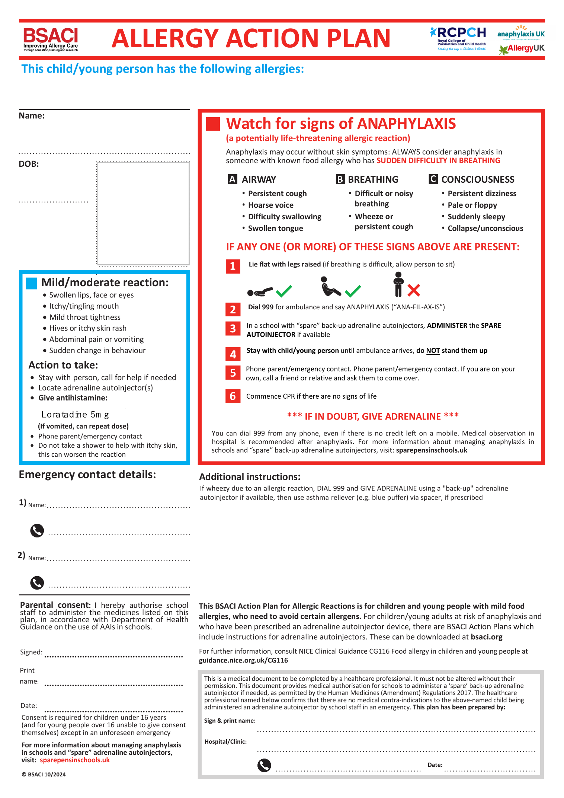

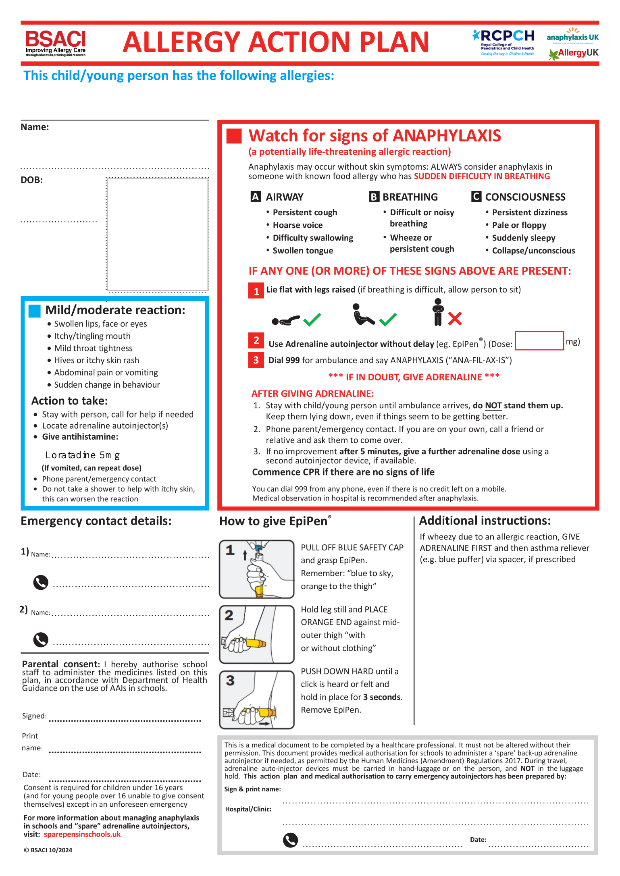
APPENDIX B

APPENDIX C
Adrenaline Auto-Injector Use Log (Incident Record)

STUDENT
DATE
TIME
KNOWN ALLERGY
LOCATION OF INCIDENT
AAI USED (STUDENTS / SCHOOL SPARE)
BRAND
DOSE
ADMINISTERED BY
AMBULANCE CALLED

REACTION DETAILS
Tick or describe symptoms observed:
- Difficulty breathing
- Swelling of face/lips/tongue
- Rash or hives
- Vomiting
- Collapse or dizziness
Other:

TIME ACTION TAKEN STAFF INITIALS

APPENDIX D
PARENT \ CARER CONTACT
DATE
TIME
NAME OF PARENT CONTACTED
PARENT CONTACTED BY
OUTCOME
USE REVERSE SIDE IF REQUIRED

Follow-up actions:
- Record incident in school accident/incident system
- Replace any used AAI
- Inform Allergy Lead and Senior Leadership
- Review procedures if necessary

APPENDIX E
Monthly Adrenaline Auto-Injector Check Log
Use this log to record routine checks of all adrenaline auto-injectors held by the school.
Date | Location of AAI | Brand | Dose amount | Expiry Date | Packaging Intact (Y/N) | Window Clear (Y/N) | Action Required | Checked By
Staff should check that the injector is present, in date, undamaged, and stored correctly. If any issues are found, notify the Allergy Lead immediately and arrange replacement.
APPENDIX F - Anaphylaxis Drill Test Record Sheet -
Date |  |  | Time
Type of Drill | Announced Drill |  |  | Unannounced Drill
Simulated trigger | Known allergen exposure / Unknown trigger / Eating area / Classroom / Playground / Other:
Medication available | Pupil-specific auto-injector present: Yes / No Spare school auto-injector present: Yes / No Practice Trainer EpiPen used: Yes / No
Emergency plan checked | Individual healthcare plan / care plan available and followed: Yes / No
Staff Involved
Students Involved

Action Required | Owner | Target Date | Complete
Report completed by |  | Position
Signature |  | Date

