

SAFEGUARDING & CHILD PROTECTION POLICY
POLICY NO. | KPS-SGP-005
POLICY OWNER | HEADTEACHER
DATE FIRST ISSUED | 26/11/2024
NEXT REVIEW DATE | 01/09/2026
 | SIGNED | DATE
HEADTEACHER  MISS STEVIE-JANE WATSON |  | 01.09.2026
PROPRIETOR  MRS AMY SAUNDERS |  | 01.09.2026
SAFEGUARDING GOVERNOR  MRS NICOLA TIMMS | 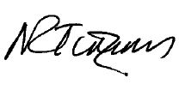 | 12/09/2026
RATIFIED BY CHAIR OF GOVERNING BOARD  MR ALEX RICHARDS | 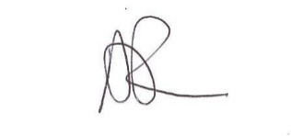 | 12/09/2026

CONTENTS
- INTRODUCTION
- CONTACTS
- LEGAL FRAMEWORK AND GUIDANCE
- PURPOSE OF THIS POLICY
- OUR ETHOS AND VALUES
- DEFINITION OF SAFEGUARDING
- SAFEGUARDING PROCEDURE
- KEY RESPONSIBILITIES
- CHILD PROTECTION PROCEDURE
- SPECIFIC SAFEGUARDING CONCERNS
- SUPPORTING CHILDREN POTENTIALLY AT GREATER RISK OF HARM
- ONLINE SAFETY
- STAFF ENGAGEMENT AND EXPECTATIONS
- SAFER RECRUITMENT AND ALLEGATIONS AGAINST STAFF
- OPPORTUNITIES TO TEACH SAFEGUARDING
- PHYSICAL SAFETY

APPENDIX A – CATEGORIES OF ABUSE
APPENDIX B - SUPPORT ORGANISATIONS
APPENDIX C – DSL POSTER
APPENDIX D – IF YOU HAVE A SAFEGUARDING CONCERN POSTER
APPENDIX E – CHILDRENS DSL POSTER
APPENDIX F – STAFF & STUDENT RELATIONSHIP LETTER
APPENDIX G – STAFF & STUDENT RELATIONSHIP GUIDANCE NOTES

1.0 INTRODUCTION
Kings Park School is an independent specialist provision, offering support and education for children and young people from ages 7-16 with various individual needs. Each child and young person’s support is guided by their Education, Health and Care Plan (EHCP), which outlines the provision required to meet their individual needs. With spacious, light-filled classrooms and a highly skilled team of specialist SEN staff, our school provides a calm and supportive environment where children and young people are empowered to move beyond past challenges.
Each learner follows a personalised timetable tailored to their individual needs and interests, with clear, achievable targets that promote motivation, confidence, and progress. In addition to the statutory annual review process, we conduct a broad range of formal and informal assessments throughout the year to monitor progress and adapt provision where necessary.
Classes are small with up to 8 pupils, depending on the individual needs. Each class is led by a teacher and supported by a dedicated teaching assistant, with additional teaching assistants provided where necessary and stated on the child’s EHCP. Children and young people will be placed in a class based on suitability rather than age. Our nurture-based approach ensures that emotional wellbeing is prioritised alongside learning, and our classrooms are designed to be sensory-friendly, providing calm, supportive environments that help students feel safe, regulated, and ready to engage.
At KPS (Kings Park School), we place the safety, well-being, and development of our students at the heart of everything we do. Our safeguarding and child protection policy reflects our commitment to providing a safe, inclusive, and aspirational learning environment for children and young people with a range of neurodivergent profiles and social, emotional and mental health needs.
At KPS, safeguarding is everyone’s responsibility. All team members whether working directly with pupils or in a supporting capacity are expected to uphold and promote the safety and wellbeing of every child in our care.
To ensure a consistent and robust safeguarding culture, the following individuals hold specific roles with additional safeguarding responsibilities and work collaboratively across the school:
- Designated Safeguarding Lead (DSL)
Stevie-Jane Watson, Head Teacher
- Deputy Designated Safeguarding Leads (DDSLs)
Grace Nicholls, Deputy Head, Tracey Watson Inclusion Lead and Nicole Douglas, Class Teacher
- Safeguarding Governor
Nicola Timms

2.0 CONTACTS
INTERNAL CONTACTS
Stevie-Jane Watson DSL Headteacher | sj.watson@kingsparkschool.co.uk
Grace Nicholls DDSL Deputy Head | grace.nicholls@kingsparkschool.co.uk
Tracey Watson DDSL Inclusion Lead | tracey.watson@kingsparkschool.co.uk
Nicole Douglas DDSL Class Teacher | nicole.douglas@kingsparkschool.co.uk
Amy Saunders - Proprietor | amy.saunders@kingsparkschool.co.uk
Nicola Timms - Safeguarding Governor | nicola.timms@kingsparkschool.co.uk
EXTERNAL CONTACTS
South Kent Safeguarding Team | TEL: 03000 423154
Local Authority Designated Officer LADO - Allegations against staff members. | For allegations against adults working with children.  Referrals must be made via the KSCMP LADO referral portal:  https://www.kscmp.org.uk/procedures/local-authority-designated-officer-lado
The Front Door - Local Authority Children's Social Services.  OUT OF HOURS EMERGENCY | TEL: 03000 411111  EMAIL: social.services@kent.gov.uk EMERGENCY: 03000 419191
Early Help & Preventative Services | TEL: 03000 410305  TEL Out of Hours: 03000 419191  EMAIL: ashfordearlyhelp@kent.gov.uk
Multi Agency Safeguarding Hub | TEL: 03000 420004 Rainbow Centre
Kent Safeguarding Children Multi-Agency Partnership (KSCMP) | www.kscmp.org.uk  EMAIL: kscmp@kent.gov.uk
Support & Advice about Extremsim | Police DS Toni Roullier EMERGENCY: 999  NON EMERGENCY NUMBER: 101 EMAIL: toni.roullier@kent.pnn.police.co.uk  Department for Education  NON EMERGENCY NUMBER: 020 7340 7264  EMAIL:counter.extremism@education.gsi.gov.uk  CONTACT FORM:  https://report-extremism.education.gov.uk/
NSPCC whistleblowing advice line | TEL: 0800 800 5000 EMAIL: help@nspcc.org.uk
OFSTED Safeguarding Children | TEL: 0300 123 4666 (Monday to Friday from 8am to 6pm)  EMAIL: Whistleblowing@ofsted.gov.uk
IMPORTANT LINKS
Kent Integrated Children Services Portal | Select URGENT if there is an immediate concern.
Early Help and Preventative Services - KELSI
Early Help Contacts - KELSI
Kent County Council - Family Hub
LESAS Enquiry Form

3.0 LEGAL FRAMEWORK AND GUIDANCE
- Keeping Children Safe in Education (2026 – updated 1st September 2026)
- Working Together to Safeguard Children (2026 – updated March 2026)
- Governance Handbook
- Data Protection and Safeguarding guidance (DfE 2024)
- Child on Child Abuse guidance (2024)
- Section 175 of the Education Act 2002
- The School Staffing (England) Regulations 2009
- Part 3 of the schedule to the Education (Independent School Standards) Regulations 2014
- Part 1 of the schedule to the Non-Maintained Special Schools (England) Regulations 2015
- Searching, Screening and Confiscation (DfE 2024)
- The Children Act 1989 (and 2004 amendment)
- Section 5B (11) of the Female Genital Mutilation Act 2003 (as amended by section 74 of the Serious Crime Act 2015)
- Statutory guidance on Female Genital Mutilation (FGM)
- The Rehabilitation of Offenders Act 1974
- Schedule 4 of the Safeguarding Vulnerable Groups Act 2006
- Statutory guidance on the Prevent duty (Counterterrorism and Security Act 2015)
- The Human Rights Act 1998
- The Equality Act 2010
- The Public Sector Equality Duty (PSED)

4.0 PURPOSE OF THIS POLICY
Kings Park School recognises our statutory responsibility to safeguard and promote the welfare of all children. Safeguarding and promoting the welfare of children is everybody’s responsibility and everyone has a role to play. All members of our community (staff, volunteers, directors, leaders, parents/carers, wider family networks, and pupils have a key role in safeguarding children, and all have an essential role to play in making our community safe and secure.
KPS believe that the best interests of children always come first. All children (defined in law and in this policy as those up to the age of 18) have a right to be heard and to have their wishes and feelings considered and all children regardless of age, sex (gender), ability, culture, race, language, religion or sexual identity or orientation, have equal rights to protection.
Staff working with children at KPS will maintain an attitude of ‘it could happen here’ where safeguarding is concerned. When concerned about the welfare of a child, staff will always act in the best interests of the child and if any member of our community has a safeguarding concern about any child or adult, they should act and act immediately.
This policy applies where there is child protection concerns regarding children who attend KPS but may also apply to other children connected to the school, for example, siblings, or younger members of staff (under 18s) or children on student/work placements.
Our core safeguarding principles are:
Prevention: positive, supportive, safe culture, curriculum and pastoral opportunities for children, safer recruitment procedures.
Protection: following the agreed procedures, ensuring all staff are trained and supported to recognise and respond appropriately and sensitively to safeguarding concerns.
Support: adopt a child centred approach and provide support for all pupils, parents/carers, and staff, and where appropriate, implement specific interventions for those who may be at risk of harm.
Collaboration: with both parents/carers where possible, and other agencies to ensure timely, appropriate communications and actions are undertaken when safeguarding concerns arise.
The procedures contained in this policy apply to all staff, including governors, temporary or third-party agency staff and volunteers, and are consistent with those outlined within ‘Keeping Children Safe in Education’ 2025.
THIS IS A CORE POLICY THAT FORMS PART OF THE INDUCTION FOR ALL STAFF. IT IS A REQUIREMENT THAT ALL MEMBERS OF STAFF HAVE ACCESS TO THIS POLICY AND SIGN TO SAY THEY HAVE READ AND UNDERSTOOD ITS CONTENTS.
THIS POLICY WILL BE REVIEWED AT LEAST ANNUALLY AND/OR FOLLOWING ANY UPDATES TO NATIONAL AND LOCAL GUIDANCE AND PROCEDURES.

5.0 OUR ETHOS AND VALUES
We are guided by our school motto: "Inspiring Dreams, Building Bright Futures Together." Our core values are:
- Kind Words: We speak with empathy and understanding.
- Positive Minds: We approach challenges with optimism and resilience.
- Strong Hearts: We show courage, compassion and strength in our relationships.

These values are more than aspirations—they are embedded in every interaction, decision, and environment within Kings Park School.
Kind Words reflect our belief in the power of language to heal, uplift, and include. Whether it is peer encouragement, staff guidance or family communication, we model respectful, thoughtful speech in all we do.
Positive Minds encourage our students and staff to reframe difficulties as opportunities to learn and grow. We promote a strengths-based approach that focuses on what each individual child can do and how they can build confidence through success.
Strong Hearts remind us of the importance of compassion, resilience and relationships. We teach students to persist through challenges, support others, and show bravery in being true to themselves.

Together, these values underpin our approach to behaviour, learning, and building a safe, inclusive school community.

Safeguarding is embedded in the culture of Kings Park School and is understood to be everyone’s responsibility.

6.0 DEFINITION OF SAFEGUARDING
In line with ‘Working Together to Safeguard Children’ and KCSIE, safeguarding and promoting the welfare of children is defined for the purposes of this policy as:
- Providing help and support to meet the needs of children as soon as problems emerge.
- Protecting children from maltreatment, whether that is within or outside the home, including online.
- Preventing impairment of children’s mental and physical health or development.
- Ensuring that children grow up in circumstances consistent with the provision of safe and effective care.
- Promoting the upbringing of children with their birth parents, or otherwise their family network, whenever possible and where this is in the best interests of the child(ren).
- Taking action to enable all children to have the best outcomes.
Child protection is part of safeguarding and promoting the welfare of all children and is defined as activity that is undertaken to protect specific children who are suspected to be suffering, or likely to suffer, significant harm. This includes harm that occurs inside or outside the home, including online.
KPS acknowledges that safeguarding includes a wide range of specific issues including, but not limited to:
- Abuse and neglect.
- Bullying, including cyberbullying.
- Child-on-child abuse.
- Children with family members in prison.
- Children who are absent or missing from education.
- Child missing from home or care.
- Child Sexual Exploitation (CSE).
- Child Criminal Exploitation (CCE).
- Contextual safeguarding (risks outside the family home).
- County lines and gangs.
- Domestic abuse.
- Drugs and alcohol misuse.
- Fabricated or induced illness.
- Faith abuse.
- Gender based abuse and violence against women and girls.
- Hate.
- Homelessness.
- Human trafficking and modern slavery.
- Mental health.
- Nude or semi-nude image sharing, also known as youth produced/involved sexual imagery or “Sexting.”
- Online safety.
- Preventing radicalisation and extremism.
- Private fostering.
- Relationship abuse.
- Serious violence.
- Sexual violence and sexual harassment.
- So-called ‘honour-based’ abuse, including Female Genital Mutilation (FGM) and forced marriage.
- “Upskirting.”
(Also see Part one and Annex B within ‘Keeping Children Safe in Education’)

7.0 SAFEGUARDING PROCEDURE
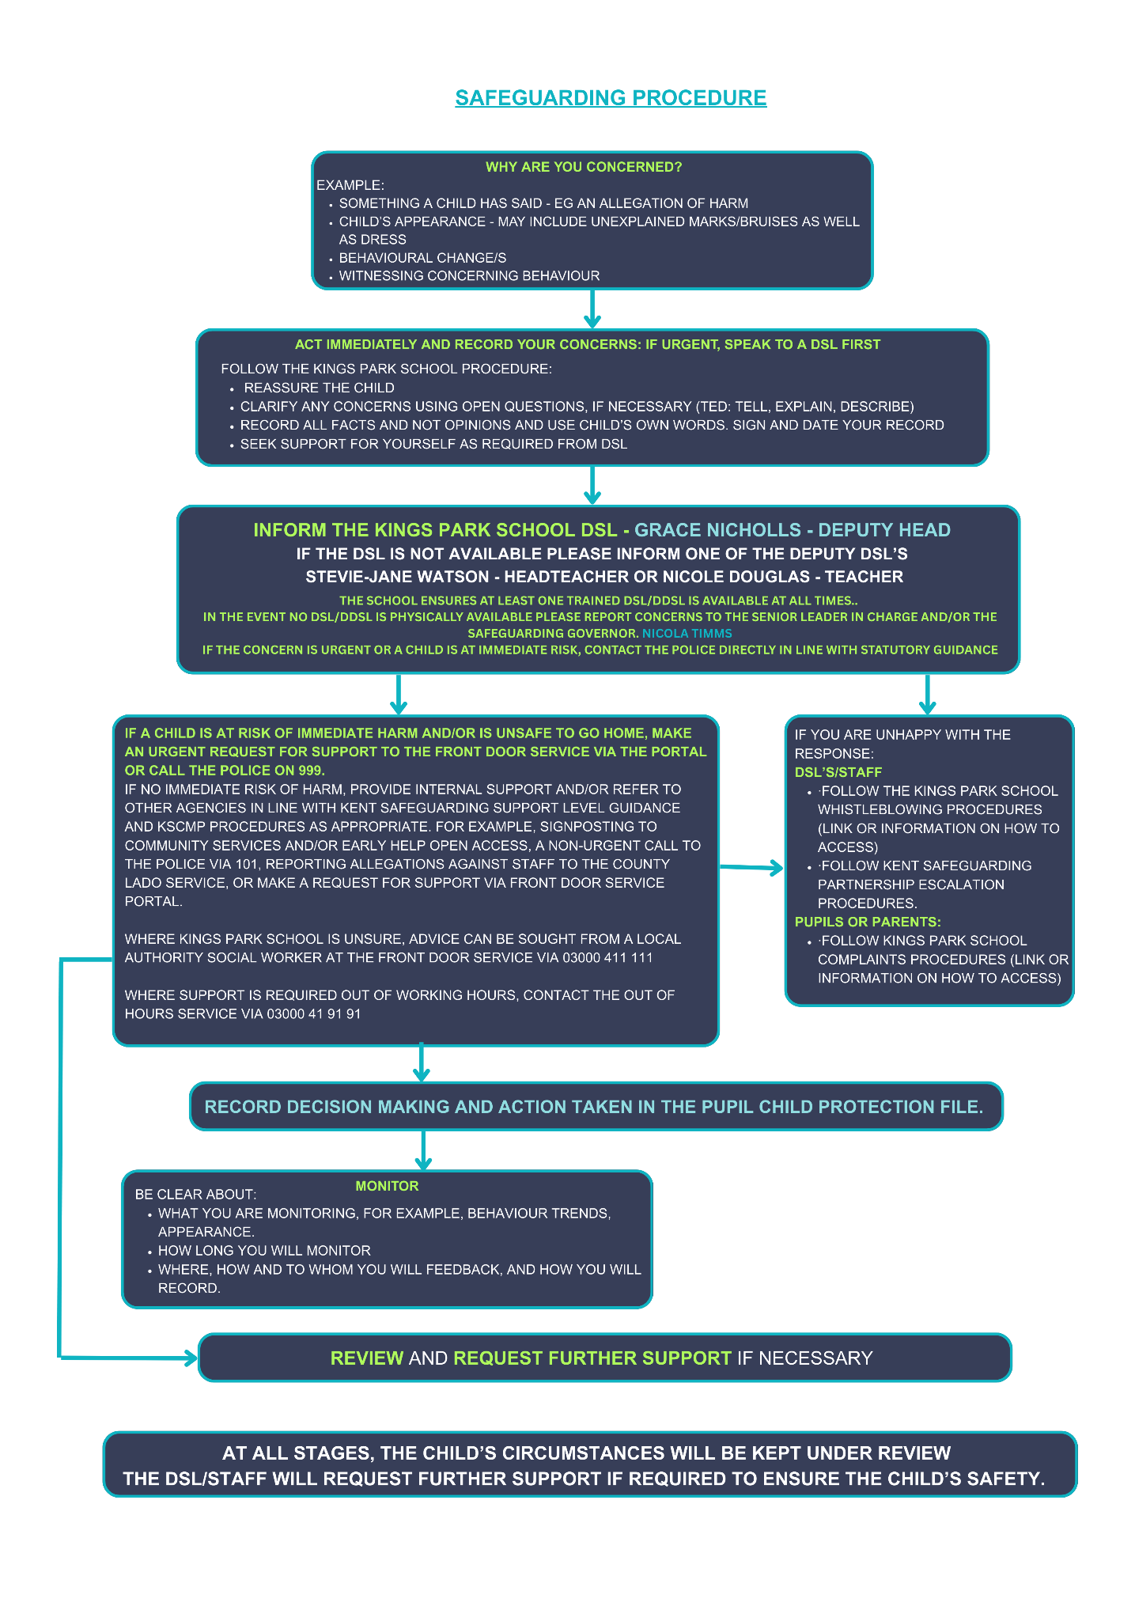

8.0 KEY RESPONSIBILITIES

GOVERNANCE AND LEADERSHIP
The Proprietor and The Leadership Team have a strategic responsibility for our safeguarding arrangements and will comply with their duties under legislation. The Proprietor has regard to the KCSIE guidance and will ensure our policies, procedures and training is effective and always complies with the law.
The Proprietor will facilitate a whole school approach to safeguarding which involves everyone. They will ensure that safeguarding and child protection are at the forefront and underpin all relevant aspects of process and policy development, so that all systems, processes, and policies operate with the best interests of the child at their heart.
The Proprietor is aware of their obligations under the Human Rights Act 1998, the Equality Act 2010, (including the Public Sector Equality Duty), and the local multi-agency safeguarding arrangements set out by the Kent Safeguarding Children Multi-Agency Partnership (KSCMP).
This includes, but is not limited to, safeguarding all members of the school community (for example, staff, pupils, parents/carers and other family members) identified with protected characteristics within the Equality Act, age, disability, gender reassignment, marriage and civil partnership, pregnancy and maternity, race, religion or belief, sex, sexual orientation.
The Proprietor and The Leadership Team will ensure that there are policies and procedures in place to ensure appropriate action is taken in a timely manner to safeguard and promote children’s welfare.
The Headteacher will ensure that our child protection and safeguarding policies and procedures adopted by The Proprietor, are understood, and followed by all staff.
The Proprietor will ensure an appropriate senior member of staff, from the school The Leadership Team, is appointed to the role of designated safeguarding lead. The Proprietor and The Leadership Team will ensure that the DSL is supported in their role and is provided with sufficient time so they can provide appropriate support to staff and children regarding any safeguarding and welfare concerns.
The school has nominated an experienced Safeguarding Lead as part of the board of Governors. The nominated governor will support the DSL and have oversight in ensuring that the school has an effective policy which interlinks with other related policies, that locally agreed procedures are in place and being followed, and that the policies are reviewed at least annually and when required.
The Safeguarding Governor provides independent oversight of safeguarding arrangements and reports to the governing board.
The Chair of Governors will ratify all policies and procedures.
DESIGNATED SAFEGUARDING LEAD (DSL)
The school has appointed Grace Nicholls – Deputy Head to act as the Designated Safeguarding Lead (DSL). DSLs must understand local filtering and monitoring systems and review filtering reports regularly with the IT lead. These are then monitored by the governing body who have lead responsibility for monitoring and filtering.
The DSL has overall responsibility for the day-to-day oversight of safeguarding and child protection systems (including online safety, understanding the filtering and monitoring systems, and processes in place) in King Parks School. All our DSLs will ensure they have sufficient understanding of the filtering and monitoring systems in place.
King Parks School has also appointed 2 x Deputy DSLs who will have delegated responsibilities and act in the DSLs absence. The DDSLs are Nicole Douglas – Class Teacher & Stevie-Jane Watson – Headteacher.
Whilst the activities of the DSL may be delegated to the deputies, the ultimate lead responsibility for safeguarding and child protection remains with the DSL and this responsibility will not be delegated.
The DSL (and any deputies) will be more likely to have a complete safeguarding picture and will be the most appropriate person to advise staff on the response to any safeguarding concerns.
It is the role of the DSL to carry out their functions as identified in Annex C of KCSIE. This includes but is not limited to:
- Acting as the central contact point for all staff to discuss any safeguarding concerns.
- Maintaining a confidential recording system for safeguarding and child protection concerns.
- Coordinating safeguarding action for individual children.
- When supporting children with a social worker or looked after children, the DSL should have the details of the child’s social worker and the name of the virtual school head in the authority that looks after the child, with the DSL liaising closely with the designated teacher.
- Consulting with other agencies and professionals in line with KCSIE and WTSC.
- Ensuring that all the schools Safeguarding Children Partnerships and the locally established procedures as put in place by the three safeguarding partners as part of the Kent Safeguarding Children Multi-Agency Partnership (KSCMP) procedures, including referrals, are followed, as necessary.
- Representing, or ensure the school is appropriately represented, at multi-agency safeguarding meetings (including child protection conferences).
- Managing and monitoring the school role in any multi-agency plan for a child.
- Being available during term time (during school hours) for staff in the school to discuss any safeguarding concerns.
- Ensuring adequate and appropriate DSL cover arrangements in response to any closures and any out of hours and/or out of term activities.
- Taking responsibility for online safety, including understanding the filtering and monitoring systems and processes in place. Creating reports for the governing body in line with DfE Filtering and Monitoring Standards (2024).
- Helping promote educational outcomes by sharing the information about the welfare, safeguarding and child protection issues that children, including children with a social worker, are experiencing, or have experienced, with teachers and school leadership staff.
- Ensuring all staff access appropriate safeguarding training and relevant updates in line with the recommendations within KCSIE.
- Consulting with the headteacher to inform them of any safeguarding issues, especially ongoing enquiries under section 47 of the Children Act 1989 and police investigations. This includes being aware of the requirement for children to have an Appropriate Adult (PACE Code C 2019).
The DSL will undergo appropriate and specific training to provide them with the knowledge and skills required to conduct their role. Deputy DSLs will be trained to the same standard as the DSL. The DSLs training will be updated formally at least every two years, but their knowledge and skills will be updated at least annually through a variety of methods at regular intervals and at least annually in line with KCSIE.
The DSL and Deputy DSLs will undertake formal safeguarding training at least every two years, with knowledge and skills updated at regular intervals and at least annually in line with KCSIE.
Staff will be briefed on out of hours availability for DSL contacts.

MEMBERS OF STAFF
Our staff play a particularly vital role in safeguarding as they can observe changes in a child’s behaviour or appearance, identify concerns early, provide help for children, promote children’s welfare and prevent concerns from escalating.
All members of staff have a responsibility to:
- Provide a safe environment in which children can learn.
- Be aware of the indicators of abuse, neglect and exploitation so that they can identify cases of children who may need help or protection.
- Know what to do if a child tells them that they are being abused, neglected, or exploited and understand the impact this can have upon a child.
- Be able to identify and act upon indicators that children are, or at risk of developing mental health issues.
- Be prepared to identify children who may benefit from early help and understand the early help process and their role in it.
- Understand the school safeguarding policies and systems.
- Undertake regular and appropriate training which is regularly updated.
- Be aware of the local process of making referrals to children’s social care and statutory assessment under the Children Act 1989.
- Know how to maintain an appropriate level of confidentiality.
- Reassure children who report concerns that they are being taken seriously and that they will be supported and kept safe.
- Act in line with Teachers’ Standards 2012 as amended 2021 which state that teachers (including headteachers) should safeguard children’s wellbeing and maintain public trust in the teaching profession as part of their professional duties.
Staff at KPS recognise that children may not feel ready or know how to tell someone that they are being abused, exploited, or neglected, and/or they may not recognise their experiences as being abusive or harmful. This should not prevent staff from having professional curiosity and speaking to a DSL if they have any concerns about a child.
Staff at KPS will determine how best to build trusted relationships with children, young people and parents/carers which facilitate appropriate professional communication in line with existing and relevant policies, for example, our staff behaviour and pupil behaviour policies.
CHILDREN AND YOUNG PEOPLE
Children and young people have a right to:
- Feel safe, be listened to, and have their wishes and feelings considered.
- Confidently report abuse, neglect or exploitation, knowing their concerns will be treated seriously, and knowing they can safely express their views and give feedback.
- Contribute to the development of KPS safeguarding policies.
- Receive help from a trusted adult.
- Learn how to keep themselves safe, including online.
PARENTS AND CARERS
Parents/carers have a responsibility to:
- Understand and adhere to the relevant school policies and procedures.
- Talk to their children about safeguarding issues and support the school in their safeguarding approaches.
- Identify behaviours which could indicate that their child is at risk of harm, including online.
- Seek help and support from the school or other agencies.

9.0 CHILD PROTECTION PROCEDURES
RECOGNISING INDICATORS OF ABUSE, NEGLECT AND EXPLOITATION
All staff are made aware of the definitions and indicators of abuse, neglect and exploitation as identified by ‘Working Together to Safeguard Children’ and ‘Keeping Children Safe in Education.’ This is outlined locally within the Kent Support Levels Guidance.
KPS recognise that when assessing whether a child may be suffering actual or potential harm there are four categories of abuse (for more in-depth information, see appendix 1):
- Physical abuse
- Sexual abuse
- Emotional abuse
- Neglect
- Prejudice-based harm, including racism and faith-based prejudice;
- Child-to-parent or caregiver abuse;
- Verbal emotional abuse, including persistent criticism, belittling and name-calling;
- Financial exploitation;
- Modern slavery as part of exploitation;
- Abuse within teenage intimate relationships, including coercive control and stalking.
By understanding the indicators of abuse, neglect and exploitation, we can respond to problems as early as possible and provide the right support and services for the child and their family.
There are four key steps to follow to help you to identify and respond appropriately to possible abuse and/or neglect. All members of staff are expected to be aware of and follow the below approach if they are concerned about a child.
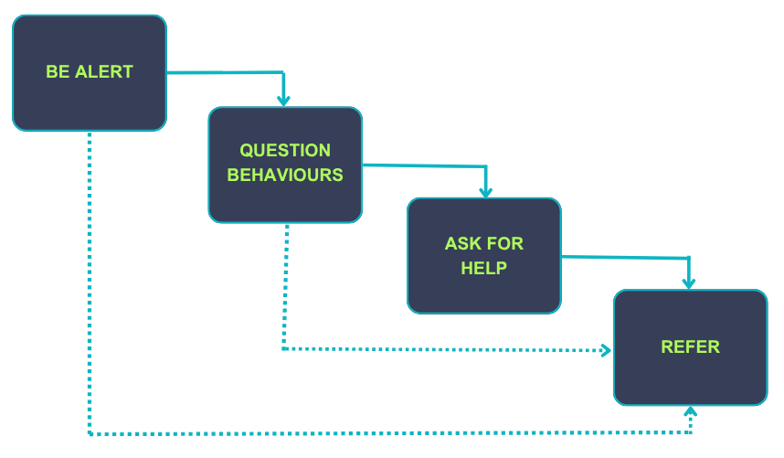

‘What to do if you are worried a child is being abused’
KPS recognises that concerns may arise in many different contexts and can vary in terms of their nature and seriousness. The indicators of child abuse, neglect and exploitation can vary from child to child. Children develop and mature at different rates, so what is worrying behaviour for a younger child might be normal for an older child. It is important to recognise that indicators of abuse, neglect and exploitation do not automatically mean a child is being harmed, however all concerns should be taken seriously and will be explored by the DSL on a case-by-case basis.
KPS recognises abuse, neglect, exploitation and other safeguarding issues are rarely standalone events and cannot always be covered by one definition or one label alone. In many cases, multiple issues will overlap with one another, therefore staff will always be vigilant and always raise concerns with a DSL.
Parental behaviours can indicate child abuse, neglect or exploitation; so staff will be alert to parent-child interactions or concerning parental behaviours; this could include parents who are under the influence of drugs or alcohol or if there is a sudden change in their mental health.
Children may report abuse, neglect or exploitation happening to themselves, their peers, or their family members. All reports made by children to staff will be taken seriously and will be responded to in line with this policy.
Safeguarding incidents and/or behaviours can be associated with factors and risks outside the school. Children can be at risk of abuse, neglect, or exploitation in situations outside their families; extra-familial harms take a variety of different forms and children can be vulnerable to multiple harms including sexual exploitation, criminal exploitation, sexual abuse, serious youth violence and county lines.
KPS recognises that technology can be a significant component in many safeguarding and wellbeing issues; children are at risk of abuse or exploitation online from people they know (including other children) and from people they do not know. In many cases, abuse will take place concurrently via online channels and in daily life.
KPS recognises that some children have additional or complex needs and may require access to intensive or specialist services to support them.
Following a concern about a child’s safety or welfare, the searching and screening of children and confiscation of any items, including any electronic devices, will be managed in line with the school behaviour policy and/or ‘Searching, Screening and Confiscation’ policy which is informed by the DfE ‘Searching, screening and confiscation at school’ guidance.
The DSL (or deputy) will be informed of any searching incidents where there were reasonable grounds to suspect a pupil was in possession of a prohibited item as listed in our behaviour policy. The DSL (or deputy) will then consider the circumstances of the pupil who has been searched to assess the incident against any potential wider safeguarding concerns.
Staff will involve the DSL (or deputy) without delay if they believe that a search has revealed a safeguarding risk.

RESPONDING TO CHILD PROTECTION CONCERNS
If staff are concerned about the safety or welfare of a child, they are expected to:
- listen carefully to child, reflecting the concern.
- use the child’s language.
- be non-judgmental.
- avoid leading questions; only prompting the child where necessary with open questions to clarify information where necessary. For example, who, what, where, when or Tell, Explain, Describe (TED).
- not promise confidentiality as concerns will have to be shared further, for example, with the DSL and potentially Integrated Children’s Services.
- be clear about boundaries and how the report will be progressed.
- record the concern using the facts as the child presents them, in line with school record keeping requirements.
- inform the DSL (or deputy), as soon as practically possible.
All staff are made aware that early information sharing is vital for the effective identification, assessment, and allocation of appropriate service provision, whether this is when problems first emerge, or where a child is already known to other agencies. Staff will not assume a colleague, or another professional will act and share information that might be critical in keeping children safe.
KPS will respond to safeguarding concerns in line with the Kent Safeguarding Children Multi-Agency Partnership procedures (KSCMP).
The full KSCMP procedures and additional guidance relating to reporting concerns and specific safeguarding issues can be found on their website: www.kscmp.org.uk
In Kent, Early Help and Preventative Services and Children’s Social Work Services are part of Integrated Children Services (ICS) and are accessed via the Front Door Service.
Early help is defined in ‘Working together to safeguard children’ as support for children of all ages that improves a family’s resilience and outcomes or reduces the chance of a problem getting worse. It is not an individual service, but a system of support delivered by local authorities and their partners, including education providers, working together and taking collective responsibility to provide the right provision in their area.
If early help support is appropriate, the DSL (or a deputy) will lead on exploring internal resources available and liaising with other universal or additional services available via local agencies.
Where Intensive Support Early Help (provided by ICS, outlined in the KSCMP support levels guidance) is considered to be appropriate, the DSL (or deputy) will make a ‘request for support’ via the Kent Children's Services Portal.
Staff, including the DSL, may be required to work with other agencies and professionals in an early help assessment.
The DSL will keep all Early Help cases under constant review and consideration will be given to escalating concerns and/or seeking advice from the Front Door Service if the situation does not appear to be improving or is getting worse.
Where a child is suffering, or is likely to suffer from harm, or is in immediate danger (for example, under section 17 or 47 of the Children Act), intensive or specialist support is required and a ‘request for support’ will be made immediately to Kent Integrated Children’s Services (via the portal) and/or the police, in line with the Kent Support Level Guidance and procedures.
KPS recognise that in situations where there is immediate child protection concerns for a child as identified in line with Support Level Guidance, it is NOT to investigate as a single agency, but to act in line with KSCMP guidance which may involve multi-agency decision making.
The DSL may seek advice or guidance from a social worker via the Front Door Service before deciding next steps.
The DSL, or a deputy DSL in the absence of the DSL will have the overall responsibility for making referrals. However, all staff are made aware of the local process for making referrals to Integrated Children’s Services and for statutory assessments under the Children Act 1989, especially section 17 (children in need) and section 47 (a child suffering, or likely to suffer, significant harm) that may follow a referral, along with the role they might be expected to play in such assessments.
If staff have any concerns about a child’s welfare, they are expected to act on them immediately. If staff are unsure if something is a safeguarding issue, they will speak to the DSL (or deputy). If in exceptional circumstances, a DSL is not available, this should not delay appropriate action being taken by staff.
Parents/carers will always be informed in the case of a request for support being submitted by the school unless there is a valid reason not to do so, for example, if informing them may put a child at risk of harm or could undermine a criminal investigation.
If, after a request for support or any other planned external intervention, a child’s situation does not appear to be improving, or concerns regarding receiving a decision or the decisions made, staff or the DSL will re-refer (if appropriate) and/or DSLs will follow the Kent Escalation and Professional Challenge Policy to ensure their concerns have been addressed and, most importantly, that the child’s situation improves.
DSLs and staff will be mindful of the need for the school to ensure any activity or support implemented to support children and/or families is recorded. Support provided by the school where families are struggling will be overseen and reviewed by the DSL on a regular basis to ensure activity does not obscure potential safeguarding concerns from the wider professional network.
RECORDING CONCERNS
- All safeguarding concerns, discussions, decisions, and reasons for those decisions, will be recorded electronically on the safeguarding system called CPOMS DSL’s /HT will be alerted without delay.
- Incident/Welfare concerns are recorded on CPOMS.
- Records will be completed as soon as possible after the incident/event, using the child’s words. All entries onto CPOMS are dated / and staff member identified. Child protection records will record facts and not personal opinions. A body map will be completed if visible injuries to a child have been observed.
- If there is an immediate safeguarding concern the member of staff will consult with a DSL before completing CPOMS as reporting urgent concerns takes priority.
- If members of staff are in any doubt about recording requirements, they will discuss their concerns with the DSL.
- Child protection records will include a clear and comprehensive summary of the concern, details of how the concern was followed up and resolved and details regarding any action taken, decisions reached and the outcome.
- All Child protection records are kept confidential and stored electronically where possible through CPOMS. Child protection records will be kept for individual children and will be maintained separately from all other records relating to the child in the school. Child protection records are kept in accordance with data protection legislation and are retained centrally and securely by the DSL.
- Safeguarding logs will be reviewed weekly by the DSL and Headteacher.
- Safeguarding logs will be reported to the Safeguarding Governor termly.
- All child protection records will be transferred in accordance with data protection legislation to the child’s subsequent school, under confidential and separate cover as soon as possible; within 5 days for an in-year transfer or within the first 5 days of the start of a new term. Child protection files will be transferred securely to the new DSL, separately to the child’s main file, and a confirmation of receipt will be obtained.
- In addition to the child protection file, the DSL will also consider if it would be appropriate to share any information with the DSL at the new school or college in advance of a child leaving, for example, information that would allow the new school or college to continue to provide support.
- Where the school receives child protection files from another setting, the DSL will ensure key staff such as the Special Educational Needs Co-Ordinators (SENCOs), will be made aware of relevant information as required.
- Where a pupil joins the school and no child protection files are received, the DSL will proactively seek to confirm from the previous setting whether any child protections exist for the pupil, and if so, if the files have been sent.

MULTI-AGENCY WORKING
KPS recognises the pivotal role we must play in multi-agency safeguarding arrangements and is committed to its responsibility to work within the KSCMP multi-agency safeguarding arrangements as identified within ‘Working Together to Safeguard Children’ and all other LSCPs.
The School, The Senior Leadership Team, proprietor and DSL will work to establish strong and co-operative local relationships with professionals in other agencies, including the safeguarding partners in line with local and national guidance.
KPS recognises the importance of multi-agency working and is committed to collaborating with partner agencies to provide a coordinated response to promote children’s welfare and protect them from harm. This includes contributing to KSCMP processes as required, such as, participation in relevant safeguarding multi-agency plans and meetings, including Child Protection Conferences, Core Groups, Strategy Meetings, Child in Need meetings or other early help multi-agency meetings. KPS recognises and is committed to all procedures from other LSCPs.
The school will allow access for Kent Children’s Social Work Service and, where appropriate, from a placing local authority, to conduct, or to consider whether to conduct, a section 17 or a section 47 assessment.
The headteacher and DSL are aware of the requirement for children to have an Appropriate Adult (PACE Code C 2019) where there is a need for detention, treatment and questioning by police officers and will respond to concerns in line with our school behaviour policy, which is informed by the DfE ‘Searching, screening and confiscation at school’ guidance.

CONFIDENTIALITY AND INFORMATION SHARING
KPS recognises our duty and powers to hold, use and share relevant information with appropriate agencies in matters relating to child protection at the earliest opportunity as per statutory guidance outlined within KCSIE.
Where possible, KPS will hold more than one emergency contact number for each pupil. There is an expectation that emergency contact information will be held for both parents/carers, unless doing so would put a child at risk of harm.
The Data Protection Act 2018, and the UK General Data Protection Regulation (UK GDPR) places duties on schools and individuals to process personal information fairly and lawfully and to keep the information they hold safe and secure. The Data Protection Act 2018 and UK GDPR do not prevent the sharing of information for the purposes of keeping children safe. Fears about sharing information must not be allowed to stand in the way of the need to safeguard and promote the welfare and protect the safety of children.
KPS has a trained Data Protection Officer (DPO) as required to ensure that our school is compliant with all matters relating to confidentiality and information sharing requirements.
All staff will be provided with training and information to ensure they have due regard to the relevant data protection principles, which allow them to share and/or withhold personal information.
KCSIE, the Information Commissioner’s Office (ICO), DfE Data Protection in schools guidance and DfE ‘Information sharing advice for safeguarding practitioners guidance provides further details regarding information sharing principles and expectations. This information will be held on the shared area on staff network/intranet.
The headteacher and DSL will disclose relevant safeguarding information about a pupil with staff on a ‘need to know’ basis.
All members of staff will be aware that whilst they have duties to keep information confidential, in line with our confidentiality policy, they also have a professional responsibility to be proactive in sharing information as early as possible to help identify, assess, and respond to risks or concerns about the safety and welfare of children; this may include sharing information with the DSL and with other agencies as appropriate.
Staff will only involve those who need to be involved, such as the DSL (or a deputy) and Kent Integrated Children’s Services (or equivalent). All staff are aware they cannot promise a child that they will not tell anyone about a report of any form of abuse, as this may not be in the best interests of the child.
COMPLAINTS
All members of the school community should feel able to raise or report any concerns about children’s safety or potential failures in the school safeguarding regime. The school has a complaints procedure available to parents, pupils and members of staff and visitors who wish to report concerns or complaints. This can be found in the office/ website.
Whilst we encourage members of our community to report concerns and complaints directly to us, we recognise this may not always be possible. Children, young people, and adults who have experienced abuse in education can contact the NSPCC ‘Report Abuse in Education’ helpline on 0800 136 663 or via email: help@nspcc.org.uk
Staff can also access the NSPCC whistleblowing helpline if they do not feel able to raise concerns regarding child protection failures internally.
Staff can call 0800 028 0285 (8:00 AM to 8:00 PM Monday to Friday) or email help@nspcc.org.uk.
The Leadership Team will take all concerns reported to the school seriously and all complaints will be considered and responded to in line with the relevant and appropriate process.

10.0 SPECIFIC SAFEGUARDING CONCERNS
KPS is aware of the range of specific safeguarding issues and situations that can put children at greater risk of harm. In addition to Part one, DSLs, school leaders and staff who work directly with children will read B of KCSIE which contains important additional information about the following specific forms of abuse and safeguarding issues.
Where staff are unsure how to respond to specific safeguarding issues, they should follow the processes as identified and speak with the DSL or a deputy.
CHILD-ON-CHILD ABUSE
All members of staff at KPS recognise that children can abuse other children; this is known as child-on-child abuse and can happen both inside and outside of school and online.

KPS recognises that child-on-child abuse can take many forms, including but not limited to:

- Bullying, including cyberbullying, prejudice-based and discriminatory bullying.
- Abuse in intimate personal relationships between children.
- Physical abuse which can include hitting, kicking, shaking, biting, hair pulling, or otherwise causing physical harm.
- Sexual violence and sexual harassment.
- Consensual and non-consensual sharing of nudes and semi-nude images and/or videos (also known as sexting or youth produced sexual imagery).
- Causing someone to engage in sexual activity without consent, such as forcing someone to strip, touch themselves sexually, or to engage in sexual activity with a third party.
- Upskirting (which is a criminal offence), which typically involves taking a picture under a person’s clothing without their permission, with the intention of viewing their genitals or buttocks to obtain sexual gratification, or cause the victim humiliation, distress, or alarm.
- Initiation/hazing type violence and rituals.
Any allegations of child-on-child abuse will be recorded, investigated, and dealt with in line with this safeguarding and child protection policy and KCSIE (in particular, part two and five).

KPS adopts a zero-tolerance approach to child-on-child abuse. We believe that abuse is abuse and it will never be tolerated or dismissed as “just banter”, “just having a laugh”, “part of growing up” or “boys being boys”; this can lead to a culture of unacceptable behaviours and can create an unsafe environment for children and a culture that normalises abuse, which can prevent children from coming forward to report it.

All staff have a role to play in challenging inappropriate behaviours between children. Staff recognise that some child-on-child abuse issues may be affected by gender, age, ability and culture of those involved. For example, for gender-based abuse, girls are more likely to be victims and boys more likely to be perpetrators.

KPS recognises that even if there are no reported cases of child-on-child abuse, such abuse is still likely to be taking place, and it may be the case that it is just not being reported. As such, it is important that staff speak to the DSL (or deputy) about any concerns regarding child-on-child abuse.
To minimise the risk of child-on-child abuse, KPS will implement a robust anti-bullying policy. The school will provide an age/ability appropriate PSHE and RSE curriculum and a range of reporting mechanisms, for example, worry boxes, trusted/safe adults.

KPS want children to feel able to confidently report abuse and know their concerns will be treated seriously. All allegations of child-on-child abuse will be reported to the DSL and will be recorded, investigated, and dealt with in line with associated school policies, including child protection, anti-bullying, and behaviour and relationship. Pupils who experience abuse will be offered appropriate support, regardless of where the abuse takes place.

Concerns about pupils’ behaviour, including child-on-child abuse taking place offsite will be responded to as part of a partnership approach with pupils’ and parents/carers. Offsite behaviour concerns will be recorded and responded to in line with existing appropriate policies, for example anti-bullying, acceptable use, behaviour and relationship and child protection policies.

Alleged victims, alleged perpetrators and any other child affected by child-on-child abuse will be supported by:
- Taking reports seriously.
- Listening carefully.
- Avoiding victim blaming.
- Providing appropriate pastoral support.
- Working with parents/carers.
- Reviewing educational approaches.
- Following procedures as identified in other policies, For example:
- the school anti-bullying
- behaviour and relationship
- child protection policy
- and where necessary and appropriate, informing the police and/or ICS.

CHILD-ON-CHILD SEXUAL VIOLENCE AND SEXUAL HARASSMENT

When responding to concerns relating to child-on-child sexual violence or harassment, KPS will follow the guidance outlined in Part five of KCSIE.

KPS recognises that:
- Sexual violence and sexual abuse can happen anywhere, and all staff will maintain an attitude of ‘it could happen here.’
- Sexual violence, and sexual harassment can occur between two children of any age and sex. It can occur through a group of children sexually assaulting or sexually harassing a single child or group of children and can occur online and face to face (both physically and verbally). Sexual violence and sexual harassment are never acceptable.
- Abuse that occurs online or outside of the school will not be dismissed or downplayed and will be treated equally seriously and in line with relevant policies/procedures, for example anti-bullying, behaviour, child protection, online safety.
- The law is in place to protect children and young people rather than criminalise them, and this will be explained in such a way to pupils that avoids alarming or distressing them.
- An initial disclosure to a trusted adult may only be the first incident reported, rather than representative of a singular incident and that trauma can impact memory, so children may not be able to recall all details or timeline of abuse. All staff will be aware certain children may face additional barriers to telling someone, for example because of their vulnerability, disability, sex, ethnicity, and/or sexual orientation.
All victims of sexual violence or sexual harassment will be reassured that they are being taken seriously, regardless of how long it has taken them to come forward, and that they will be supported and kept safe. A victim will never be given the impression that they are creating a problem by reporting sexual violence or sexual harassment or ever be made to feel ashamed for making a report.
The DSL (or deputy) is likely to have a complete safeguarding picture and will be the most appropriate person to advise on the initial response. They will make an immediate risk and needs assessment which will be considered on a case-by-case basis which explores how best to support and protect the victim and the alleged perpetrator, and any other children involved/impacted, in line with part five of KCSIE and relevant local/national guidance and support, for example KSCMP procedures.

The risk and needs assessment will be recorded and kept under review and will consider the victim (especially their protection and support), the alleged perpetrator, and all other children, adult students (if appropriate), and staff and any actions that are required to protect them.

Any concerns involving an online element will take place in accordance with relevant local/national
guidance and advice.

Reports will initially be managed internally by the school and where necessary will be referred to Integrated Children’s Services (Early Help and/or Children’s Social Work Service) via the Children’s Portal and/or the police. Important considerations which may influence this decision include:
- The wishes of the victim in terms of how they want to proceed.
- The nature of the alleged incident(s), including whether a crime may have been committed and/or whether Harmful Sexual Behaviour has been displayed.
- The ages of the children involved.
- The developmental stages of the children involved.
- any power imbalance between the children.
- If the alleged incident is a one-off or a sustained pattern of abuse - sexual abuse can be accompanied by other forms of abuse and a sustained pattern may not just be of a sexual nature.
- That sexual violence and sexual harassment can take place within intimate personal relationships between children.
- Understanding intra familial harms and any necessary support for siblings following incidents.
- Whether there are any ongoing risks to the victim, other children, adult students, or school staff.
- Any other related issues and wider context, including any links to child sexual exploitation and child criminal exploitation.
The school will engage with both the victim’s and alleged perpetrator’s parents/carers when there has been a report of sexual violence although this might not be necessary or proportionate in the case of sexual harassment and will depend on a case-by-case basis. The exception to this is if there is a reason to believe informing a parent/carer will put a child at additional risk. Any information shared with parents/carers will be in line with information sharing expectations, our confidentiality policy, and any data protection requirements, and where they are involved, will be subject to discussion with other agencies (for example Children’s Social Work Service and/or the police) to ensure a consistent approach is taken.
If at any stage the DSL is unsure if a request for support is appropriate, advice may be sought from the Front Door Service.

NUDE AND/OR SEMI-NUDE IMAGE SHARING BY CHILDREN
The term ‘sharing nudes and semi-nudes’ is used to mean the sending or posting of nude or semi-nude images, videos, or live streams of/by young people under the age of eighteen. Creating and sharing nudes and semi-nudes of under-18s (including those created and shared with consent) is illegal which makes responding to incidents complex.
sharing-nudes-and-semi-nudes-advice-for-education-settings-working-with-children-and-young-people outlines how schools and colleges should respond to all incidents of consensual and non-consensual image sharing; it should be read and understood by all DSLs working with all age groups.
KPS recognises every incident involving nude or semi-nude images requires a safeguarding response, including consensual, non-consensual, AI-generated, altered or “deepfake” images.
Staff are advised:
- To report any concerns to the DSL immediately.
- Never to view, copy, print, share, forward, store or save the imagery, or ask a child to share or download it – this may be illegal. If staff have already inadvertently viewed imagery, this will be immediately reported to the DSL.
- Not to delete the imagery or ask the child to delete it.
- To avoid saying or doing anything to blame or shame any children involved.
- To reassure the child(ren) involved and explain that the DSL will be informed so they can receive appropriate support and help. Do not promise confidentiality, as other agencies may need to be informed and be involved.
- Not to investigate or ask the child(ren) involved to disclose information regarding the imagery.
- To not share information about the incident with other members of staff, children/young people, or parents/carers, including the families and child(ren) involved in the incident; this is the responsibility of the DSL.
DSLs will respond to concerns in line with the non-statutory UKCIS guidance: ‘Sharing nudes and semi-nudes: advice for education settings working with children and young people’ and the local KSCMP guidance. When made aware of a concern involving consensual and non-consensual sharing of nudes and semi-nude images and/or videos:
The DSL will hold an initial review meeting to explore the context and ensure appropriate and proportionate safeguarding action is taken in the best interests of any child involved. This may mean speaking with relevant staff and the children involved as appropriate.
Parents/carers will be informed at an early stage and be involved in the process to best support children, unless there is good reason to believe that involving them would put a child at risk of harm.
All decisions and action taken will be recorded in line with our child protection procedures. A referral will be made to ICS via the Children’s Portal and/or the police immediately if:
- The incident involves an adult (over 18).
- There is reason to believe that a child has been coerced, extorted, or groomed, or there are concerns about their capacity to consent, for example, age of the child or they have special educational needs.
- The image/videos involve sexual acts and a child under the age of thirteen, depict sexual acts which are unusual for the child’s developmental stage, or are violent.
- A child is at immediate risk of harm owing to the sharing of nudes and semi-nudes.
- The DSL may choose to involve other agencies at any time if further information/concerns are disclosed later.
- If DSLs are unsure if a request for support is appropriate, advice may be sought from the Front Door Service.

CHILD SEXUAL EXPLOITATION (CSE) AND CHILD CRIMINAL EXPLOITATION (CCE)
KPS recognises that both CSE and CCE are forms of abuse that occur where an individual or group takes advantage of an imbalance in power to coerce, manipulate or deceive a child into taking part in sexual or criminal activity, in exchange for something the victim needs or wants, and/or for the financial advantage or increased status of the perpetrator or facilitator and/or through violence or the threat of violence. CSE and CCE can affect children, both male and female and can include children who have been moved (commonly referred to as trafficking) for the purpose of exploitation.

We know that children can become trapped in CCE as perpetrators can threaten victims and their families with violence or entrap and coerce them into debt. Children involved in criminal exploitation often commit crimes themselves which can mean their vulnerability as victims is not always recognised (particularly older children) and they are not treated as victims; despite the harm they have experienced. The experience of girls who are criminally exploited can also be quite different to that of boys. We also recognise that children being criminally exploited may be at higher risk of child sexual exploitation (CSE).

KPS recognises that CSE can occur over time or be a one-off occurrence and may happen without the child’s immediate knowledge, for example through others sharing videos or images of them on social media. CSE can affect any child who has been coerced into engaging in sexual activities and includes 16- and 17-year-olds who can legally consent to have sex. Some children may not realise they are being exploited, for example they may believe they are in a genuine romantic relationship.
If staff are concerned that a child may be at risk of CSE or CCE, immediate action should be taken by speaking to the DSL or a deputy.

SERIOUS VIOLENCE
All staff are aware of the indicators which may signal children are at risk from or are involved with serious violent crime. These may include unexplained gifts or new possessions, increased absence from school, a change in friendships or relationships with older individuals or groups, a significant decline in performance, signs of self-harm or a significant change in wellbeing, or signs of assault or unexplained injuries. Unexplained gifts or new possessions could also indicate that children have been approached by, or are involved with, individuals associated with criminal networks or gangs and may be at risk of CCE.
Any concerns regarding serious violence will be reported and responded to in line with other child protection concerns by speaking with a DSL or deputy. The initial response to child victims is important and staff will take any allegations seriously and work in ways that support children and keep them safe.

MODERN SLAVERY

Modern slavery encompasses human trafficking and slavery, servitude and forced compulsory labour. Exploitation can take many forms, including sexual exploitation, forced labour, slavery, servitude, forced criminality and the removal of organs. Further information on the signs that someone may be a victim of modern slavery, the support available to victims and how to refer them to the NRM is available in the Statutory Guidance: Modern slavery: how to identify and support victims.

If there are concerns that any member of the community is a victim of, or involved in modern slavery, concerns should be shared with the DSL or deputy. This will be responded to in line with this policy.

SO-CALLED HONOUR BASED ABUSE (HBA)
So-called ‘honour’-based abuse (HBA) encompasses incidents or crimes which have been committed to protect or defend the honour of the family and/or the community, including female genital mutilation (FGM), forced marriage, and practices such as breast ironing.

All forms of HBA are abuse, regardless of the motivation, and concerns will be responded to. Staff will report any concerns about HBA to the DSL (or a deputy). If there is an immediate threat, the police will be contacted.

All staff will speak to the DSL (or deputy) if they have any concerns about forced marriage. Staff can also contact the Forced Marriage Unit if they need advice or information: 020 7008 0151 or fmu@fcdo.gov.uk

Whilst all staff will speak to the DSL (or deputy) if they have any concerns about FGM, there is a specific legal reporting duty on teachers.
Section 5B of the Female Genital Mutilation Act 2003 (as inserted by section 74 of the Serious Crime Act 2015) places a statutory duty upon teachers in England and Wales, to personally report to the police where they discover that FGM appears to have been carried out on a girl.
It will be rare for teachers to see visual evidence, and they should not be examining pupils, however teachers who do not personally report such concerns may face disciplinary sanctions. Further information on when and how to make a report can be found at: Mandatory reporting of female genital mutilation procedural information and FGM Guidance
Unless the teacher has good reason not to, they are expected to also discuss any FGM concerns with the DSL (or a deputy), and Kent Integrated Children’s Services should be informed as appropriate. The mandatory reporting duty only applies to teaching staff.

PREVENTING RADICALISATION
KPS recognises that children may be susceptible to radicalisation into terrorism.
KPS is aware of our duty under section 26 of the Counter-Terrorism and Security Act 2015 (the CTSA 2015), to have “due regard to the need to prevent people from being drawn into terrorism”, also known as the Prevent duty and the specific obligations placed upon us as an education provider regarding risk assessments, working in partnership, staff training, and IT policies.
All staff have received appropriate training to enable them to be alerted to changes in children’s behaviour which could indicate that they may prevent-duty-safeguarding-learners-vulnerable-to-radicalisation
In line with KCSIE and the Prevent Duty guidance for schools, all KPS staff are required to take part in annual Prevent Duty training. A register is maintained.
Staff are trained to identify children who may be vulnerable to radicalisation.
Staff will be supported to use their judgement in identifying children who might be at risk of radicalisation and will act proportionately; staff will report concerns to the DSL (or a deputy), who, where appropriate, will follow the local procedures or the correct Local authority depending on the child’s area, in regard to making a Prevent referral. If there is an immediate threat to safety, the police will be contacted via 999.

CYBERCRIME
KPS recognise that children with particular skills and interests in computing and technology may inadvertently or deliberately stray into ‘cyber-enabled’ (crimes that can happen offline but are enabled at scale and at speed online) or ‘cyber dependent’ (crimes that can be committed only by using a computer/internet enabled device) cybercrime.
If staff are concerned that a child may be at risk of becoming involved in cyber-dependent cybercrime, the DSL or a deputy will be informed, and consideration will be given to accessing local support and/or referring into the Cyber Choices programme, which aims to intervene when young people are at risk of committing, or being drawn into, low level cyber-dependent offences and divert them to a more positive use of their skills and interests.
Where there are concerns about ‘cyber-enabled’ crime such as fraud, purchasing of illegal drugs online, child sexual abuse and exploitation, or other areas of concern such as online bullying or general online safety, they will be responded to in line with the child protection policy and other appropriate policies.
KPS DSLs may also seek advice from Kent Police and/or the Front Door Service
DOMESTIC ABUSE
KPS recognises that:
- Domestic abuse can encompass a wide range of behaviours and may be a single incident or a pattern of incidents.
- Domestic abuse can include, but is not limited to, psychological (including coercive control), physical, sexual, economic, or emotional abuse.
- Children can be victims of domestic abuse if they see, hear, or experience the effects of abuse at home and/or suffer domestic abuse in their own intimate relationships (teenage relationship abuse).
- Anyone can be a victim of domestic abuse, regardless of sexual identity, age, ethnicity, socio-economic status, sexuality or background, and domestic abuse can take place inside or outside of the home.
- Domestic abuse can take place within different types of relationships, including ex-partners and family members.
- There is always a potential for domestic abuse to take place when parents/families separate, or for existing domestic abuse to persist or escalate post separation.
- Domestic abuse can have a detrimental and long-term impact on children’s health, well-being, development, and ability to learn.
- Domestic abuse concerns will not be looked at in isolation and our response will be considered as part of a holistic approach which considers children’s lived experiences.
- It is important not to use victim blaming language and to adopt a trauma informed approach when responding to concerns relating to domestic abuse.
If staff are concerned that a child may be at risk of seeing, hearing, or experiencing the effects of any form of domestic abuse, or in their own intimate relationships, immediate action should be taken by speaking to the DSL or a deputy.
KPS is an Operation Encompass School. This means we work in partnership with Kent Police to provide support to children experiencing the effects of domestic abuse. An Operation Encompass notification is sent to the school when the police are called to an incident of domestic abuse and there are children in the household; the police are expected to inform schools before the child(ren) arrive the following day.
The DSL or Deputy DSL will act as the Operation Encompass Key Adult.
Operation Encompass notifications help ensure that we have up to date and relevant information about children’s circumstances and enables us to put immediate support in place according to the child’s needs.
This does not replace statutory safeguarding procedures and where appropriate, a referral to the Front Door Service will be made if there are any concerns about a child’s welfare.
Where the school is unsure of how to respond to a notification, advice may be sought from the Front Door Service, or the Operation Encompass helpline which is available 8AM to 1PM, Monday to Friday on 0204 513 9990.
More information about the scheme and how as a school we can become involved is available on the Operation Encompass website. Operation Encompass provides an advice and helpline service for all staff members from educational settings who may be concerned about children who have experienced domestic abuse. The helpline is available 8AM to 1PM, Monday to Friday on 0204 513 9990
Guidance taken from Domestic Abuse Act 2021 and guidance (updated 2024) including “post-separation abuse.”
MENTAL HEALTH
All staff recognise that mental health problems can, in some cases, be an indicator that a child has suffered or is at risk of suffering abuse, neglect or exploitation.
Staff are aware that children’s experiences, for example where children have suffered abuse and neglect, or other potentially traumatic Adverse Childhood Experiences (ACEs), can impact on their mental health, behaviour, and education.
Staff are well placed to observe children day-to-day and identify those whose behaviour suggests that they may be experiencing a mental health problem or be at risk of developing one.
If staff have a mental health concern about a child that is also a safeguarding concern, immediate action should be taken by speaking to the DSL or a deputy.

11.0 SUPPORTING CHILDREN POTENTIALLY AT GREATER RISK OF HARM
Whilst all children should be protected, KPS acknowledge that some groups of children are potentially at greater risk of harm. This can include the following groups.

SAFEGUARDING CHILDREN WITH SPECIAL EDUCATIONAL NEEDS OR DISABILITIES (SEND)
KPS acknowledges that children with special educational needs or disabilities (SEND) or certain health conditions can face additional safeguarding challenges and barriers for recognising abuse, neglect, or exploitation.
KPS recognises that children with SEND may face additional communication barriers and experience difficulties in managing or reporting abuse or challenges. Children with SEND will be supported to communicate and ensure that their voice is heard and acted upon.
All members of staff are encouraged to appropriately explore potential indicators of abuse, neglect and exploitation, such as behaviour, mood changes or injuries and not to assume that they are related to the child’s disability. Staff will be mindful that children with SEND, or certain medical conditions may be disproportionally impacted by behaviours such as bullying, without outwardly showing any signs.
Members of staff are encouraged to be aware that children with SEND can be disproportionally impacted by safeguarding concerns, such as exploitation, peer group isolation or bullying including prejudice-based bullying. We will always consider implementing extra pastoral support and attention for all our children. The DSL will work closely with the SENCO to plan support as required.
Our school has robust intimate/personal care policies as and when needed which ensure that the health, safety, independence, and welfare of children is promoted, and their dignity and privacy are respected.
Arrangements for intimate and personal care are open and transparent and accompanied by robust recording systems.

CHILDREN REQUIRING MENTAL HEALTH SUPPORT
Kings Park School has a vital role to play in supporting the mental health and wellbeing of our pupil’s.
Mental health problems can, in some cases, be an indicator that a child has suffered or is at risk of suffering abuse, neglect or exploitation. Where there are concerns regarding possible mental health problems for pupils, staff should:
- Report all concerns to the DSL/headteacher who will then escalate and follow routes for a referral etc.
Age/ability appropriate education will be provided to our pupils to help promote positive health, wellbeing, and resilience. The school will provide a curriculum and clear values that supports the pupils understanding through the subjects of PSHE and RSHE. They will use specific educational approaches depending on the individual child’s needs.

CHILDREN WHO ARE ABSENT FROM EDUCATION
Children being absent from education for prolonged periods and/or on repeat occasions can act as a vital warning sign to a range of safeguarding issues including neglect, child sexual and child criminal exploitation - particularly county lines.
A robust response to children who are absent from education for prolonged periods and/or on repeat occasions will support the identification of such abuse and may help prevent the risk of children going missing in the future. This includes when problems are first emerging and also where children are already known to Kent Integrated Children’s Services and/or have a social worker (such as a child who is a child in need or who has a child protection plan, or is a looked after child), where being absent from education may increase known safeguarding risks within the family or in the community.
Where possible, Kings Park School will hold more than one emergency contact number for each pupil, so we have additional options to contact a responsible adult if a child missing in education is also identified as a welfare and/or safeguarding concern.
Where the school has concerns that a child has unexplainable and/or persistent absences from education and/or is missing from education, we will respond in line with our statutory duties (DfE: gov education) and local policies. Local support is available via the Kent PRU, Inclusion and Attendance Service (PIAS).

ELECTIVE HOME EDUCATION (EHE)
Where a parent/carer expresses their intention to remove a child from school with a view to educating at home, we will respond in line with National Elective Home Education guidance and local KCC Educating your child at home.
We will work together with parents/carers and other key professionals and organisations to ensure decisions are made in the best interest of the child.

CHILDREN WHO MAY BENEFIT FROM EARLY HELP
Staff should be aware of the ‘Early Help Framework (Kent 2024)’ which aligns with Working Together to safeguard children 2026. Any child may benefit from early help, but all staff should be particularly alert to the potential need for early help for a child who:
- Is disabled or has certain health conditions and has specific additional needs.
- Has special educational needs (whether they have a statutory Education, Health and Care plan).
- Has a mental health need.
- Is a young carer.
- Is showing signs of being drawn in to anti-social or criminal behaviour, including gang involvement and association with organised crime groups or county lines.
- Is frequently missing/goes missing from education, home, or care.
- Has experienced multiple suspensions, is at risk of being permanently excluded from schools, colleges and in Alternative Provision or a Pupil Referral Unit.
- Is at risk of modern slavery, trafficking, sexual and/or criminal exploitation.
- Is at risk of being radicalised or exploited.
- Has a parent or carer in custody or is affected by parental offending.
- Is in a family circumstance presenting challenges for the child, such as drug and alcohol misuse, adult mental health issues and domestic abuse.
- Is misusing alcohol and other drugs themselves.
- Is at risk of so-called ‘honour’-based abuse such as Female Genital Mutilation or forced marriage.
- Is a privately fostered child.

CHILDREN WHO NEED A SOCIAL WORKER (CHILD IN NEED AND CHILD PROTECTION PLANS)
The DSL will hold details of social workers working with children in the school so that decisions can be made in the best interests of the child’s safety, welfare, and educational outcomes.
Where children have a social worker, this will inform school decisions about their safety and promoting their welfare, for example, responding to unauthorised absence and provision of pastoral and/or academic support.

LOOKED AFTER CHILDREN, PREVIOUSLY LOOKED AFTER CHILDREN AND CARE LEAVERS.
Kings Park School are aware that many children become “looked after” following abuse, neglect and/or exploitation, and a previously looked after child also potentially remains vulnerable.
The school has appointed a ‘designated teacher’ (SENCO) who works with local authorities, including the Virtual School Kent to promote the educational achievement of registered pupils who are looked after or who have been previously looked after.
The designated teacher (SENCO) will work with the DSL to ensure appropriate staff have the information they need in relation to a child’s looked after legal status, contact arrangements with birth parents or those with parental responsibility, care arrangements and the levels of authority delegated to the carer by the authority looking after them.
Where a child is looked after, the DSL will hold details of the social worker and the name of the virtual school head in the authority that looks after the child.
Where the school believes a child is being cared for as part of a private fostering arrangement (occurs when a child under 16 is cared for and lives with an adult who is not a relative for 28 days or more) there is a duty to recognise these arrangements and inform the Local Authority via the Front Door.
Where a child is leaving care, the DSL will hold details of the local authority Personal Advisor appointed to guide and support them and will liaise with them as necessary regarding any issues of concern.

CHILDREN WHO ARE LESBIAN, GAY, BISEXUAL, OR GENDER QUESTIONING/TRANS (LGBT)
The fact that a child or a young person may be LGBT is not in itself an inherent risk factor for harm, however, Kings Park School recognises that children who are LGBT or are perceived by other children to be LGBT (whether they are or not) can be targeted by other children or others within the wider community.
When supporting a trans or gender questioning child, the school/colleges will consider the broad range of their individual needs, in partnership with the child’s parents/carers (other than in the exceptionally rare circumstances where involving parents would constitute a significant risk of harm to the child), including any clinical advice that is available and how to address wider vulnerabilities such as the risk of bullying.
Kings Park School recognises risks can be compounded where children who are LGBT lack a trusted adult with whom they can be open. LGBT education is included within our Relationships Education/ Relationship and Sex Education and Health Education curriculum, and our staff will endeavour to reduce the additional barriers faced and provide a safe space that facilitates a culture where children can speak out or share any concerns.

CHILDREN WHO ARE PRIVATELY FOSTERED
Private fostering occurs when a child under the age of 16 (under 18 for children with a disability) is provided with care and accommodation by a person who is not a parent, person with parental responsibility for them or a relative in their own home. A child is not privately fostered if the person caring for and accommodating them has done so for less than 28 days and does not intend to do so for longer. Such arrangements may come to the attention of our staff through the normal course of their interaction, and promotion of learning activities, with children.
Where private fostering arrangements come to the attention of the Kings Park School, we must notify Kent Integrated Children’s Services in line with the local KSCMP in order to allow the local authority to check the arrangement is suitable and safe for the child.

12.0 ONLINE SAFETY
It is essential that children are safeguarded from potentially harmful and inappropriate material or behaviours online. Kings Park School will adopt a whole school approach to online safety which will empower, protect, and educate our pupils and staff in their use of technology, and establish mechanisms to identify, intervene in, and escalate any concerns where appropriate.
Kings Park School will ensure online safety is considered as a running and interrelated theme when devising and implementing our policies and procedures, and when planning our curriculum, staff training, the role and responsibilities of the DSL and parental engagement.
Kings Park School identifies that the breadth of issues classified within online safety is considerable, but can be categorised into four areas of risk:
- Content: being exposed to illegal, inappropriate, or harmful content. For example, pornography, fake news, racism, misogyny, self-harm, suicide, anti-Semitism, radicalisation and extremism.
- Contact: being subjected to harmful online interaction with other users. For example, peer on peer pressure, commercial advertising and adults posing as children or young adults with the intention to groom or exploit them for sexual, criminal, financial or other purposes.
- Conduct: personal online behaviour that increases the likelihood of, or causes, harm. For example, making, sending and receiving explicit images (including consensual and non-consensual sharing of nudes and semi-nudes and/or pornography), sharing other explicit images and online bullying.
- Commerce: risks such as online gambling, inappropriate advertising, phishing/financial scams.
Kings Park School recognises that technology and the risks and harms related to it evolve and change rapidly. The school will carry out an annual review of our approaches to online safety, supported by an annual risk assessment, which considers and reflects the current risks our children face online.
As per DfE Filtering and Monitoring Standards (2024) and Education Access Review (Ofcom/DSIT 2024) The Headteacher will be informed of any online safety concerns by the DSL, as appropriate.

POLICIES AND PROCEDURES
The DSL has overall responsibility for online safety within the school but will liaise with other members of staff where required.
The DSL will respond to online safety concerns in line with our child protection and other associated policies, including our Anti-bullying policy and behaviour policy.
Internal sanctions and/or support will be implemented as appropriate.
Where necessary, concerns will be escalated and reported to relevant partner agencies in line with local policies and procedures.
Kings Park School uses a wide range of technology. This includes computers, laptops, tablets and other digital devices, the internet, our learning platform and email systems.
All school owned devices and systems will be used in accordance with our acceptable use policies and with appropriate safety and security measures in place.
Kings Park School recognises that generative artificial intelligence (AI) tools may have many uses which could benefit our school community. However, it is important to recognise that AI tools can also pose risks; this is including, but not limited to, bullying and harassment, abuse and exploitation (including child sexual abuse), privacy and data protection risks, plagiarism and cheating, and inaccurate, harmful and/or biased material, and additionally its use can pose moral, ethical and legal concerns.
Staff and pupils will be made aware of the benefits and risks of using AI tools; through specific lessons and staff training where required.
Staff are required to carry out a risk assessment and seek written approval from The Senior Leadership Team prior to any use of AI in school.
Kings Park School will respond to any misuse of AI in line with relevant policies, including but not limited to, anti-bullying, behaviour and relationship and safeguarding and child protection.
Where the School believe that AI tools may have facilitated the creation of child sexual abuse material, including the sharing of nude/semi-nude images by children, the school will respond in line with the UKCIS guidance ‘Sharing nudes and semi-nudes: advice for education settings working with children and young people’ and the local KSCMP guidance.
Kings Park School Leaders may need/wish to refer to use of AI in relevant curriculum-based policies according to leadership decisions in relation to the use (or not) of AI tools. The following links may also provide further information for leaders to consider:
- Generative artificial intelligence (AI) in education - GOV.UK (www.gov.uk)
- Data protection in schools - Artificial intelligence (AI) and data protection in schools - Guidance - GOV.UK (www.gov.uk)
- Artificial Intelligence and Online Safety | SWGfL
- Using artificial intelligence (AI) safely | Internet Matters
Kings Park School recognises the specific risks that can be posed by mobile and smart technology including mobile/smart phones, cameras, wearable technology and any other electronic devices with imaging and/or sharing capabilities.
Kings Park School has appropriate mobile and smart technology and image use policies in place, which are shared and understood by all members of the community. These policies can be found on the staff intranet/ website and are available from the school office.

APPROPRIATE FILTERING AND MONITORING
Kings Park School ensures the filter and monitoring systems are appropriate following a risk assessment (required by the Prevent Duty). This will depend on the IT systems in place as well as the school risk profile, which includes: the age range/ability of children, the number of children, those who are potentially at greater risk of harm and how often they access devices and IT systems.
The UK Safer Internet Centre has published guidance as to what “appropriate” filtering and monitoring might look like; Kings Park Schools DSLs and SLT will ensure they are familiar with this guidance and its implications.
To ensure Kings Park School meets this duty, the Department for Education has published filtering and monitoring standards of which the school should:
- Identify and assign roles and responsibilities to manage filtering and monitoring systems.
- Review filtering and monitoring provision at least annually.
- Block harmful and inappropriate content without unreasonably impacting teaching and learning.
- Have effective monitoring strategies in place that meet their safeguarding need.
Kings Park School will do all we reasonably can to limit children’s exposure to online risks, through school provided devices and networks and in line with the requirements of the Prevent Duty and KCSIE, we will ensure that appropriate filtering and monitoring systems are in place.
When implementing appropriate filtering and monitoring, Kings Park School will ensure that “over blocking” does not lead to unreasonable restrictions as to what children can be taught with regards to online teaching and safeguarding.
Whilst filtering and monitoring is an important part of our online safety responsibilities, it is only one part of our approach to online safety and we recognise that we cannot rely on filtering and monitoring alone to safeguard our pupils; effective safeguarding practice, robust policies, appropriate classroom/behaviour management and regular education/training about safe and responsible use is essential and expected.
Pupils will use appropriate search tools, apps and online resources as identified by staff, following an informed risk assessment.
Internet use will be supervised by staff as appropriate to pupils age, ability and potential risk of harm.
At Kings Park School our pupils may be supervised by a member of staff if they have been identified as being at potentially greater risk of harm. Risk assessments will be carried out and pupils will always be directly supervised by an adult where required.

RESPONSIBILITIES
Our proprietor has overall strategic responsibility for our filtering and monitoring approaches, including ensuring that our filtering and monitoring systems are regularly reviewed, and that The Leadership Team and relevant staff have an awareness and understanding of the appropriate filtering and monitoring provisions in place, manage them effectively and know how to escalate concerns when identified.
The Senior Leadership Team and Proprietor are responsible for ensuring that our school has met the DfE Filtering and monitoring standards for schools and colleges.
Our Senior Leadership Team are responsible for:
- Procuring filtering and monitoring systems.
- Documenting decisions on what is blocked or allowed and why.
- Reviewing the effectiveness of our provision.
- Overseeing reports.
- Ensuring that all staff understand their role, are appropriately trained, follow policies, processes and procedures and act on reports and concerns.
- Ensuring the DSL and IT service providers/staff have sufficient time and support to manage their filtering and monitoring responsibilities.
The DSL has lead responsibility for overseeing and acting on:
- Any filtering and monitoring reports.
- Any child protection or safeguarding concerns identified.
- Checks to filtering and monitoring system.
All members of staff are provided with an understanding of the expectations, applicable roles and responsibilities in relation to filtering and monitoring as part of our induction process, and in our child protection staff training.
All staff, pupils and parents/carers have a responsibility to follow this policy to report and record any filtering or monitoring concerns.

DECISION MAKING AND REVIEWING OUR FILTERING AND MONITORING PROVISION
Decisions made by school leaders will consider the proportionality of costs versus safeguarding risks for their specific context.
When procuring and/or making decisions about our filtering and monitoring provision, our senior leadership team works closely with the DSL and the IT service provider. Decisions will be recorded and informed by an approach which ensures our systems meet our schools’ specific needs and circumstances, including but not limited to our pupil risk profile and specific technology use.
Any changes to the filtering and monitoring approaches will be assessed by staff with safeguarding, educational and technical experience and, where appropriate, with consent from The Leadership Team; all changes to the filtering policy are logged and recorded.
KPS will annually review our filtering and monitoring systems to ensure we understand the changing needs and potential risks posed to our community.
In addition, our school undertakes regular checks on our filtering and monitoring systems, which are logged and recorded, to ensure our approaches are effective and can provide assurance to The Proprietor that we are meeting our safeguarding obligations.
These checks are achieved by:
- Using KCSIE signposts to Test Filtering to check filtering systems.
- Termly checks where required, undertaken with two members of staff present (DSL and a member of IT staff and/or a member of SLT). Checks will be undertaken in a location where confidentiality can be achieved, during working hours, when pupils/students are not present. Checks are logged/recorded, any technical concerns are flagged to the IT staff/IT service provider and safeguarding concerns are actioned by the DSL etc in line with this policy.
- Checks to our filtering and monitoring provision should be completed and recorded as part of our filtering and monitoring review process. Kings Park School will use the DfE filtering and monitoring standards for further advice and information.

APPROPRIATE FILTERING
The Proprietor will ensure that appropriate filtering is established and achieved at the Kings Park School setting. Leaders and DSLs can access the UK Safer Internet Centre guidance and the DfE filtering and monitoring standards for further information about appropriate monitoring approaches and what they entail.
As a school we will understand the coverage of our filtering system, any limitations it has, and mitigate accordingly to minimise harm and meet their statutory requirements as identified in KCSIE and the Prevent duty.
- Kings Park School’s education broadband connectivity is provided through Hayden-Brothers Limited via Openreach.
- Hayden-Brothers Limited is a member of Internet Watch Foundation (IWF).
- Hayden-Brothers Limited has signed up to Counter-Terrorism Internet Referral Unit list (CTIRU)
- Hayden-Brothers Limited is blocking access to illegal content including child sexual abuse material (CSAM).
- Hayden-Brothers Limited blocks access to sites which could promote or include harmful and/or inappropriate behaviour or material. This includes content which promotes discrimination or extremism, drugs/substance misuse, malware/hacking, gambling, piracy and copyright theft, pro-self-harm, eating disorder and/or suicide content, pornographic content and violent material.
We filter internet use on all school owned, or provided, internet enabled devices and networks. Our filtering system is operational, up to date and is applied to all users, including guest accounts, all school owned devices and networks, and all devices using the school broadband connection.
We work with Hayden-Brothers Limited and our IT service providers/staff to ensure that our filtering policy is continually reviewed to reflect our needs and requirements.
If there is failure in the software or abuse of the system, for example if pupils or staff accidentally or deliberately access, witness or suspect unsuitable material has been accessed, they are required to:
- Turn off monitor/screen, report the concern immediately to a DSL/SLT report the URL of the site to technical staff/services.
- Filtering breaches will be reported to the DSL and technical staff and will be recorded and escalated as appropriate and in line with relevant policies, including our child protection, acceptable use, allegations against staff and behaviour policies.
- Parents/carers will be informed of filtering breaches involving their child.
- Any access to material believed to indicate a risk of significant harm, or that could be illegal, will be reported as soon as it is identified to the appropriate agencies, including but not limited to the Internet Watch Foundation (where there are concerns about child sexual abuse material), Kent Police, NCA-CEOP or Kent Integrated Children’s Services via the Kent Integrated Children’s Services Portal.
- If staff are teaching topics which could create unusual activity on the filtering logs, or if staff perceive there to be unreasonable restrictions affecting teaching, learning or administration, they will report this to the DSL and/or The Leadership Team.

APPROPRIATE MONITORING
We will appropriately monitor internet use on all school provided devices and networks.
All users will be informed that use of our devices and networks can/will be monitored and that all monitoring is in line with data protection, human rights and privacy legislation.
If a concern is identified via our monitoring approaches:
- PUPILS - it will be reported to the DSL and will be recorded and responded to in line with relevant policies, such as child protection, acceptable use, and behaviour policies.
- STAFF - it will be reported to the headteacher (or proprietor if the concern relates to the headteacher), in line with our staff behaviour/ allegations policy.
Where our monitoring approaches detect any immediate risk of harm or illegal activity, this will be reported as soon as possible to the appropriate agencies; including but not limited to, the emergency services via 999, Kent Police via 101, NCA-CEOP , LADO or KSCMP via the Kent Integrated Children’s Services Portal.

INFORMATION SECURITY AND ACCESS MANAGEMENT
Kings Park School is responsible for ensuring an appropriate level of security protection procedures are in place, to safeguard our systems as well as staff and pupils. Further information can be found in the information security, acceptable use policies and online safety policy.
Kings Park School will review the effectiveness of our procedures periodically to keep up with evolving cyber-crime technologies.
The Headteacher and proprietor are responsible for ensuring that our school has met the DfE cyber security standards for schools and colleges.

REMOTE / ONLINE LEARNING
Kings Park School DSL’s and SLT’s will use guidance from the following:
- DfE: Safeguarding and remote education during coronavirus (COVID-19)
- NSPCC: Undertaking remote teaching safely
- Kent County Council: Remote Learning Guidance for SLT
Kings Park School will ensure any remote sharing of information, communication and use of online learning tools and systems will be in line with privacy and data protection requirements and any local/national guidance.
All communication with pupils and parents/carers will take place using school provided or approved communication channels; for example, school provided email accounts and phone numbers and agreed systems:

Any pre-existing relationships or situations which mean this cannot be complied with will be discussed with the DSL.

Staff and pupils will engage with remote teaching and learning in line with existing behaviour principles as set out in our school Behaviour Policy/Code of Conduct and Acceptable Use Policies.
Staff and pupils will be encouraged to report issues experienced at home and concerns will be responded to in line with our child protection and other relevant policies.
When delivering remote learning, staff will follow our Remote Learning Acceptable Use Policy (AUP).

ONLINE SAFETY TRAINING FOR STAFF
Kings Park School will ensure that all staff receive online safety training, which, amongst other things, will include providing them with an understanding of the expectations, applicable roles and their responsibilities in relation to filtering and monitoring, as part of induction.
Ongoing online safety training and updates for all staff will be integrated, aligned and considered as part of our overarching safeguarding approach.

EDUCATING PUPILS
Kings Park School will ensure a comprehensive whole school curriculum response is in place to enable all pupils to learn about and manage online risks effectively as part of providing a broad and balanced curriculum.

WORKING WITH PARENTS/CARERS
KPS will foster a partnership with parents/carers in all aspects of online safety. We will make them aware and alert about the potential benefits and risks to reinforce the importance of children being safe online by:
- Providing information on our school website and through existing communication channels such as official social media and newsletters.
Where the school is made aware of any potentially harmful risks, challenges and/or hoaxes circulating online, national or locally, we will respond in line with the DfE ‘Harmful online challenges and online hoaxes’ guidance to ensure we adopt a proportional and helpful response. Both DSLs and SLT will use local advice available via the Education Safeguarding Service blog post: ‘ Think before you scare’

13.0 STAFF ENGAGEMENT AND EXPECTATIONS
STAFF AWARENESS, INDUCTION AND TRAINING
All staff including staff who do not work directly with pupils read Part One of KCSIE in full. The former condensed version has been removed. They will read each amended version as and when they are released as part their CPD.
All members of staff have been provided with a copy of part one of the current version of ‘Keeping Children Safe in Education’ which covers safeguarding information for staff.
School leaders, including the DSL and proprietor will read KCSIE in its entirety.

All members of staff have signed to confirm that they have read and understood the national guidance shared with them.

It is a requirement that all members of staff have access to this policy and sign to say they have read and understood its contents. All staff are expected to re-read this policy at least annually (and following any updates) to ensure they understand our expectations and requirements.
All new staff and volunteers (including agency and third-party staff) receive safeguarding and child protection training (including online safety, which, amongst other things, will include ensuring an understanding of the expectations, applicable roles and responsibilities in relation to filtering and monitoring) to ensure they are aware of the school internal safeguarding processes, as part of their induction. This training is regularly updated and is in line with advice from the local safeguarding partners and explores the Kent processes to follow.
All staff members (including agency and third-party staff) will receive appropriate child protection training (including online safety) that is updated at least annually, to ensure they are aware of a range of safeguarding issues and how to report concerns.
Online safety training for staff will be integrated, aligned and considered as part of the whole school safeguarding approach and wider staff training and curriculum planning. This will be achieved by specific online safety training and annual updates.
In addition to specific child protection training, all staff will receive regular safeguarding and child protection updates, at least annually, to provide them with relevant skills and knowledge to safeguard children effectively. This will take place through staff meetings, CPD delivery by the DSL and LA.
Kings Park School recognises the expertise staff build by undertaking safeguarding training and from managing safeguarding concerns daily, and staff are encouraged to contribute to and shape school safeguarding arrangements and child protection policies. Staff will be invited to have input into the various safeguarding policies.

SAFER WORKING PRACTICE
Our school takes the steps outlined in this, and other relevant policies to ensure processes are in place for staff that promote continuous vigilance, maintain an environment that deters and prevents abuse and challenges inappropriate behaviour.
All members of staff are required to work within our clear guidelines on safer working practice as outlined in the school code of conduct.
The DSL will ensure that all staff (including contractors) and volunteers are aware of the school expectations regarding safe and professional practice via the staff behaviour policy/code of conduct and Acceptable Use Policy (AUP).
Staff will be made aware of the school behaviour and relationship and physical intervention policies. Staff will manage behaviour effectively to ensure a good and safe educational environment and will have a clear understanding of the needs of all children. Any physical interventions and/or use of reasonable force will be in line with our agreed policy and procedures, and national guidance.
All staff will be made aware of the professional risks associated with the use of social media and electronic communication (such as email, mobile phones, texting, social networking). Staff will adhere to relevant school policies including staff behaviour policy, mobile and smart technology, Acceptable Use Policies (AUPs).

SUPERVISION AND SUPPORT
The induction process will include familiarisation with child protection responsibilities and procedures to be followed if members of staff have any concerns about a child’s safety or welfare.
The school will provide appropriate supervision and support for all members of staff to ensure that:
- All staff are competent to carry out their responsibilities for safeguarding and promoting the welfare of children.
- All staff are supported by the DSL in their safeguarding role.
- All members of staff have regular reviews of their own practice to ensure they improve over time.
- Any member of staff affected by issues arising from concerns for children’s welfare or safety can seek support from the DSL.
The DSL will also put staff in touch with outside agencies for professional support if they so wish. Staff can also approach organisations such as their Union, the Education Support Partnership, or other similar organisations directly.

14.0 SAFER RECRUITMENT AND ALLEGATIONS AGAINST STAFF

SAFER RECRUITMENT AND SAFEGUARDING CHECKS
Kings Park School is committed to ensure that we develop a safe culture and that all steps are taken to recruit staff and volunteers who are safe to work with our pupils and staff. We recognise that we must ensure that people working with children and young people in our setting are suitable, have the relevant qualifications/training and have passed any required checks to fulfil their roles.
Kings Park School will follow Part three, ‘Safer recruitment’ of Keeping Children Safe in Education and relevant guidance from The Disclosure and Barring Service (DBS).
The Proprietor and The Leadership Team are responsible for ensuring that the school follows safe recruitment processes as outlined within guidance.
The Leadership Team will ensure that at least one of the persons who conducts an interview has completed safer recruitment training.
The school maintains an accurate Single Central Record (SCR) in line with statutory guidance.
Kings Park School are committed to supporting the statutory guidance from the Department for Education on the application of the Childcare (Disqualification) Regulations 2009 and related obligations under the Childcare Act 2006 in schools.
We advise all staff to disclose any reason that may affect their suitability to work with children including convictions, cautions, court orders, reprimands, and warnings.
Where the school places a pupil with an alternative provision provider, we continue to be responsible for the safeguarding of that pupil and will need to satisfy ourselves that the provider can meet the needs of the pupil.
Kings Park School will obtain written confirmation from the alternative provision provider that appropriate safeguarding checks have been carried out on individuals working at the establishment, i.e., those checks that our school/college would otherwise perform in respect of our own staff.
Where the school organises work experience placements, we will follow the advice and guidance as identified in Part three of KCSIE.

ALLEGATIONS/CONCERNS RAISED IN RELATION TO STAFF, INCLUDING SUPPLY TEACHERS, VOLUNTEERS AND CONTRACTORS.
Any concerns or allegations about staff will be recorded and dealt with appropriately in line with Part four of KCSIE and the Local Authority Designates Officer In depth information can be found within our ‘Managing Allegations against Staff’ policy. This can be found in the school office.
Any concerns or allegations about staff will be recorded and dealt with in line with Part four of KCSIE and local Kent allegations arrangements. Ensuring concerns are dealt with effectively will protect those working in or on behalf of the school from potential false allegations or misunderstandings.
If as a school we are unsure if a concern meets the harm ‘thresholds,’ advice will be sought via the LADO Education Safeguarding Advisory Service enquiry form.
In all cases where allegations are made against staff or low-level concerns are reported, once proceedings have been concluded, the headteacher (and if they have been involved, the LADO) will consider the facts and determine whether any lessons can be learned and if any improvements can be made.
CONCERNS THAT MEET THE ‘HARM THRESHOLD’
Kings Park School recognises that it is possible for any member of staff, including volunteers, Support /Challenge partners, contractors, agency and third-party staff (including supply teachers) and visitors to behave in a way that indicates a person would pose a risk of harm if they continue to work in their present position, or in any capacity with children in a school or college. This includes when someone has:
- Behaved in a way that has harmed a child or may have harmed a child.
- Possibly committed a criminal offence against or related to a child.
- Behaved towards a child or children in a way that indicates he or she may pose a risk of harm to children.
- Behaved or may have behaved in a way that indicates they may not be suitable to work with children.
Allegations against staff which meet this threshold will be responded to and managed in line with Part four of KCSIE. Allegations that meet the harm threshold will be referred immediately to the headteacher who will contact the LADO to agree further action to be taken in respect of the child and staff member. In the event of allegations of abuse being made against the headteacher, staff are advised that allegations should be reported to The Proprietor of school who will contact the LADO.
CONCERNS THAT DO NOT MEET THE ‘HARM THRESHOLD’
Kings Park School may also need to act in response to ‘low-level’ concerns about staff. Additional information regarding low-level concerns is contained with our staff behaviour policy/code of conduct – this includes what a low-level concern is, the importance of sharing them and the confidential procedure to follow when sharing them. The school will refer to the more detailed guidance and case studies on low-level concerns and can be found in ‘Developing and implementing a low-level concerns policy’
Kings Park School has an open and transparent culture in which all concerns about all adults working in or on behalf of the school are dealt with promptly and appropriately; this enables us to identify inappropriate, problematic or concerning behaviour early, minimise the risk of abuse and ensure that adults working in or on behalf of the school are clear about and act within appropriate professional boundaries, and in accordance with our ethos and values.
A ‘low-level’ concern does not mean that it is insignificant; a low-level concern is any concern that an adult working in or on behalf of the school may have acted in a way that is inconsistent with our code of conduct policy, including inappropriate conduct outside of work and does not meet the ‘harm threshold’ or is otherwise not serious enough to consider a referral to the LADO.
Low-level concerns may arise in several ways and from several sources. For example, suspicion, complaints, or allegations made by a child, parent, or other adult within or outside of the organisation, or because of vetting checks.
It is crucial that all low-level concerns are shared responsibly, recorded and dealt with appropriately to protect staff from becoming the subject of potential false low-level concerns or misunderstandings.
Low-level concerns should be shared confidentially in line with our code of conduct to the headteacher and/or DSL. If low-level concerns are reported to the DSL, they will inform the headteacher of all low-level concerns in a timely fashion according to the nature of each particular concern. Additionally, the headteacher may wish to consult with the DSL and take a more collaborative decision-making approach.
Where low-level concerns are reported to the school, the headteacher will be informed of all low-level concerns and is the ultimate decision maker in respect of the response to all low-level concerns.
The headteacher will share concerns and liaise with the LADO enquiries officer.
Low-level concerns shared about supply staff and contractors will be shared with their employers so any potential patterns of inappropriate behaviour can be identified.
If the school is in any doubt as to whether the information which has been shared about a member of staff as a low-level concern in fact meets the harm threshold, we will consult with the LADO.
Low-level concerns will be recorded in writing and reviewed so potential patterns of concerning, problematic or inappropriate behaviour can be identified.
Records will be kept confidential and will be held securely and retained and in compliance with the Data Protection Act 2018 and the UK General Data Protection Regulation (UK GDPR) and other relevant policies and procedures (for example data retention policies).
Where a pattern is identified, the school will implement appropriate action, for example consulting with the LADO and following our disciplinary/HR procedures.
SAFE CULTURE
As part of our approach to safeguarding, the school has created and embedded a culture of openness, trust and transparency in which our values and expected behaviour as set out in our code of conduct are constantly practised, monitored and reinforced by all staff (including supply teachers, volunteers and contractors) and where all concerns are dealt with promptly and appropriately.
Staff are encouraged and should feel confident to self-refer, if they have found themselves in a situation which could be misinterpreted, might appear compromising to others, and/or on reflection they believe they have behaved in such a way that they consider falls below the expected professional standards. This includes where concerns may be felt to be deliberately invented or malicious; such allegations are extremely rare and as such all concerns should be reported and recorded.
All staff and volunteers should feel able to raise any concerns about poor or unsafe practice and potential failures in the school safeguarding regime. The Leadership Team at Kings Park School will take all concerns or allegations received seriously.
All members of staff are made aware of the school Whistleblowing procedure. The policy is available in the school office/on the intranet. It is a disciplinary offence not to report concerns about the conduct of a colleague that could place a child at risk.
Staff can access the NSPCC whistleblowing helpline if they do not feel able to raise concerns regarding child protection failures internally. Staff can call 0800 028 0285 (8:00 AM to 8:00 PM Monday to Friday) or email help@nspcc.org.uk.
Kings Park School has a legal duty to refer to the Disclosure and Barring Service (DBS) anyone who has harmed, or poses a risk of harm, to a child, or if there is reason to believe the member of staff has committed one of a number of listed offences, and who has been removed from working (paid or unpaid) in regulated activity or would have been removed had they not left. The DBS will consider whether to bar the person.
If these circumstances arise in relation to a member of staff at our school, a referral will be made as soon as possible after the resignation or removal of the individual in accordance with advice from the LADO .

15.0 OPPORTUNITIES TO TEACH SAFEGUARDING
Kings Park School will ensure that children are taught about safeguarding, including online safety, as part of providing a broad and balanced curriculum. This will include covering relevant issues through our pastoral/wellbeing curriculum which will include Relationships Education/Relationships and Sex Education (for older children) and Health Education.
We recognise that Kings Park School plays an essential role in helping children to understand and identify the parameters of what is appropriate child and adult behaviour, what is ‘safe,’ to recognise when they and others close to them are not safe, and how to seek advice and support when they are concerned. Our curriculum provides opportunities for increasing self-awareness, self-esteem, social and emotional understanding, assertiveness, and decision making so that pupils have a range of age-appropriate contacts and strategies to ensure their own protection and that of others.
Kings Park School recognises the crucial role we must play in preventative education. Preventative education is most effective in the context of a whole school approach which prepares pupils for life in modern Britain and creates a culture of zero tolerance for sexism, misogyny/misandry, homophobia, biphobia and sexual violence/harassment.
Kings Park School has a clear set of values and standards, upheld, and demonstrated throughout all aspects of school life which are underpinned by our behaviour policy and pastoral support system, as well as by a planned programme of evidence based RSHE delivered in regularly timetabled lessons and reinforced throughout the whole curriculum. Our programme is fully inclusive and developed to be age and stage of development appropriate.
Kings Park School recognise that a one size fits all approach will not be appropriate for all children, and a more personalised or contextualised approach, tailored to the specific needs and vulnerabilities of individual children might be needed, for example children who are victims of abuse, neglect or exploitation, and children with SEND.
Our school systems support children to talk to a range of staff. All children will be listened to and heard, and their concerns will always be taken seriously and acted upon as appropriate.

16.0 PHYSICAL SAFETY
USE OF ‘REASONABLE FORCE’
There may be circumstances when it is appropriate for staff to use reasonable force to safeguard children from harm. Further information regarding our approach and expectations can be found in our behaviour policy and is in line with the DfE ‘Use of reasonable force in schools’ guidance.

THE USE OF SCHOOL PREMISES BY OTHER ORGANISATIONS
KPS WILL NOT BE HIRED OR RENTED BY ANY ORGANISATION NOT DIRECTLY LINKED TO THE SCHOOL.
SITE SECURITY
All members of staff have a responsibility for maintaining awareness of buildings and grounds security and for reporting concerns that may become known.
Appropriate checks will be undertaken in respect of visitors and volunteers coming into school as outlined within national guidance. Visitors will be expected to sign in and out via the office visitors log and to display a visitor’s badge whilst on site.
Any individual who is not known or identifiable on site should be challenged for clarification and reassurance.
The school will not accept the behaviour of any individual (parent/carer or other) that threatens school security or leads others (child or adult) to feel unsafe. Such behaviour will be treated as a serious concern and may result in a decision to refuse access for that individual to the school site.

This policy will be reviewed by the Senior Leaders every year. At every review, the policy will be

approved by The Chair of Governors.

APPENDIX A: CATEGORIES OF ABUSE
All staff should be aware that abuse, neglect, exploitation and other safeguarding issues are rarely standalone events that can be covered by one definition or label. In most cases multiple issues will overlap with one another.
Abuse: a form of maltreatment of a child. Somebody may abuse or neglect a child by inflicting harm, or by failing to act to prevent harm. They may be abused by an adult or adults or another child or children. It should be noted that abuse can be carried out both on and offline and be perpetrated by men, women, and children.
Sexual abuse: involves forcing or enticing a child or young person to take part in sexual activities, not necessarily involving a high level of violence, whether the child is aware of what is happening. The activities may involve physical contact, including assault by penetration (for example rape or oral sex) or non-penetrative acts such as masturbation, kissing, rubbing, and touching outside of clothing. They may also include non-contact activities, such as involving children in looking at, or in the production of, sexual images, watching sexual activities, encouraging children to behave in sexually inappropriate ways, or grooming a child in preparation for abuse (including via the internet). Sexual abuse is not solely perpetrated by adult males. Women can also commit acts of sexual abuse, as can other children.
Signs that MAY INDICATE Sexual Abuse:
- Sudden changes in behaviour and performance.
- Displays of affection which are sexual and age inappropriate.
- Self-harm, self-mutilation or attempts at suicide.
- Alluding to secrets which they cannot reveal.
- Tendency to cling or need constant reassurance.
- Regression to younger behaviour, for example thumb sucking, playing with discarded toys, acting like a baby.
- Distrust of familiar adults, for example, anxiety of being left with relatives, a childminder or lodger
- Unexplained gifts or money.
- Depression and withdrawal.
- Fear of undressing, for example for PE.
- Secrecy relating to use of technology.
- Sexually transmitted disease or pregnancy.
- Fire setting.
Physical abuse: a form of abuse which may involve hitting, shaking, throwing, poisoning, burning, or scalding, drowning, suffocating or otherwise causing physical harm to a child. Physical harm may also be caused when a parent or carer fabricates the symptoms of, or deliberately induces, illness in a child.
Signs that MAY INDICATE physical abuse:
- Bruises and abrasions around the face.
- Damage or injury around the mouth.
- Bi-lateral injuries, such as two bruised eyes.
- Bruising to soft area of the face such as the cheeks.
- Fingertip bruising to the front or back of torso.
- Bite marks.
- Burns or scalds (unusual patterns and spread of injuries).
- Deep contact burns, such as cigarette burns.
- Injuries suggesting beatings (strap marks, welts).
- Covering arms and legs even when hot.
- Inappropriate/harmful medication usage.
- Aggressive behaviour or severe temper outbursts.
- Injuries that cannot be accounted for. Inadequate, inconsistent, or excessively plausible explanations for an injury, or a delay in seeking treatment should signal concern.
Emotional abuse: the persistent emotional maltreatment of a child such as, to cause severe and adverse effects on the child’s emotional development. It may involve conveying to a child that they are worthless or unloved, inadequate, or valued only as far as they meet the needs of another person. It may include not giving the child opportunities to express their views, deliberately silencing them or ‘making fun’ of what they say or how they communicate. It may feature age or developmentally inappropriate expectations being imposed on children. These may include interactions that are beyond a child’s developmental capability as well as overprotection and limitation of exploration and learning or preventing the child participating in normal social interaction. It may involve seeing or hearing the ill-treatment of another. It may involve serious bullying (including cyberbullying), causing children frequently to feel frightened or in danger, or the exploitation or corruption of children. Some level of emotional abuse is involved in all types of maltreatment of a child, although it may occur alone.
Signs that MAY INDICATE emotional abuse:
- Over reaction to mistakes.
- Lack of self-confidence/esteem.
- Bi-lateral injuries, such as two bruised eyes.
- Sudden speech disorders.
- Self-harming.
- Eating Disorders.
- Extremes of passivity and/or aggression.
- Compulsive stealing.
- Drug, alcohol, solvent abuse.
- Fear of parents being contacted.
- Unwillingness or inability to play.
- Secrecy relating to use of technology.
- Excessive need for approval, attention, and affection.
Neglect: the persistent failure to meet a child’s basic physical and/or psychological needs, likely to result in the serious impairment of the child’s health or development. Neglect may occur during pregnancy because of maternal substance abuse. Once a child is born, neglect may involve a parent or carer failing to: provide adequate food, clothing, and shelter (including exclusion from home or abandonment); protect a child from physical and emotional harm or danger; ensure adequate supervision (including the use of inadequate caregivers); or ensure access to appropriate medical care or treatment. It may also include neglect of, or unresponsiveness to, a child’s basic emotional needs.
Signs that MAY INDICATE neglect:
- Constant hunger.
- Poor personal hygiene.
- Constant tiredness.
- Inadequate clothing.
- Frequent lateness or non-attendance.
- Untreated medical problems.
- Poor relationship with peers.
- Compulsive stealing and scavenging.
- Rocking, hair twisting and thumb sucking.
- Running away.
- Loss of weight or being constantly underweight.
- Low self esteem.

APPENDIX B: SUPPORT ORGANISATIONS
NSPCC ‘REPORT ABUSE IN EDUCATION’ HELPLINE
- 0800 136 663 or help@nspcc.org.uk
NATIONAL ORGANISATIONS
- NSPCC: www.nspcc.org.uk
- Barnardo’s: www.barnardos.org.uk
- Action for Children: www.actionforchildren.org.uk
- Children’s Society: www.childrenssociety.org.uk
- Centre of Expertise on Child Sexual Abuse: www.csacentre.org.uk
SUPPORT FOR STAFF
- Education Support Partnership: www.educationsupportpartnership.org.uk
- Professional Online Safety Helpline: www.saferinternet.org.uk/helpline
- Harmful Sexual Behaviour Support Service: https://swgfl.org.uk/harmful-sexual-behaviour-support-service
SUPPORT FOR PUPILS/STUDENTS
- ChildLine: www.childline.org.uk
- Papyrus: www.papyrus-uk.org
- The Mix: www.themix.org.uk
- Shout: www.giveusashout.org
- Fearless: www.fearless.org
- Victim Support: www.victimsupport.org.uk
SUPPORT FOR ADULTS
- Family Lives: www.familylives.org.uk
- Crime Stoppers: www.crimestoppers-uk.org
- Victim Support: www.victimsupport.org.uk
- The Samaritans: www.samaritans.org
- NAPAC (National Association for People Abused in Childhood): www.napac.org.uk
- MOSAC: www.mosac.org.uk
- Action Fraud: www.actionfraud.police.uk
- Shout: www.giveusashout.org
- Advice now: www.advicenow.org.uk
SUPPORT FOR LEARNING DISABILITIES
- Respond: www.respond.org.uk
- Mencap: www.mencap.org.uk
- Council for Disabled Children: https://councilfordisabledchildren.org.uk
CONTEXTUAL SAFEGUARDING NETWORK
- https://contextualsafeguarding.org.uk/
KENT RESILIENCE HUB
- https://kentresiliencehub.org.uk/
CHILDREN WITH FAMILY MEMBERS IN PRISON
- National information Centre on Children of Offenders (NICCO): www.nicco.org.uk/

SUBSTANCE MISUSE
- We are with you (formerly Addaction): www.wearewithyou.org.uk/services/kent-for-young-people/
- Talk to Frank: www.talktofrank.com
DOMESTIC ABUSE
- Domestic abuse services: www.domesticabuseservices.org.uk
- Refuge: www.refuge.org.uk
- Women’s Aid: www.womensaid.org.uk
- Men’s Advice Line: www.mensadviceline.org.uk
- Mankind: www.mankindcounselling.org.uk
- National Domestic Abuse Helpline: www.nationaldahelpline.org.uk
- Respect Phoneline: https://respectphoneline.org.uk
CRIMINAL AND SEXUAL EXPLOITATION
- National Crime Agency: www.nationalcrimeagency.gov.uk/who-we-are
- It is not okay: www.itsnotokay.co.uk
- NWG Network: www.nwgnetwork.org
- County Lines Toolkit for Professionals: www.childrenssociety.org.uk/information/professionals/resources/county-lines-toolkit
- Multi-agency practice principles for responding to child exploitation and extra-familial harm: https://tce.researchinpractice.org.uk/
HONOUR BASED ABUSE
- Karma Nirvana: https://karmanirvana.org.uk
- Forced Marriage Unit: www.gov.uk/guidance/forced-marriage
- FGM Factsheet: https://assets.publishing.service.gov.uk/government/uploads/system/uploads/attachment_data/file/496415/6_1639_HO_SP_FGM_mandatory_reporting_Fact_sheet_Web.pdf
- Mandatory reporting of female genital mutilation: procedural information: www.gov.uk/government/publications/mandatory-reporting-of-female-genital-mutilation-procedural-information
- The right to choose - government guidance on forced marriage: www.gov.uk/government/publications/the-right-to-choose-government-guidance-on-forced-marriage
RADICALISATION AND HATE
- Educate against Hate: www.educateagainsthate.com
- Counter Terrorism Internet Referral Unit: www.gov.uk/report-terrorism
- True Vision: www.report-it.org.uk
CHILD-ON-CHILD ABUSE, INCLUDING BULLYING, SEXUAL VIOLENCE AND HARASSMENT
- Rape Crisis: https://rapecrisis.org.uk
- Brook: www.brook.org.uk
- Disrespect Nobody: www.disrespectnobody.co.uk
- Upskirting – know your rights: www.gov.uk/government/news/upskirting-know-your-rights
- Lucy Faithfull Foundation: www.lucyfaithfull.org.uk
- Stop it Now! www.stopitnow.org.uk
- Parents Protect: www.parentsprotect.co.uk
- Anti-Bullying Alliance: www.anti-bullyingalliance.org.uk
- Diana Award: www.antibullyingpro.com
- Kidscape: www.kidscape.org.uk
- Centre of expertise on Child Sexual Abuse: www.csacentre.org.uk
ONLINE SAFETY
- NCA-CEOP: www.ceop.police.uk and www.thinkuknow.co.uk
- Internet Watch Foundation (IWF): www.iwf.org.uk
- Childnet: www.childnet.com
- UK Safer Internet Centre: www.saferinternet.org.uk
- Report Harmful Content: https://reportharmfulcontent.com
- Marie Collins Foundation: www.mariecollinsfoundation.org.uk
- Internet Matters: www.internetmatters.org
- NSPCC: www.nspcc.org.uk/onlinesafety
- Get Safe Online: www.getsafeonline.org
- Parents Protect: www.parentsprotect.co.uk
- Cyber Choices: https://nationalcrimeagency.gov.uk/what-we-do/crime-threats/cyber-crime/cyberchoices
- National Cyber Security Centre (NCSC): www.ncsc.gov.uk
MENTAL HEALTH
- Mind: www.mind.org.uk
- Moodspark: https://moodspark.org.uk
- Young Minds: www.youngminds.org.uk
- We are with you: www.wearewithyou.org.uk/services/kent-for-young-people/
- Anna Freud: www.annafreud.org/schools-and-colleges/

APPENDIX C – DSL POSTER

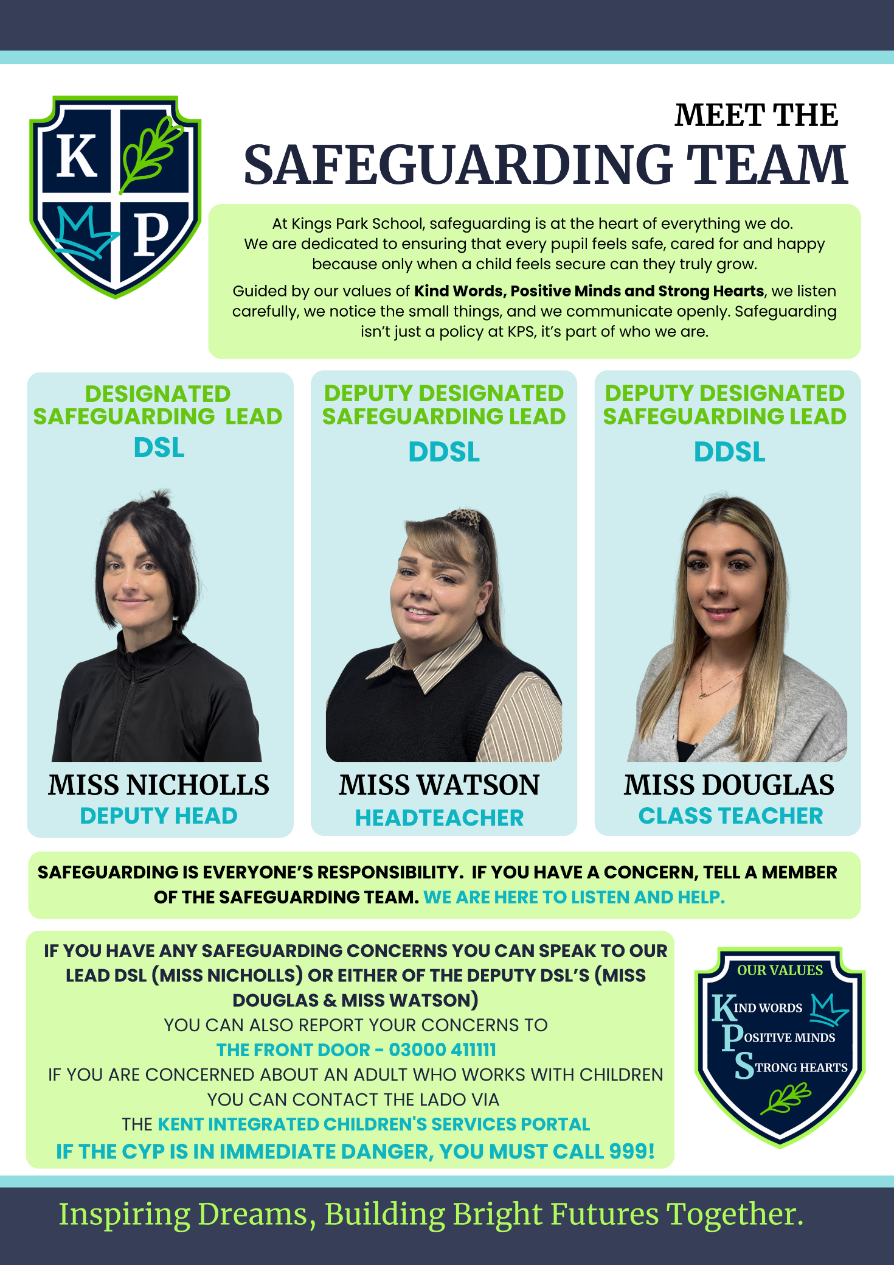
APPENDIX D – IF YOU HAVE A SAFEGUARDING CONCERN

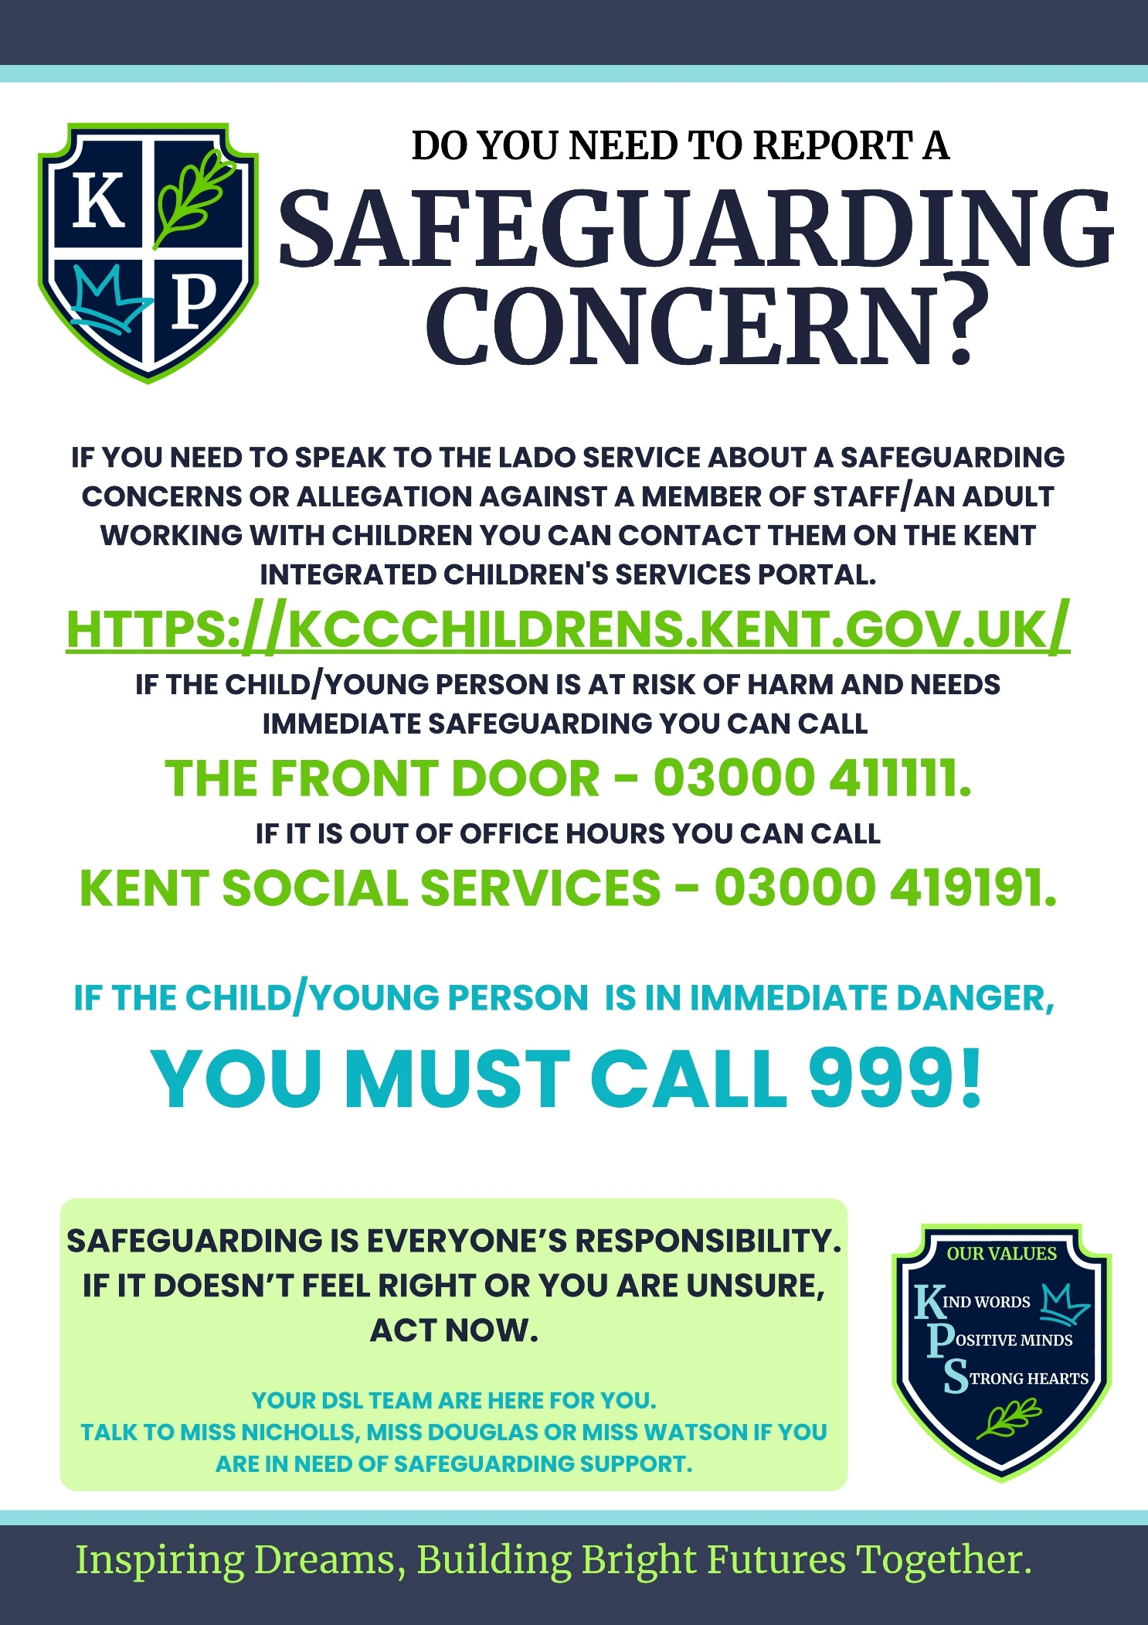

APPENDIX E – CHILDRENS DSL POSTER

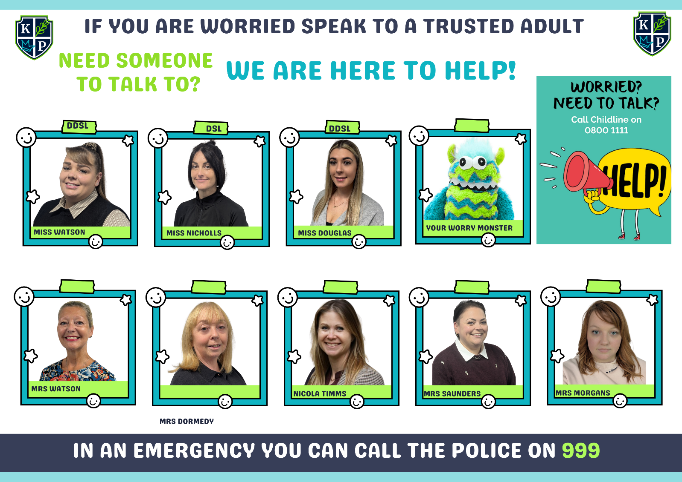

APPENDIX F – STAFF & STUDENT RELATIONSHIP LETTER
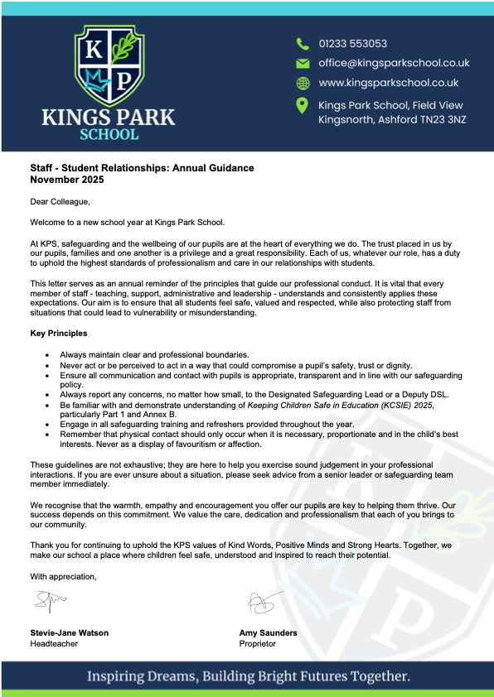

APPENDIX G – STAFF/STUDENT RELATIONSHIPS: GUIDANCE NOTES

